1. **Connecting to MySQL using Apache + PHP**

**+ Install MySQL**

**Question: Install MySQL 5.7.28 (install cmake)**

**Answer (follow step-by-step):**

sudo apt update

sudo apt install -y build-essential cmake libncurses5-dev libaio-dev bison zlib1g-dev pkg-config libtirpc-dev libssl-dev

cd ~

wget https://downloads.mysql.com/archives/get/p/23/file/mysql-5.7.28.tar.gz

tar -xzf mysql-5.7.28.tar.gz

cd mysql-5.7.28

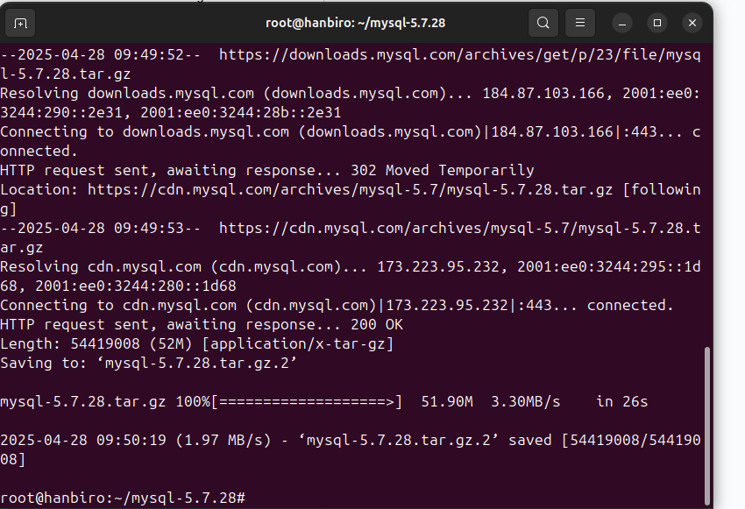

* download and unzip Boost 1.59.0:

cd ~

wget https://sourceforge.net/projects/boost/files/boost/1.59.0/boost_1_59_0.tar.gz/download -O boost_1_59_0.tar.gz

tar -xzf boost_1_59_0.tar.gz

check file: ls ~/boost_1_59_0/boost/version.hpp

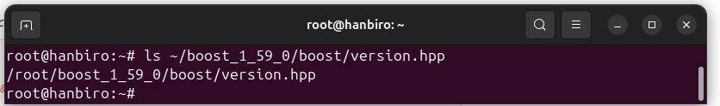

* compile OpenSSL 1.1.1 (required since MySQL 5.7 does not support OpenSSL 3):

cd ~

wget https://www.openssl.org/source/openssl-1.1.1w.tar.gz

tar -xzf openssl-1.1.1w.tar.gz

cd openssl-1.1.1w

./config --prefix=/opt/openssl-1.1.1 --openssldir=/opt/openssl-1.1.1 no-shared

make -j$(nproc)

sudo make install

* download MySQL source code and create ‘build’ directory:

cd ~

wget https://downloads.mysql.com/archives/get/p/23/file/mysql-5.7.28.tar.gz

tar -xzf mysql-5.7.28.tar.gz

cd mysql-5.7.28

mkdir build && cd build

* run cmake with full configuration and fix errors:

**cmake .. \**

**-DCMAKE_INSTALL_PREFIX=/usr/local/mysql \**

**-DWITH_SSL=/opt/openssl-1.1.1 \**

**-DOPENSSL_INCLUDE_DIR=/opt/openssl-1.1.1/include \**

**-DOPENSSL_LIBRARIES=/opt/openssl-1.1.1/lib/libssl.a\;/opt/openssl-1.1.1/lib/libcrypto.a \**

**-DDOWNLOAD_BOOST=0 \**

**-DWITH_BOOST=~/boost_1_59_0 \**

**-DCMAKE_C_FLAGS="-I/usr/include/tirpc" \**

**-DCMAKE_CXX_FLAGS="-I/usr/include/tirpc" \**

**-DWITH_INNOBASE_STORAGE_ENGINE=1 \**

**-DWITH_PARTITION_STORAGE_ENGINE=1 \**

**-DWITH_FEDERATED_STORAGE_ENGINE=1 \**

**-DWITH_EXTRA_CHARSETS=all \**

**-DWITH_ZLIB=system \**

**-DWITH_MYSQLD_LDFLAGS=--static \**

**-DENABLED_LOCAL_INFILE=1**

**\*Note:**

* use OpenSSL manually due to OpenSSL 3 incompatibility
* Boost must be available, do not use -DDOWNLOAD_BOOST=1 because the old download link does not work
* add flag -I/usr/include/tirpc to handle rpc/rpc.h errors
* -all-static => --static
* build and config:

make -j$(nproc)

sudo make install

* config MySQL (temporary root password is printed out - ):

sudo useradd -r -s /bin/false mysql

sudo mkdir -p /usr/local/mysql/data

sudo chown -R mysql:mysql /usr/local/mysql

cd /usr/local/mysql

sudo bin/mysqld --initialize --user=mysql

**my issue:**

* compile with **-DWITH_MYSQLD_LDFLAGS=-all-static**, meaning mysqld is completely statically linked, including glibc
* when glibc is statically linked but the system still configures /etc/nsswitch.conf to use systemd or ldap → causing a crash when calling initgroups() (because static glibc cannot use NSS plugins like libnss_systemd.so)

**solution:**

* **1:** remove the -DWITH_MYSQLD_LDFLAGS=-all-static configuration and rebuild
* ***‘2 (my option)’:*** want to keep -all-static [ temporary solution (just to run --initialize) ], can try temporarily commenting out the line with systemd in /etc/nsswitch.conf. Follow steps:

sudo nano /etc/nsswitch.conf

find line:

group: files systemd sss

and edit to:

group: files

save and rerun:

sudo /usr/local/mysql/bin/mysqld --initialize --user=mysql

password

**a temporary password will appear:** !Tq>mtrlG7em

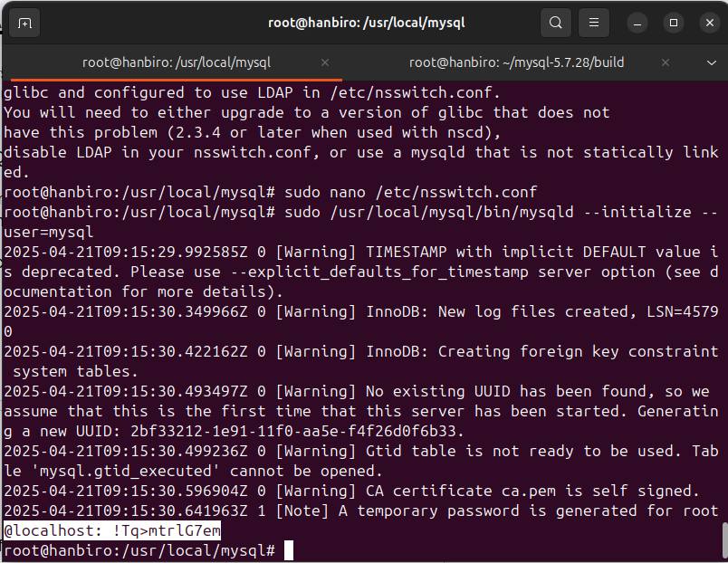

* **restore nsswitch.conf:**

run: sudo nano /etc/nsswitch.conf

group: files

-> **group: files systemd sss**

* start MySQL:

sudo cp /usr/local/mysql/support-files/mysql.server /etc/init.d/mysql

sudo update-rc.d mysql defaults

sudo service mysql start

sudo /usr/local/mysql/bin/mysql -u root -p

**passwd (temporary password):** !Tq>mtrlG7em

ALTER USER 'root'@'localhost' IDENTIFIED BY 'your_new_yourpassword';

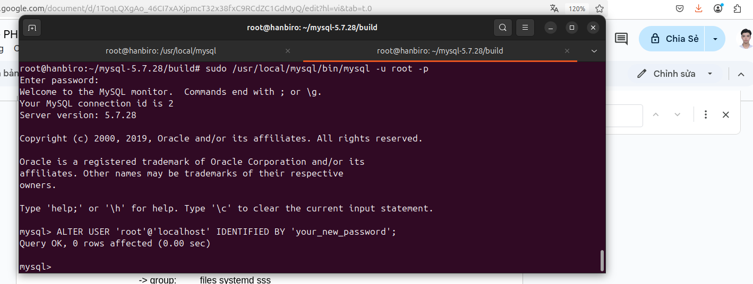

**Summary the meaning of each installation option**

- **prefix = /usr/local/mysql**

→MySQL installation directory. All executable files, libraries... will be in this directory.

**DWITH_INNOBASE_STORAGE_ENGINE=1**

→enable InnoDB (InnoBase) – default storage engine, transaction support, foreign key

**DWITH_PARTITION_STORAGE_ENGINE=1**

→enable table partitioning – useful for large databases

**DWITH_FEDERATED_STORAGE_ENGINE=1**

→enable Federated engine – allows accessing data from other MySQL (remote MySQL server)

**DWITH_EXTRA_CHARSETS=all**

→install all supported charsets (UTF8, latin1, sjis, ...)

**DWITH_SSL=yes**

→enable SSL connection support for MySQL – secure client-server connections

**DWITH_ZLIB=system**

→use system-level zlib instead of bundled version – to reduce the risk of build errors

**DWITH_MYSQLD_LDFLAGS=-all-static**

→link statically instead of using dynamic libraries – helps portable, less system dependent

**DENABLED_LOCAL_INFILE=1**

→allows use of LOAD DATA LOCAL INFILE – very useful when importing data from files into DB

**additional used options to fix any issue:**

**-DWITH_SSL=/opt/openssl-1.1.1**

→use SSL library (here OpenSSL 1.1.1 installed at /opt/openssl-1.1.1 - this MySQL version is not compatible with the default OpenSSL 3

**-DOPENSSL_INCLUDE_DIR=/opt/openssl-1.1.1/include**

→specifies the directory containing the OpenSSL header file

**-DOPENSSL_LIBRARIES=/opt/openssl-1.1.1/lib/libssl.a;/opt/openssl-1.1.1/lib/libcrypto.a**

→list OpenSSL .a (static) libraries to link when building

**-DDOWNLOAD_BOOST=0**

→do not automatically download Boost (included with cmake) because there are some errors when downloading such as bandwidth throttling

**-DWITH_BOOST=~/boost_1_59_0**

→path to manually downloaded and unzipped Boost library

**-DCMAKE_C_FLAGS="-I/usr/include/tirpc"**

**-DCMAKE_CXX_FLAGS="-I/usr/include/tirpc"**

→add include path for TIRPC (transport independent RPC library) library — often needed when the system does not have the default rpc/rpc.h

**+ Install Apache**

**Question: Install Apache 2.4.41**

***current version (on Hanbiro’s computer): [ Apache HTTP Server 2.4.58, released on 04/06/2023 ]***

* compile from source:

sudo apt update

sudo apt update

sudo apt install -y build-essential libpcre3 libpcre3-dev libssl-dev \

libexpat1-dev libxml2-dev liblua5.2-dev libtool \

libnghttp2-dev libcurl4-openssl-dev pkg-config \

libjansson-dev

cd ~

wget https://archive.apache.org/dist/httpd/httpd-2.4.41.tar.gz

tar -xzf httpd-2.4.41.tar.gz

cd httpd-2.4.41

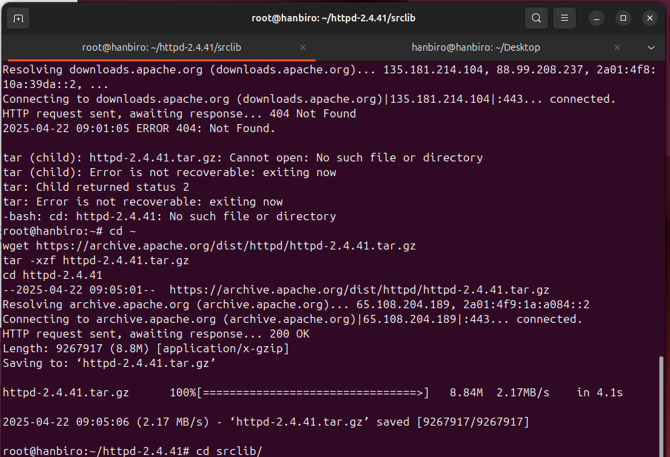

* download APR 1.7.5:

cd ~

sudo wget <https://dlcdn.apache.org//apr/apr-1.7.5.tar.gz>

*check:

ls -lh apr-1.7.5.tar.gz

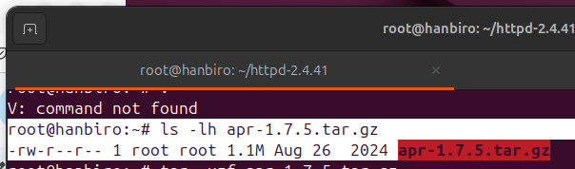

unpack APR into apr directory, compile and install APR:

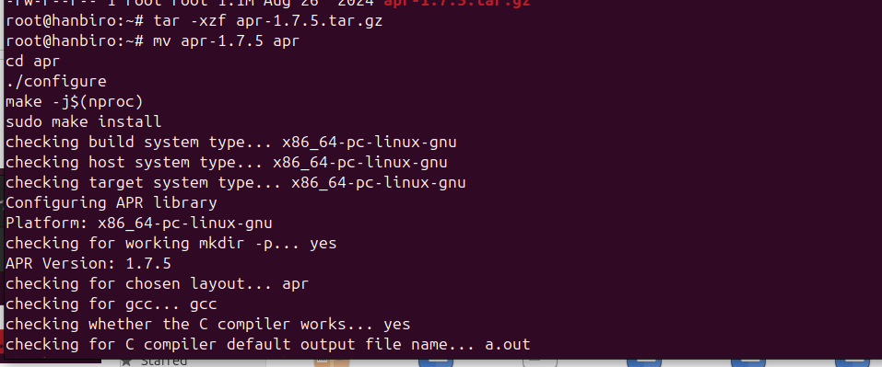

* download APR-Util 1.6.3:

cd ~

sudo wget: <https://dlcdn.apache.org//apr/apr-util-1.6.3.tar.gz>

*check: ls -lh apr-util-1.6.3.tar.gz



*unpack APR-Util into apr directory, compile and install APR-Util:

tar -xzf apr-util-1.6.3.tar.gz

mv apr-util-1.6.3 apr-util

cd apr-util

./configure --with-apr=/usr/local/apr

make -j$(nproc)

sudo make install

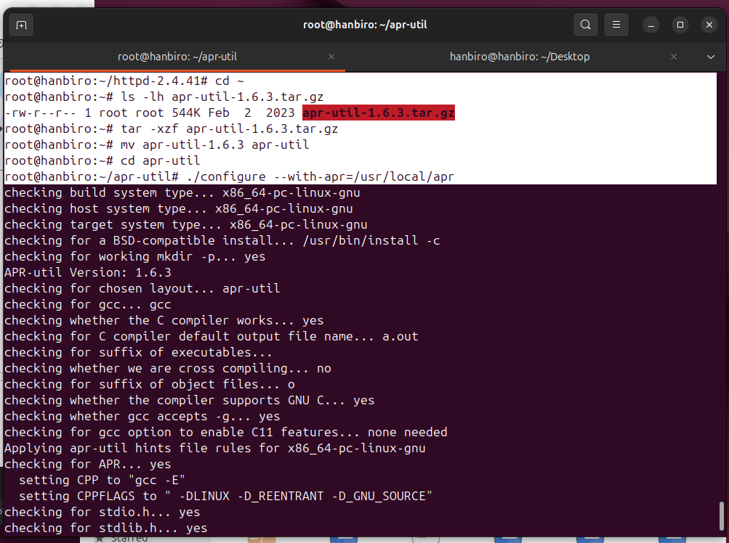

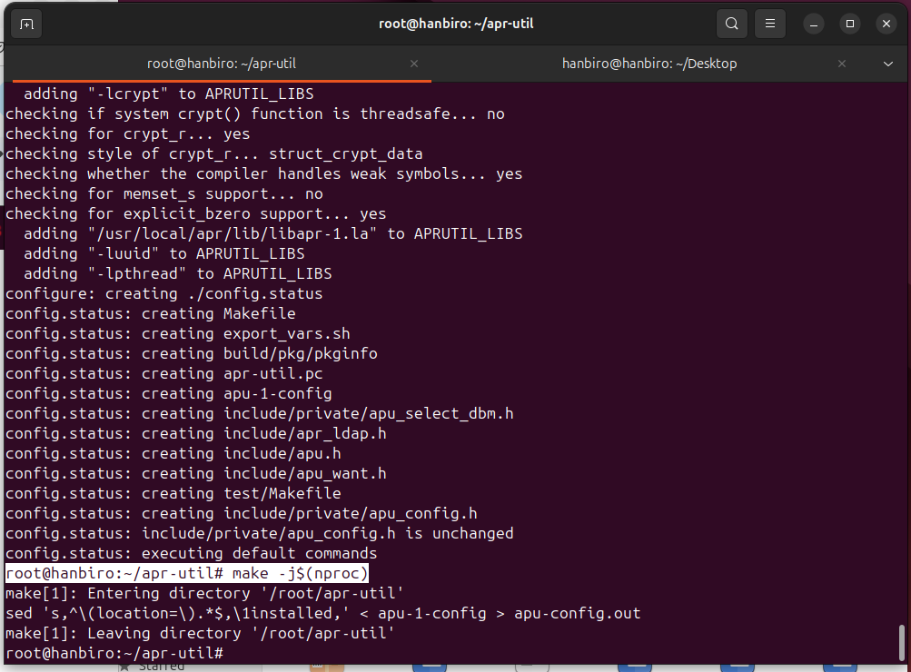

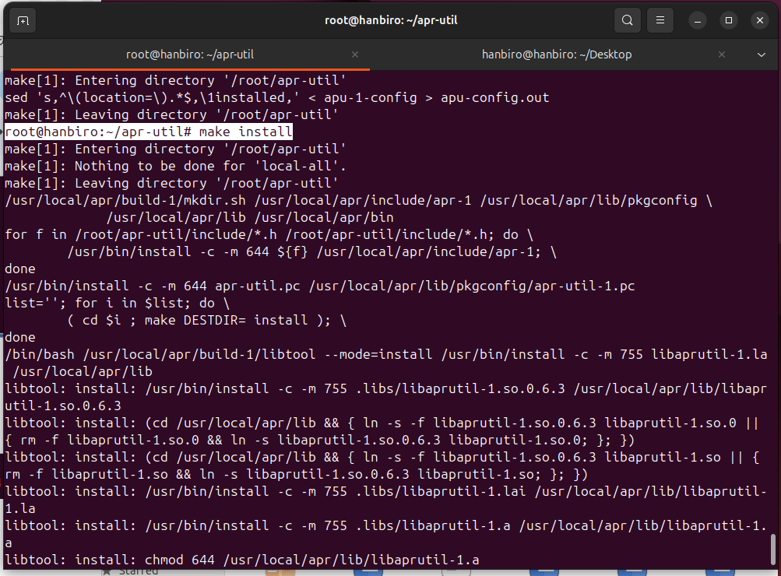

* configure Apache:

cd ~/httpd-2.4.41

*a few tweaks:

--with-included-apr=/usr/local/apr: Use APR installed at /usr/local/apr

--with-apr-util=/usr/local/apr-util: Use APR-util installed at /usr/local/apr-util

./configure --prefix=/usr/local/httpd2 \

--enable-modules=all \

--enable-charset-lite \

--enable-so \

--with-included-apr=/usr/local/apr \

--with-apr-util=/usr/local/apr-util \

--with-mpm-shared=all \

--with-mpm=prefork

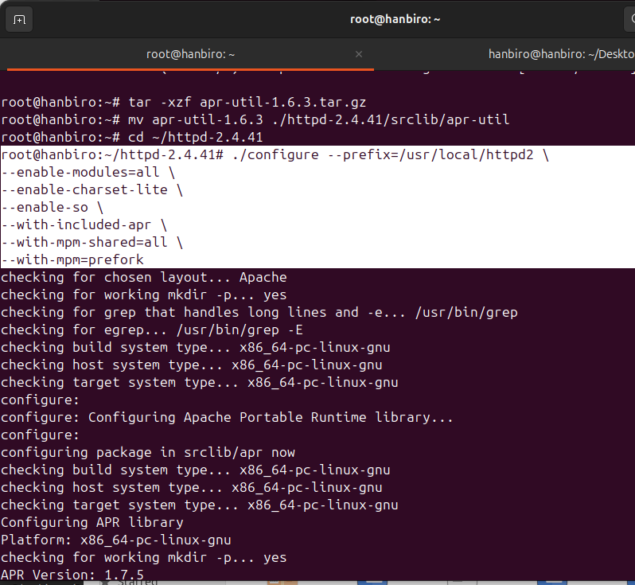

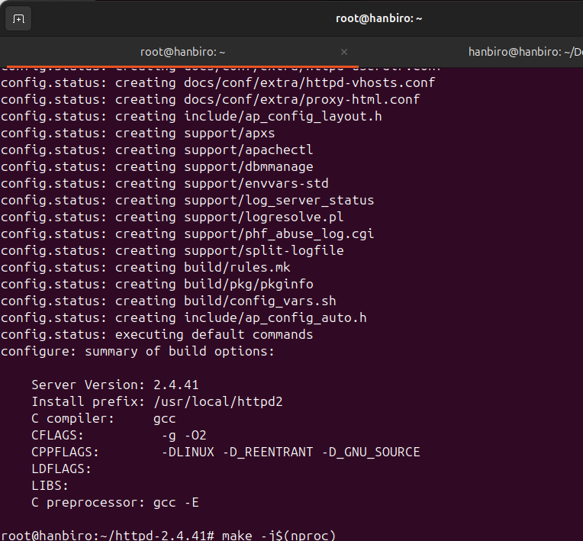

* compile Apache:

Run the following command to compile Apache:

make -j$(nproc)

-> this command will use all of CPU cores to speed up the compilation process

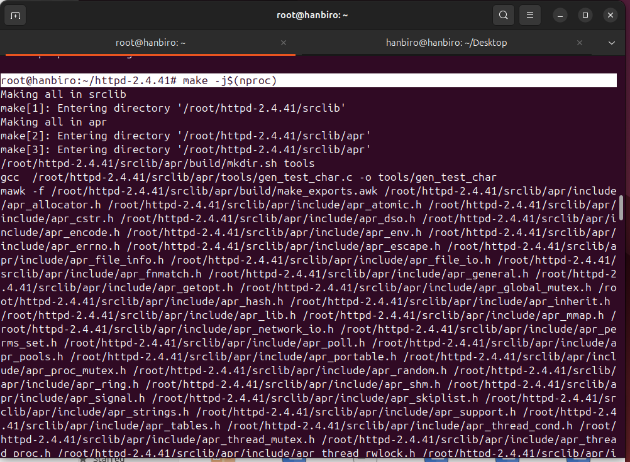

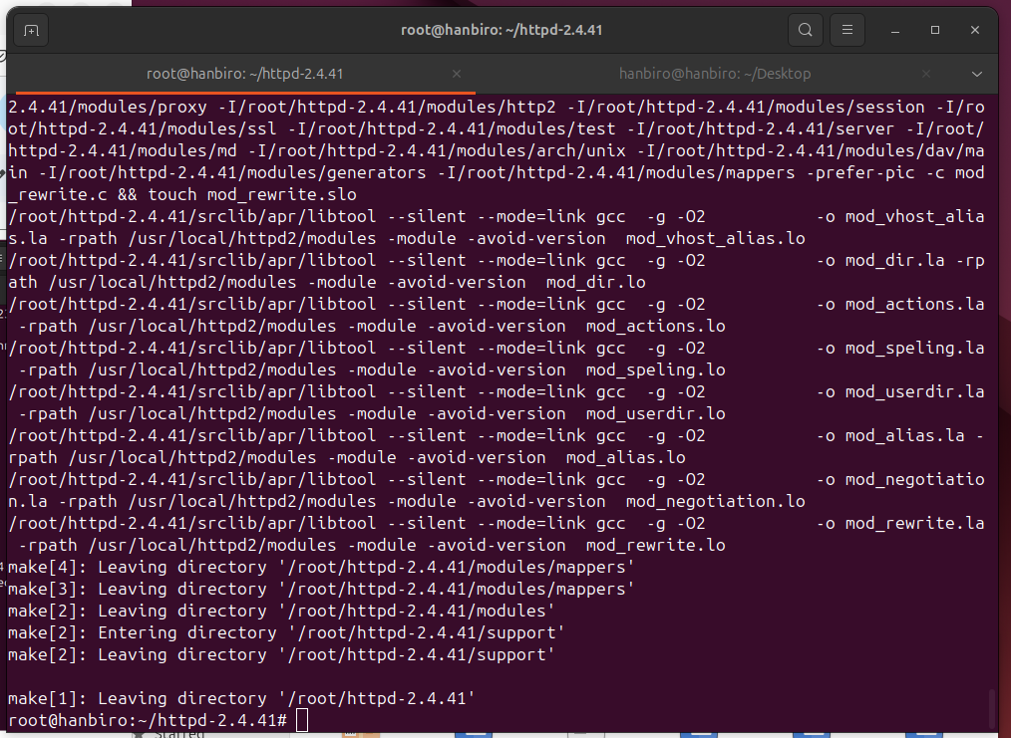

* install Apache into the /usr/local/httpd2 directory:

sudo make install

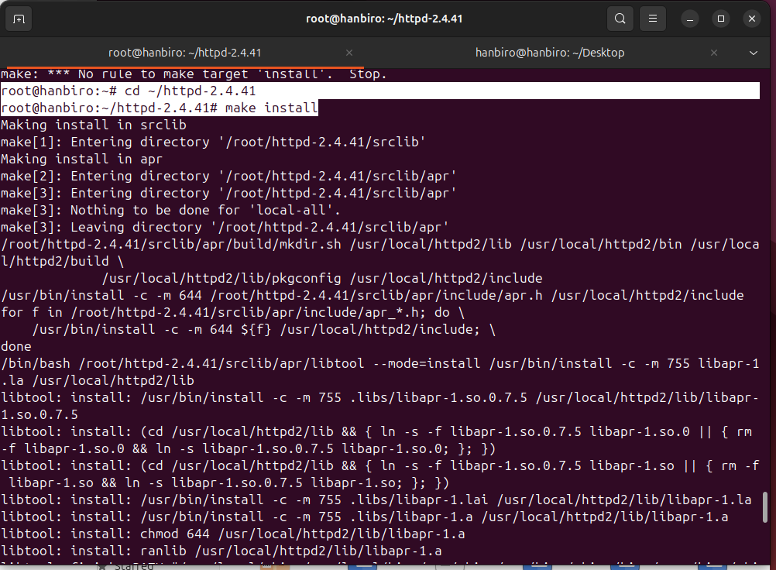

**Question: mpm is prefork**

* installed Apache with the --with-mpm=prefork option, this ensures Apache uses the Prefork MPM. Check:

/usr/local/httpd2/bin/httpd -V | grep MPM



**Question: Set up the cband to work**

**Purpose:** Limit Bandwidth and Number of Concurrent Connections

* download mod_cband from Fossies Archive:

wget https://fossies.org/linux/www/apache_httpd_modules/old/mod-cband-0.9.7.5.tgz

* extract and install:L

tar -xzf mod-cband-0.9.7.5.tgz

cd mod-cband-0.9.7.5

./configure --prefix=/usr/local/pcre

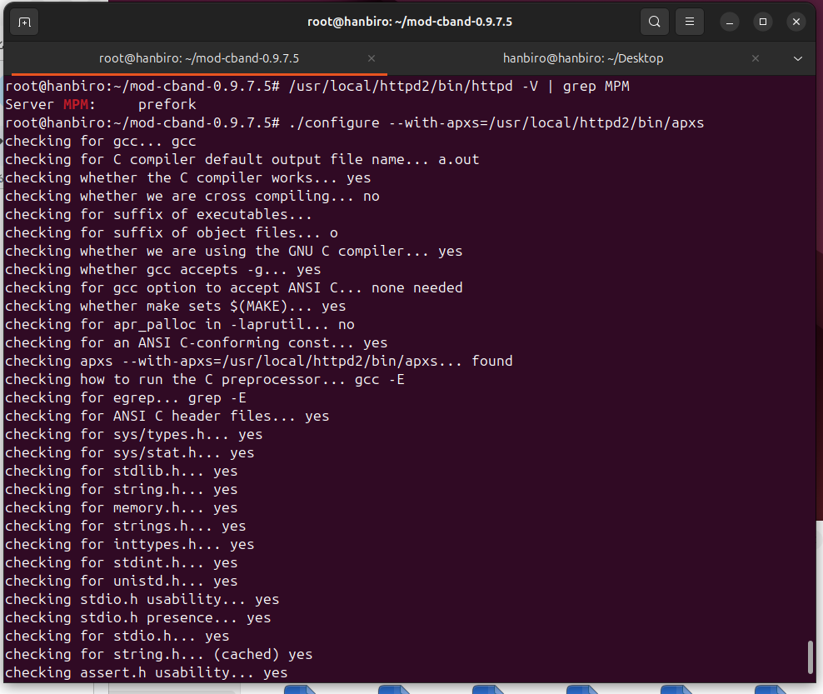

make

**conflict: conn_rec structure changes between Apache versions**

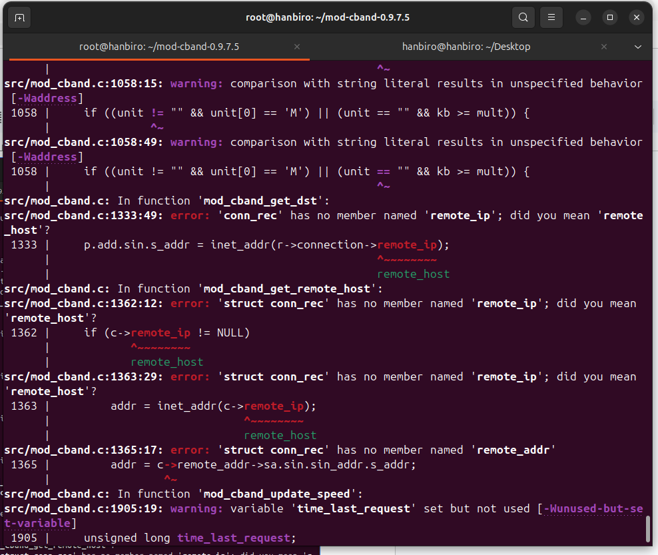

**resolve:** change remote_ip to client_ip and remote_addr to client_addr

Follow these steps:

nano src/mod_cband.c

***step 1: fix r->connection->remote_ip*** *to* ***r->connection->client_ipto***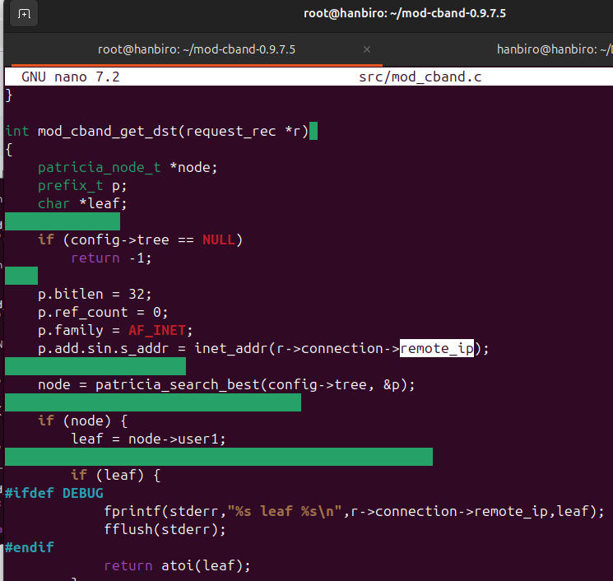**edit to:**

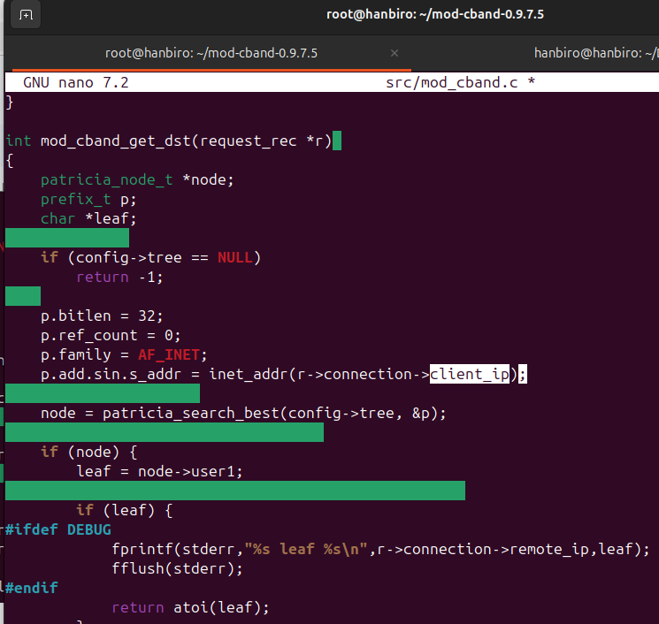

***step 2: c>remote_ip*** *to* ***c->client_ip***

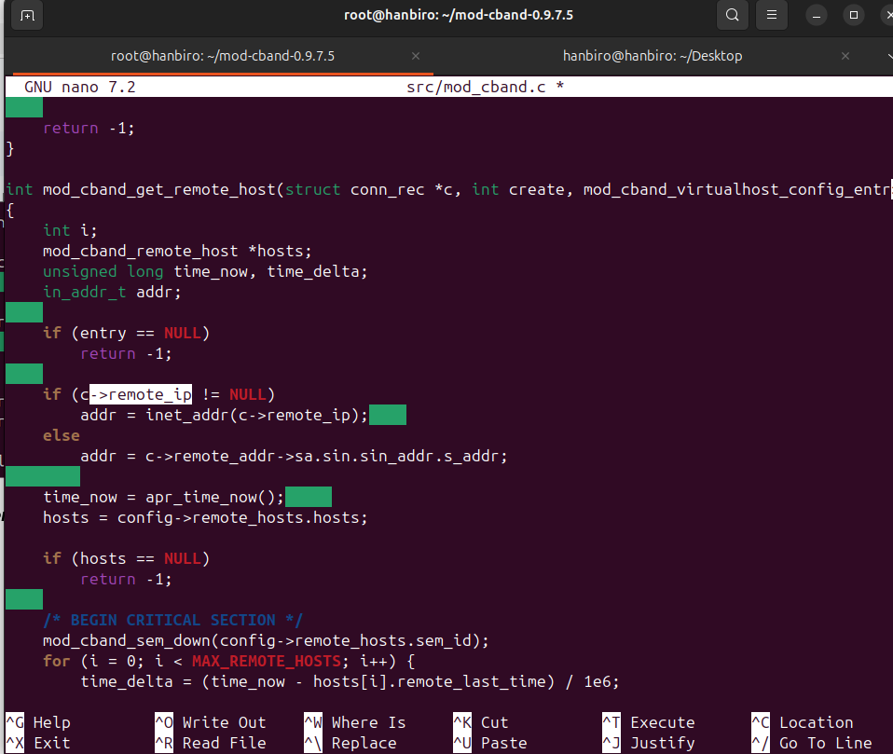

**edit to (need to cast client_addr -> sockaddr_in to access sin_addr):**

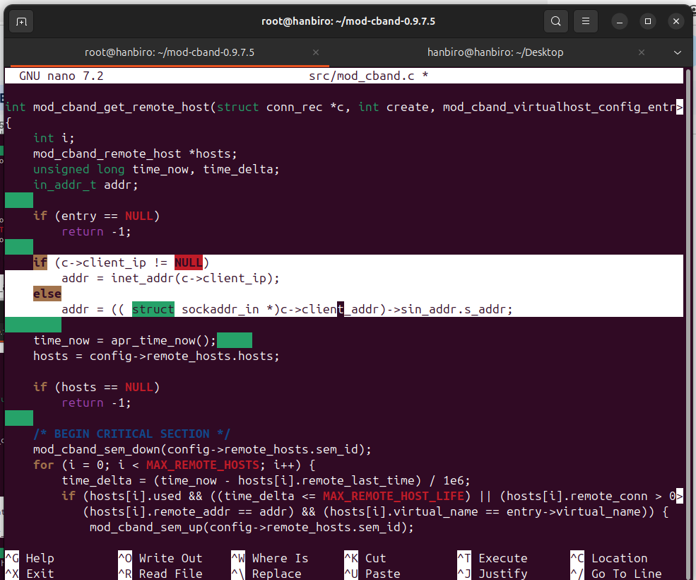

**rerun:**

make clean

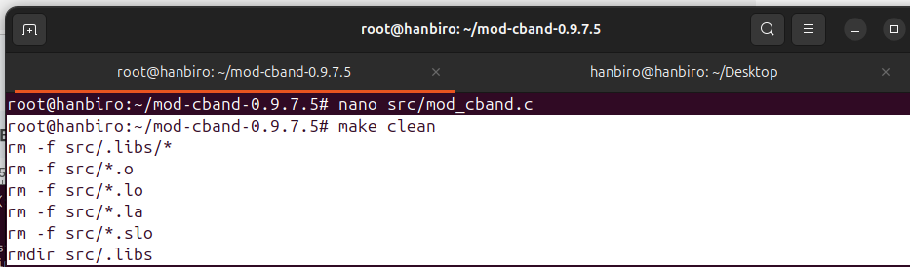

make

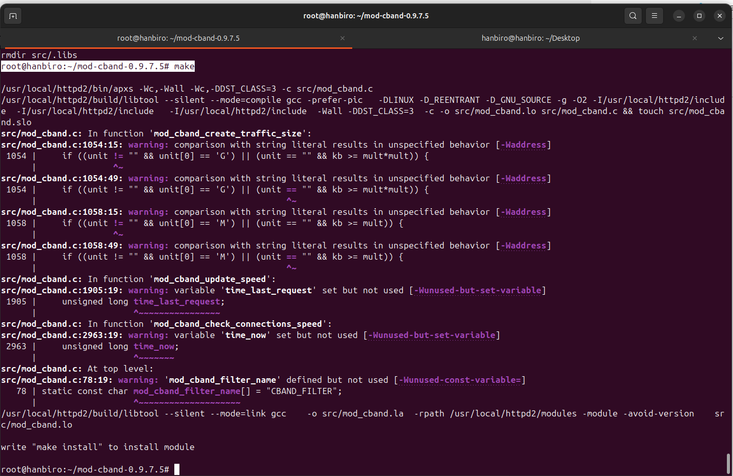

sudo make install

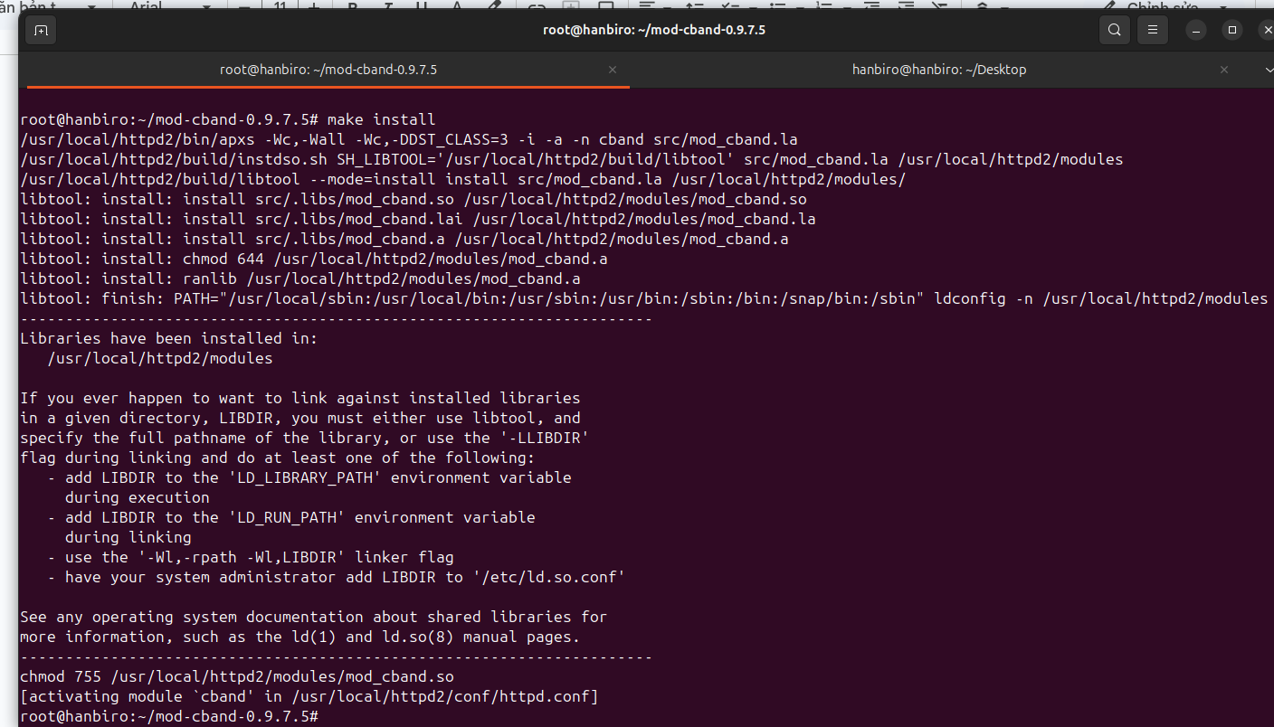

* config Apache to use mod_cban:

nano /usr/local/httpd2/conf/httpd.conf

add VirtualHost text:

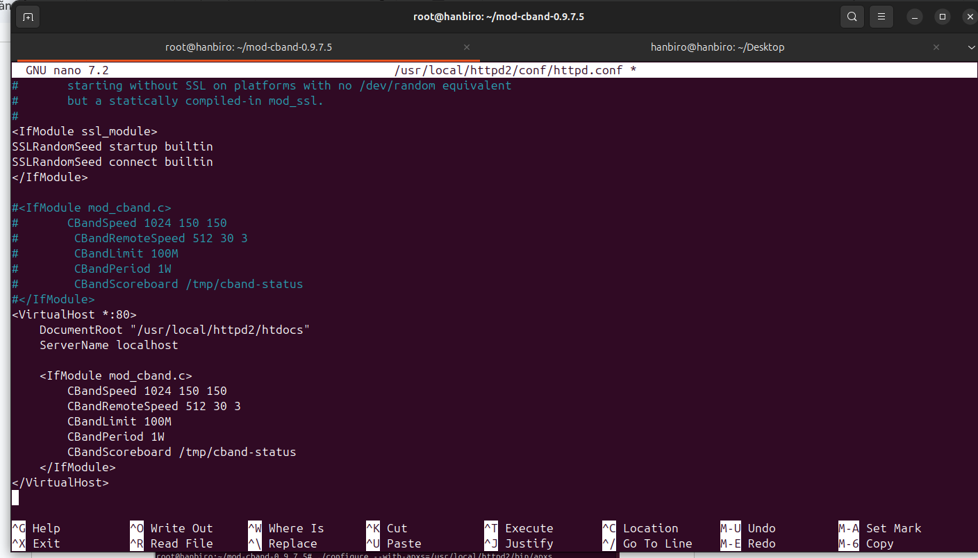

* create scoreboard directory and authorize, so that mod_cband can write status information to it:

sudo mkdir -p /tmp/cband-status

sudo chmod 777 /tmp/cband-status

* after editing the configuration, check the Apache configuration again:

/usr/local/httpd2/bin/apachectl -t



*\*warning: ServerName is not defined*

*=> resolve: replace www.example.com with my domain name or localhost if just want to use Apache on your local machine:*

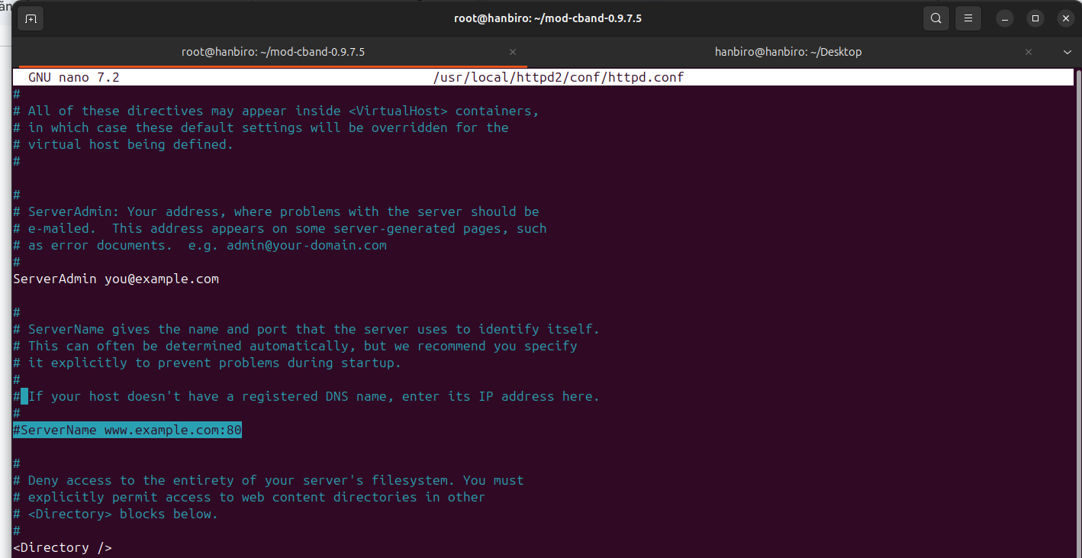

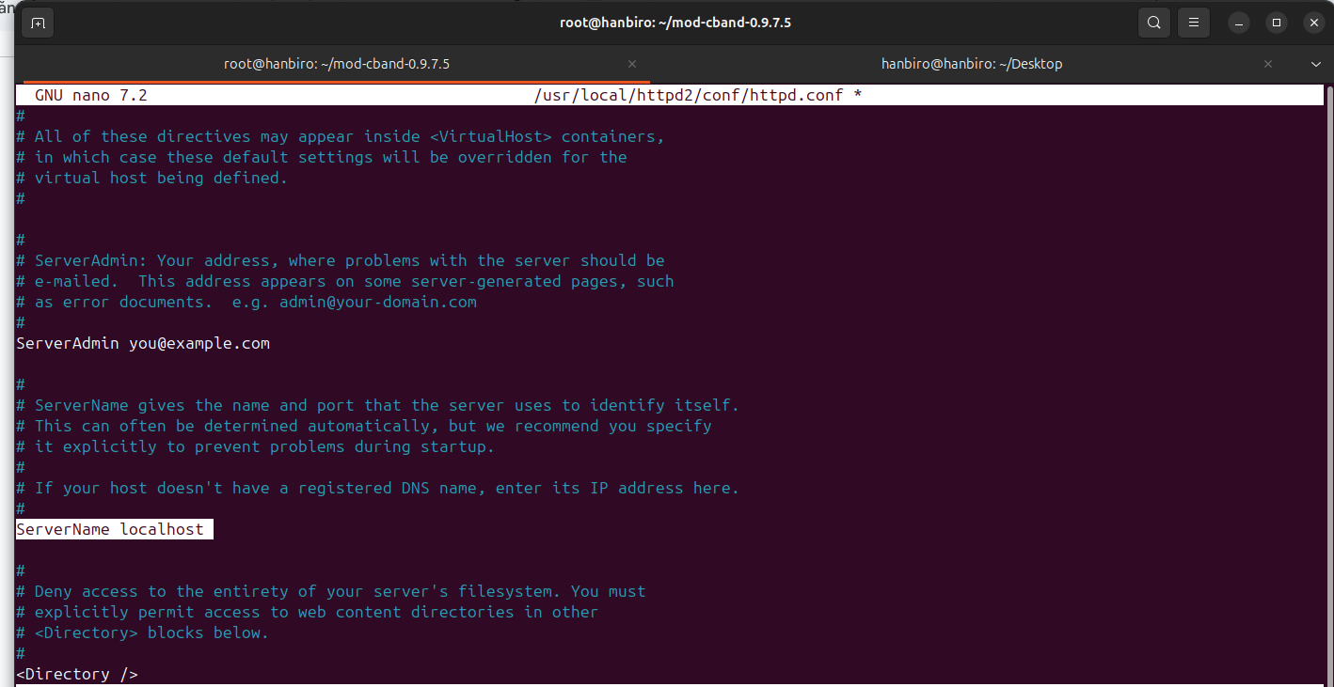

* restart Apache and access **http://localhost**to check:

/usr/local/httpd2/bin/apachectl restart

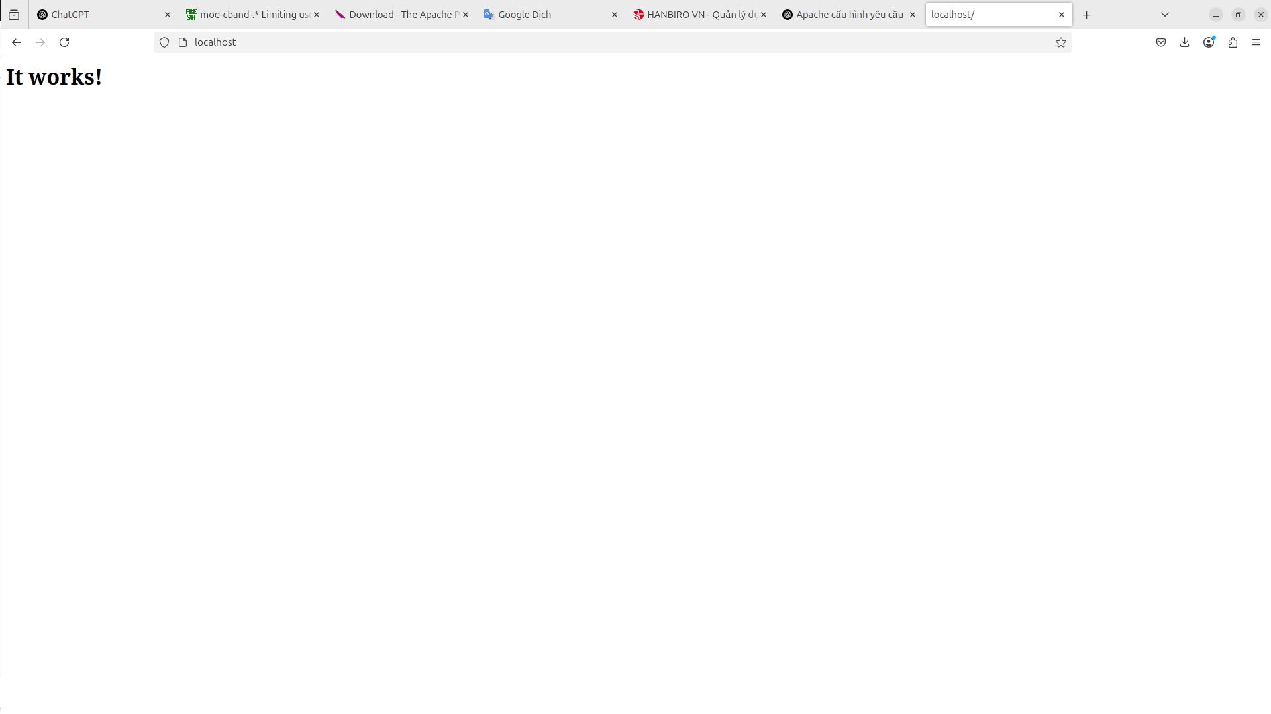

**Question: Set up to enable maxclient 2048**

* edit file config: sudo nano /usr/local/httpd2/conf/httpd.conf
* configure:

*with:

* ServerLimit is a hard limit
* MaxRequestWorkers is the maximum number of connections desired

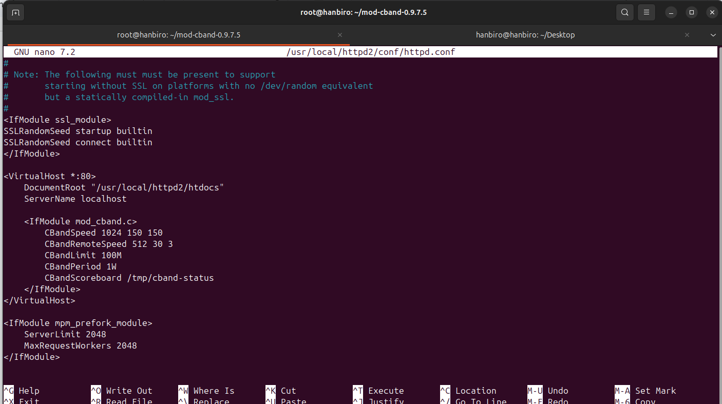

* check syntax, restart apache:

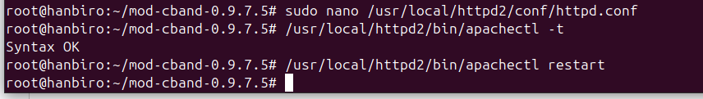

**Question: Set up mod_security**

* instal any packages:

sudo apt install -y build-essential libxml2 libxml2-dev libpcre3 libpcre3-dev libcurl4-openssl-dev doxygen

*\*note:*

build-essential GCC compiler, Make…

libxml2-dev XML library (ModSecurity uses to process rules)

libpcre3-dev Regex library

libcurl4-openssl-dev HTTP connection in rules

doxygen (optional) Internal code documentation

* install ModSecurity 2.9.7 from source:

cd ~

wget https://github.com/SpiderLabs/ModSecurity/releases/download/v2.9.7/modsecurity-2.9.7.tar.gz

tar -xzf modsecurity-2.9.7.tar.gz

cd modsecurity-2.9.7

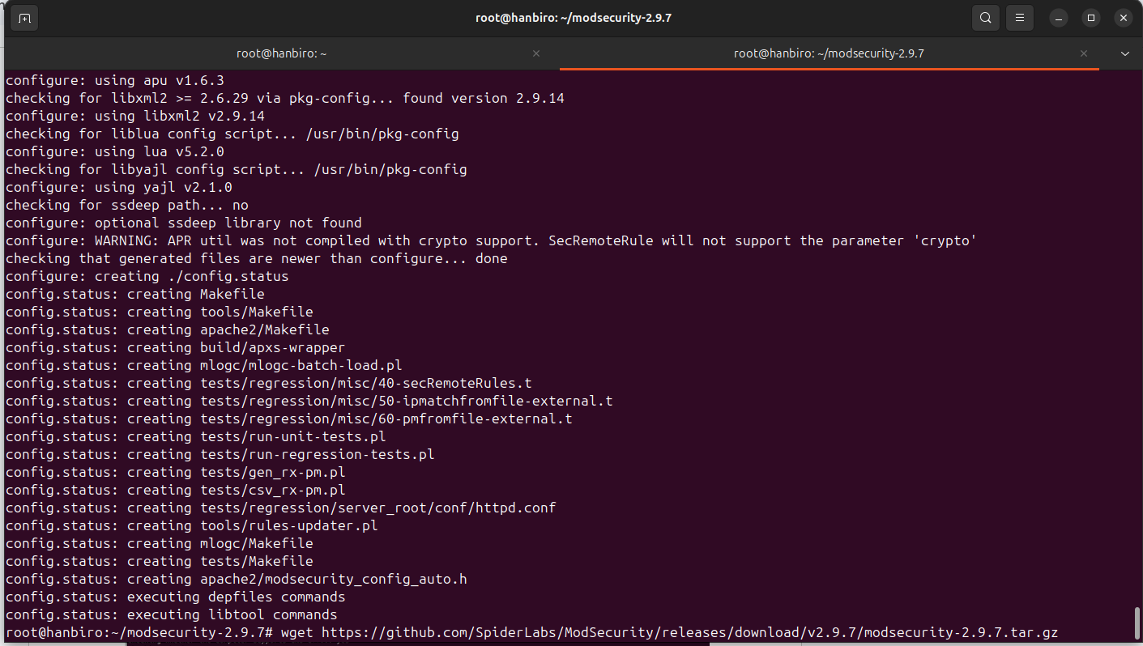

* configure the build process, specify the installation directory as /usr/local/modsecurity

./configure --prefix=/usr/local/modsecurity2

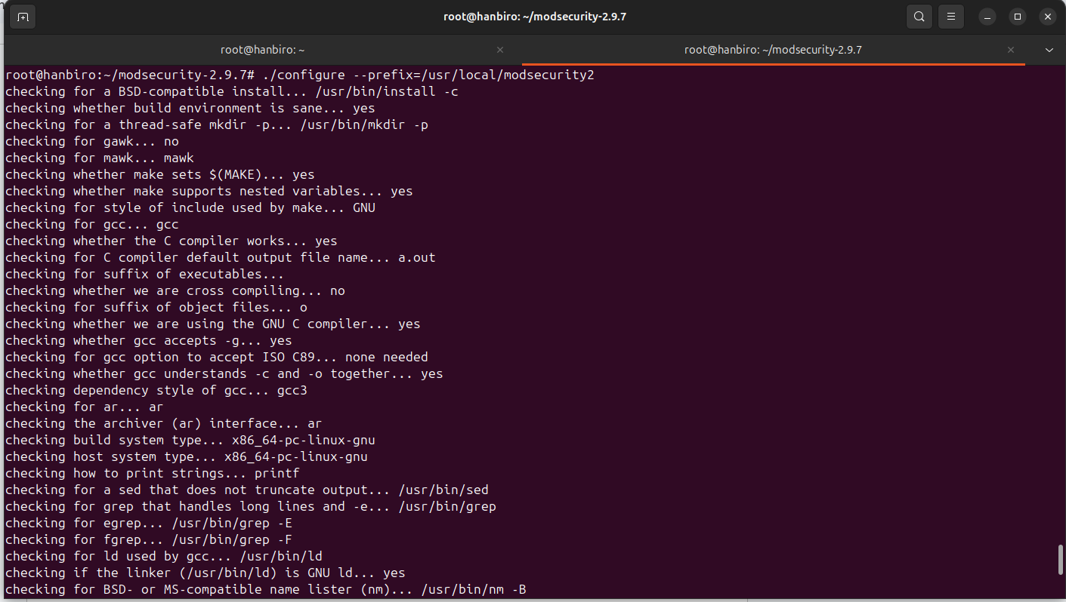

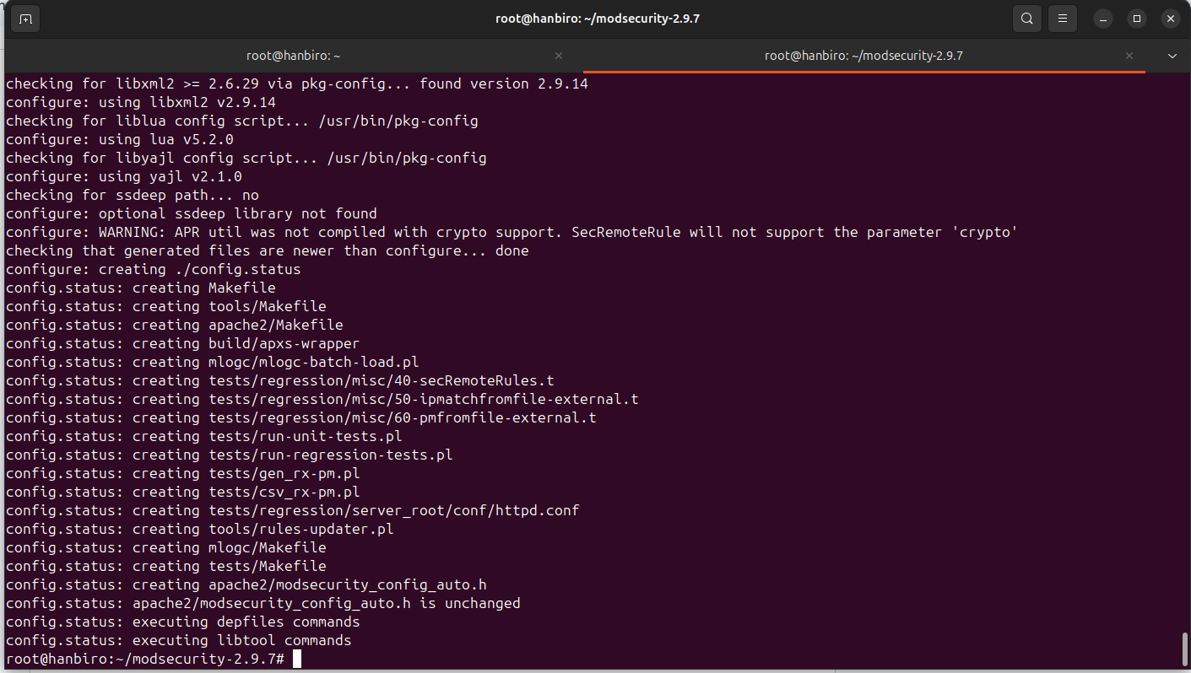

* compile the source code, using all available CPU cores to speed up the process

make -j$(nproc)

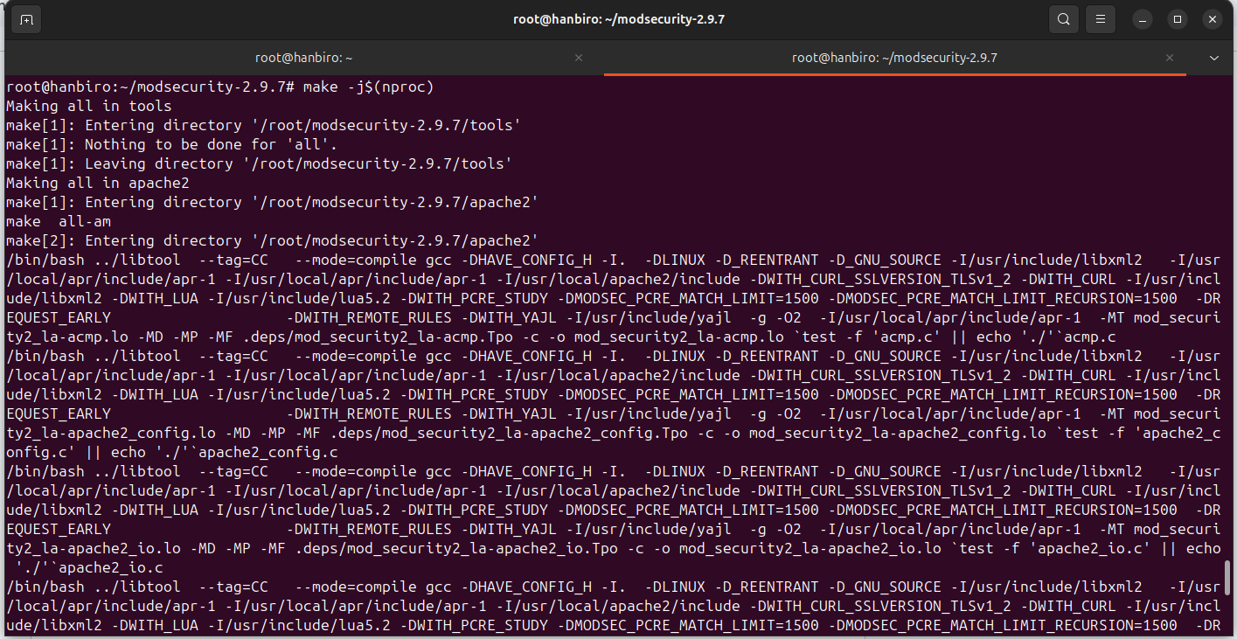

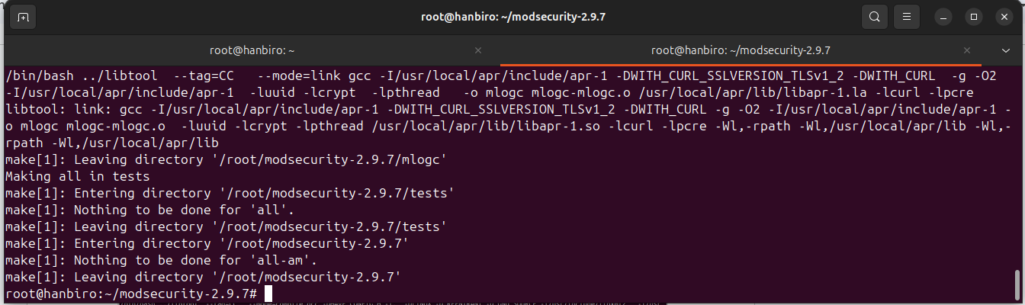

* install ModSecurity on your system

sudo make install

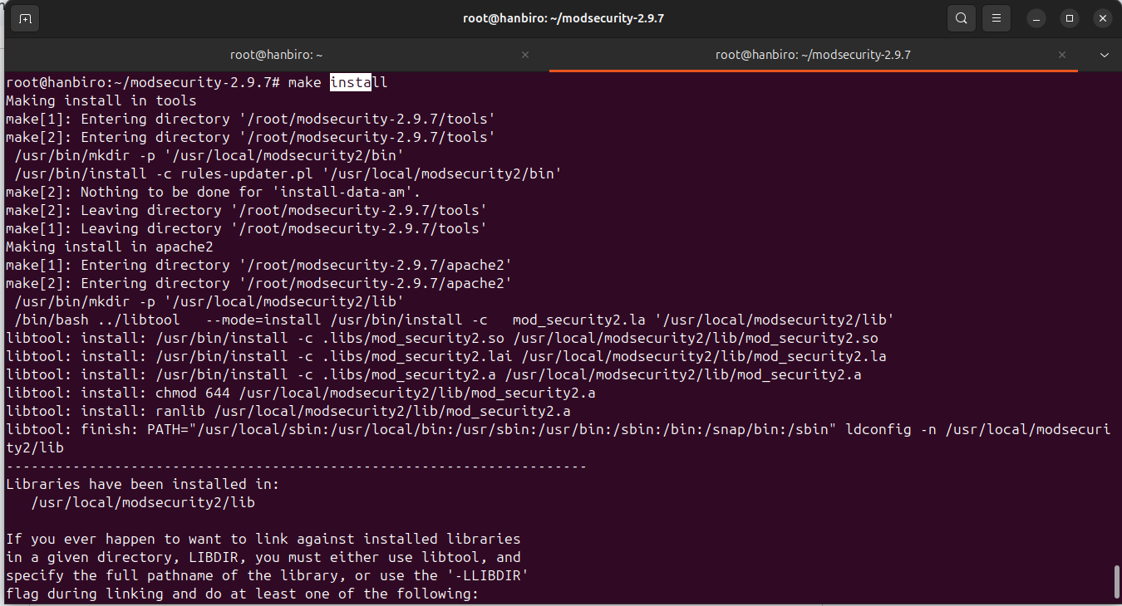

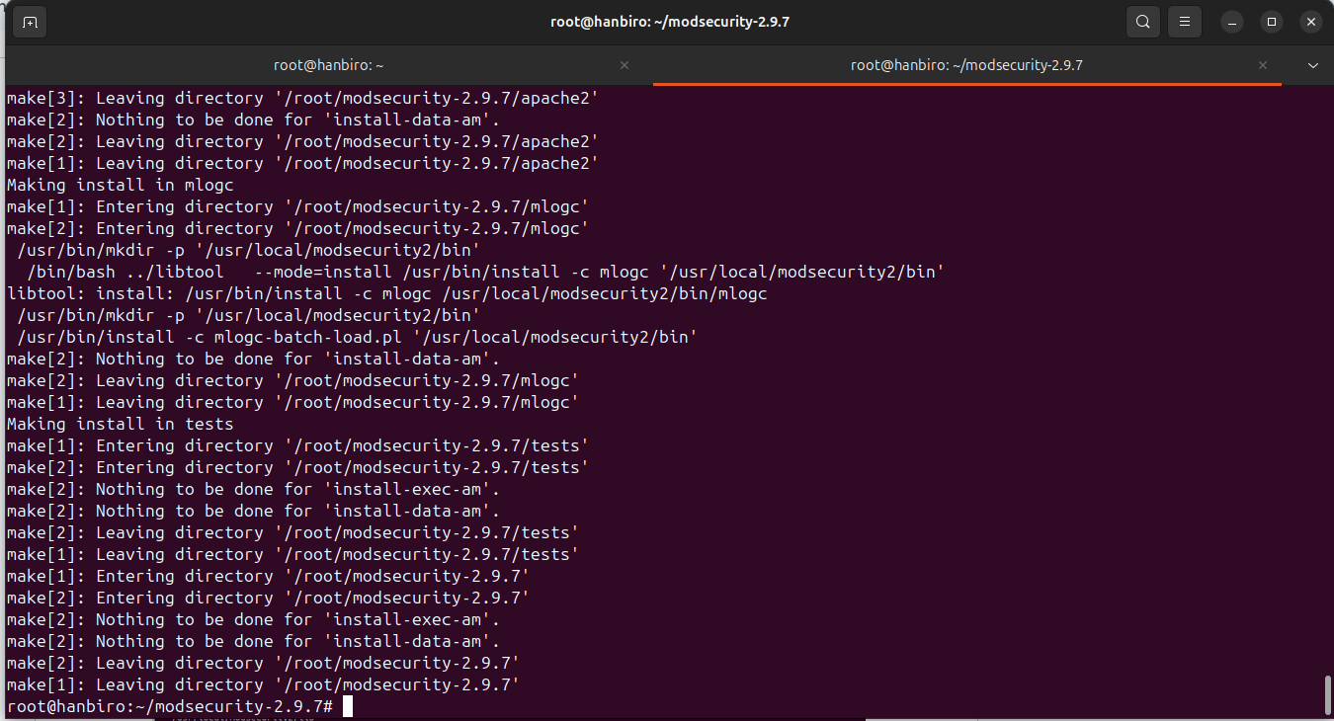

* copy .so file to Apache:

sudo cp apache2/.libs/mod_security2.so /usr/local/httpd2/modules/

* copy the sample configuration file

sudo cp modsecurity.conf-recommended /usr/local/modsecurity2/modsecurity.conf

sudo nano /usr/local/modsecurity2/modsecurity.conf

edit: SecRuleEngine **DetectionOnly** -> SecRuleEngine **On**

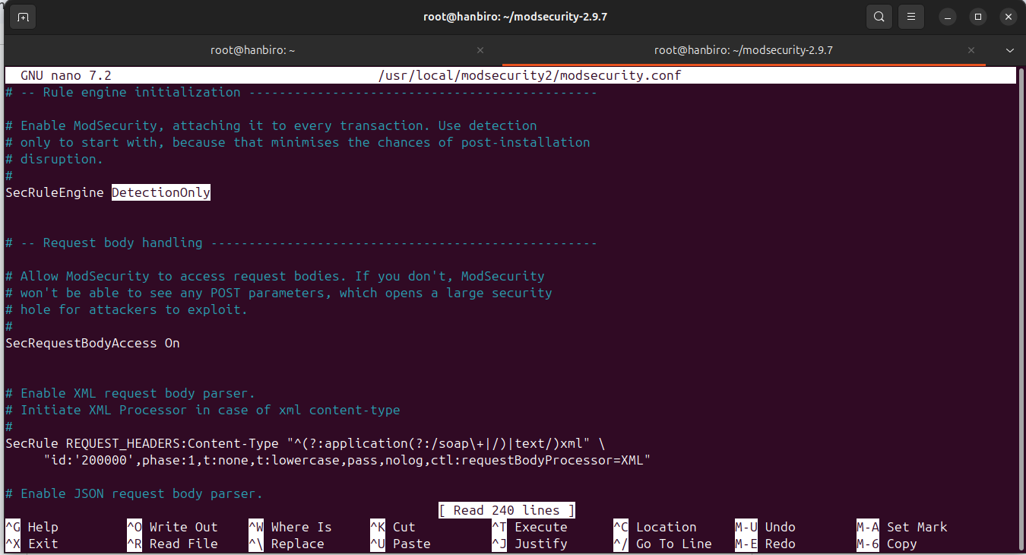

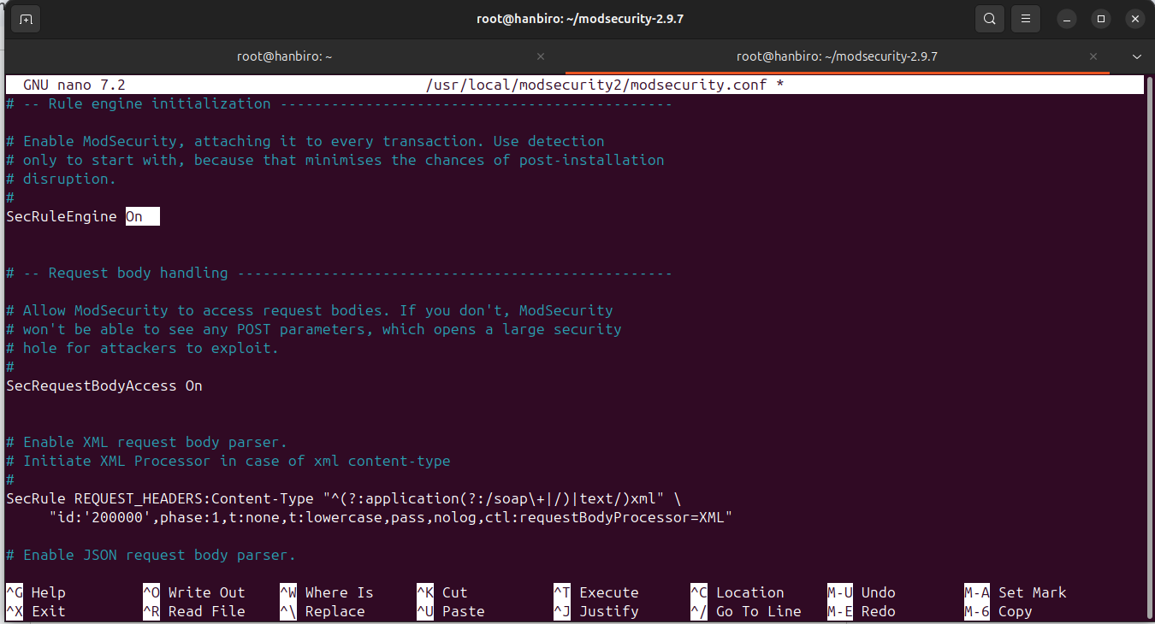

* config /usr/local/httpd2/conf/httpd.conf file:

LoadModule security2_module modules/mod_security2.so

Include /usr/local/modsecurity2/modsecurity.conf

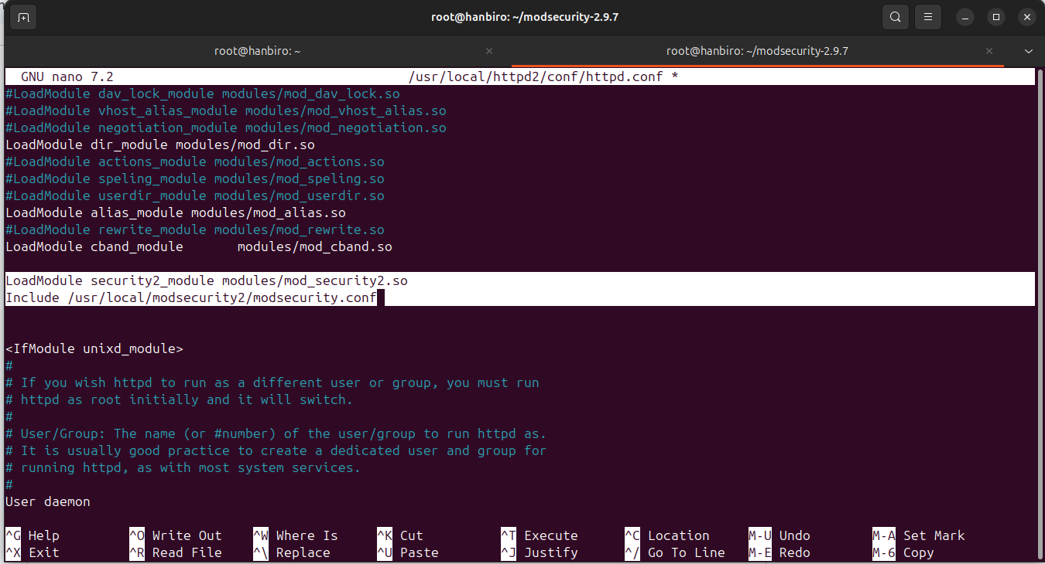

* check and restart Apache:

**issue:**

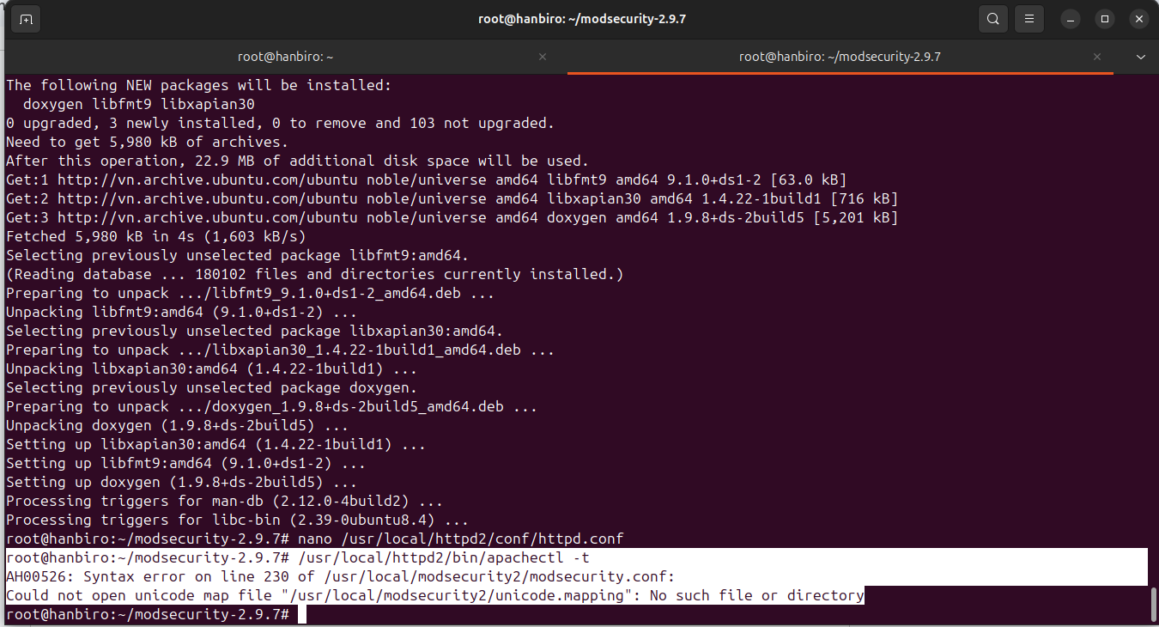

**resolve: the file below comes with the modsecurity-2.9.7 source, but if not copied to the correct directory, it will give the error as above**

cd /usr/local/modsecurity2

sudo wget https://raw.githubusercontent.com/SpiderLabs/ModSecurity/v2.9.7/unicode.mapping

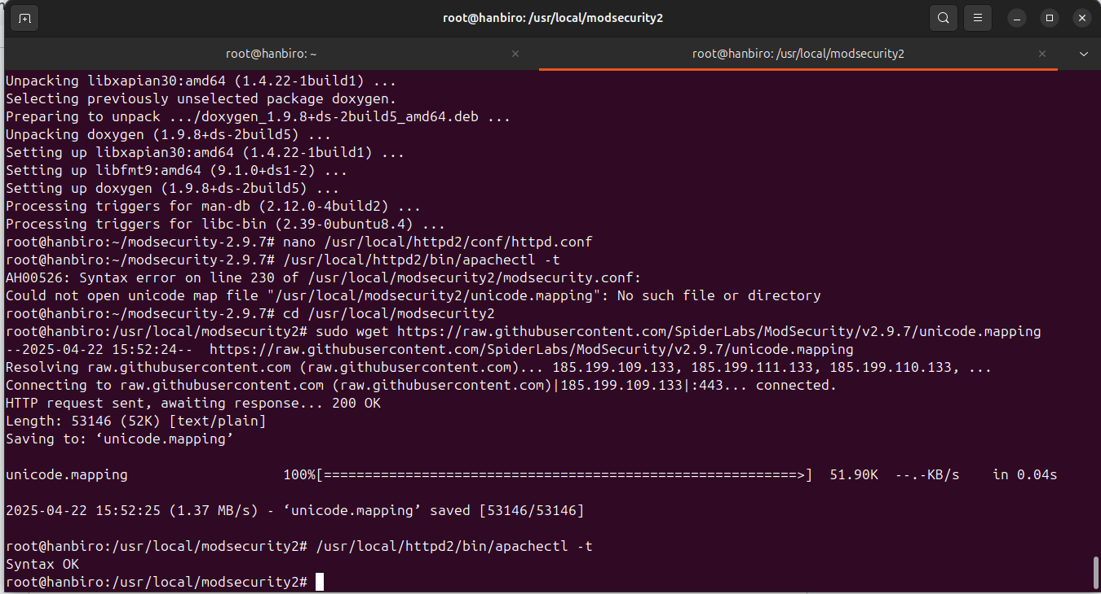

/usr/local/httpd2/bin/apachectl -t

sudo /usr/local/httpd2/bin/apachectl restart

**Question: Set up mod_url**

* used --enable-modules=all in ./configure so this module is enabled. But still need to load manually in httpd.conf

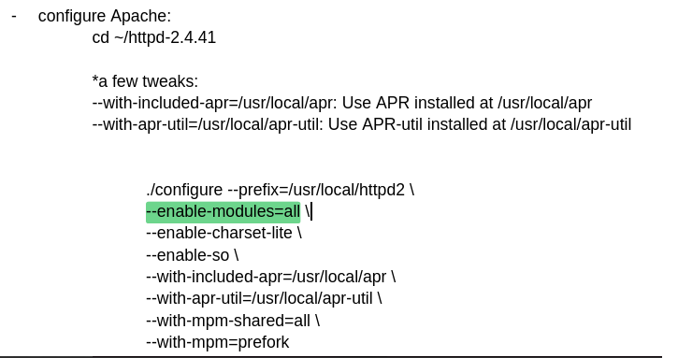

* run command line and uncomment the line **LoadModule rewrite_module modules/mod_rewrite.so**:

nano /usr/local/httpd2/conf/httpd.conf

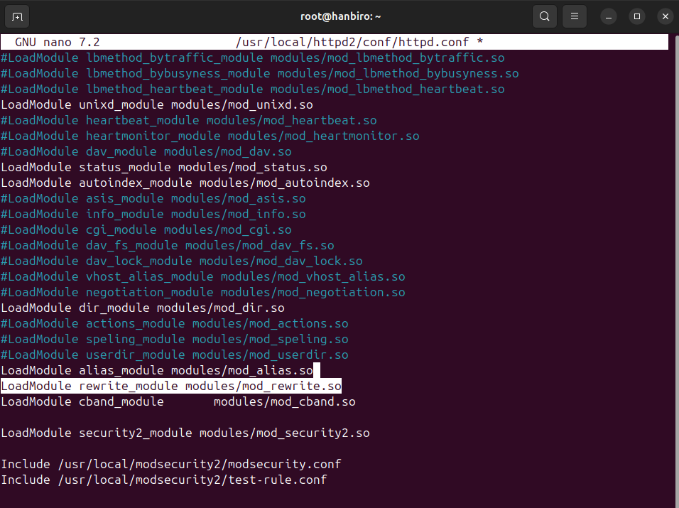

* check if it is loaded:

/usr/local/httpd2/bin/httpd -M | grep rewrite

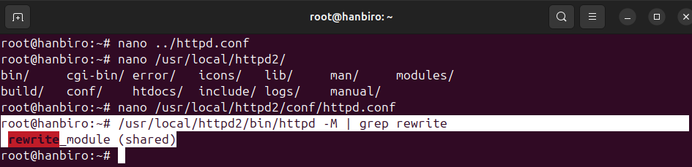

**Question: Set up lua**

mod_lua allows running Lua scripts in Apache – often used for custom request processing, authorization, ...

* use Lua v5.2.4:

sudo apt install build-essential libtool apache2-dev lua5.2 liblua5.2-dev

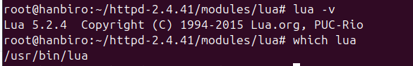

* run:

cd ~/httpd-2.4.41/modules/lua

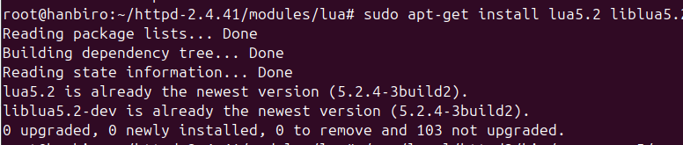

* compile **mod_lua**:

cd ~/httpd-2.4.41/modules/lua

/usr/local/httpd2/bin/apxs -c -I/usr/include/lua5.2 -lm -llua5.2 mod_lua.c

*with:

-I/usr/include/lua5.2 add directory containing Lua header files

-lm link with math library (libm)

-llua5.2 link with Lua library (v5.2)l

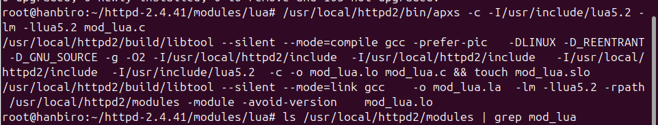

* access to:

sudo nano /usr/local/httpd2/conf/httpd.conf

and uncomment line:

LoadModule lua_module modules/mod_lua.so

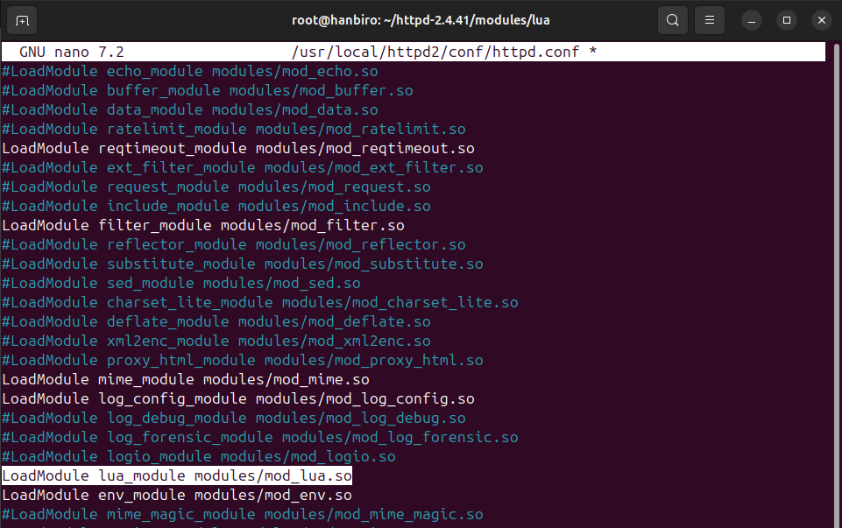

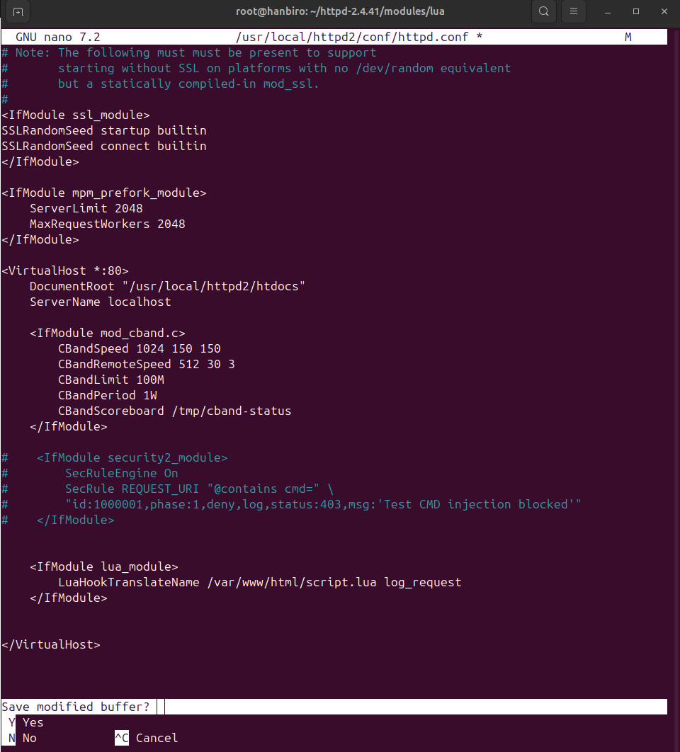

* grant Apache read/write permissions to the /var/log/apache2 directory:

sudo chown -R www-data:www-data /var/log/apache2/

sudo chmod -R 755 /var/log/apache2/

**[ TEST ]**

* **create scirpt.lua** file to test:

nano /var/www/html/script.lua

*and write script to storage request URL into log file ():

**function log_request(r)**

**local url = r.uri or "(nil uri)"**

**-- Ghi log de kiem tra soucre Lua co duoc thuc thi hay khong**

**r:err("Lua script is running. URL requested: " .. url)**

**-- Neu URL la /lua_test, ghi vao log**

**if url == "/lua_test" then**

**local file, err = io.open("/var/log/apache2/lua_requests.log", "a")**

**if not file then**

**r:err("Lua file open error: " .. (err or "unknown") .. "\n")**

**return apache2.DECLINED**

**end**

**file:write("URL requested: " .. url .. "\n")**

**file:close()**

**end**

**return apache2.DECLINED**

**end**

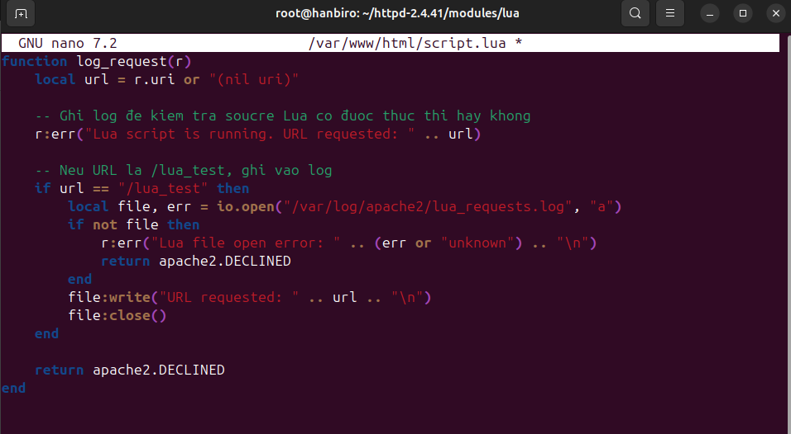

* grant permissions to the log file /var/log/apache2/lua_requests.log:

sudo touch /var/log/apache2/lua_requests.log

sudo chown www-data:www-data /var/log/apache2/lua_requests.log

sudo chmod 644 /var/log/apache2/lua_requests.log

**! create and test URL for Test**

* create a simple HTML file in the Apache root directory (/usr/local/httpd2/htdocs):

echo "Test Lua Request" > /usr/local/httpd2/htdocs/lua_test

* go to the URL /lua_test to test:

curl http://localhost/lua_test



* check Apache log file (/usr/local/httpd2/logs/error_log):

tail -f /usr/local/httpd2/logs/error_log

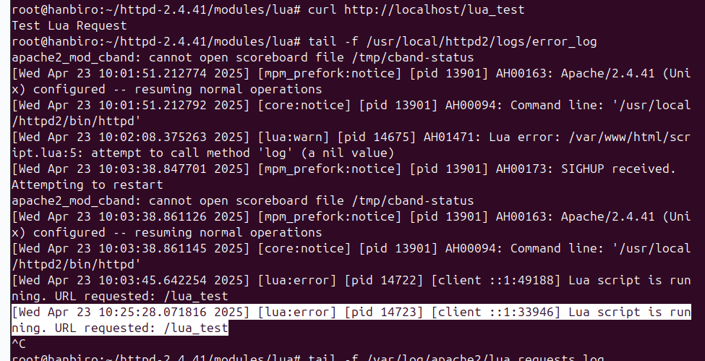

- check Apache log Lua (/var/log/apache2/lua_requests.log)

tail -f /var/log/apache2/lua_requests.log

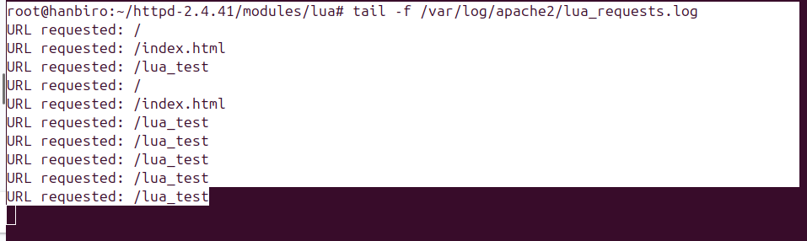

**Question: Set up pcre**

[ PCRE (perl compatible regular expression) to support any function as **mod_rewrite** and regular expressions ]

* install:

sudo apt install libpcre3 libpcre3-dev

* check **mod_rewrite** in Apache:

/usr/local/httpd2/bin/httpd -M | grep rewrite

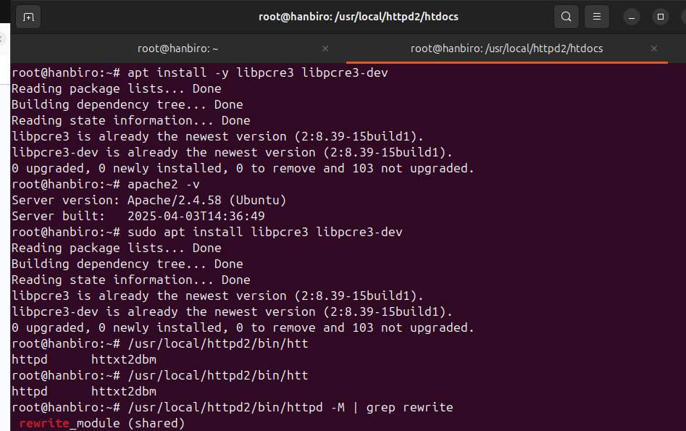

* create destination file:

cd /usr/local/httpd2/htdocs/

echo "true rewrited" > target.html

* create .htaccess file:

nano .htaccess

*and add text (enable rewrite and any access to /pcretest (with or without a trailing /) will be rewritten to target.html):

RewriteEngine On

RewriteRule ^pcretest/?$ target.html [L]

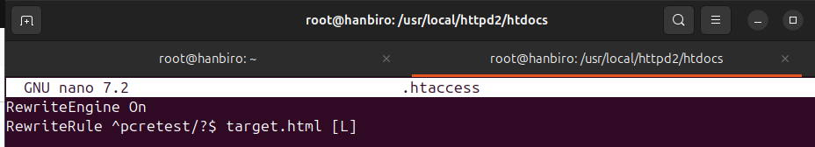

* enable AllowOverride to allow Apache to allow .htaccess to work

nano /usr/local/httpd2/conf/httpd.conf

*edit:

<Directory "/usr/local/httpd2/htdocs">

AllowOverride **None ->** **All**

Require all granted

</Directory>

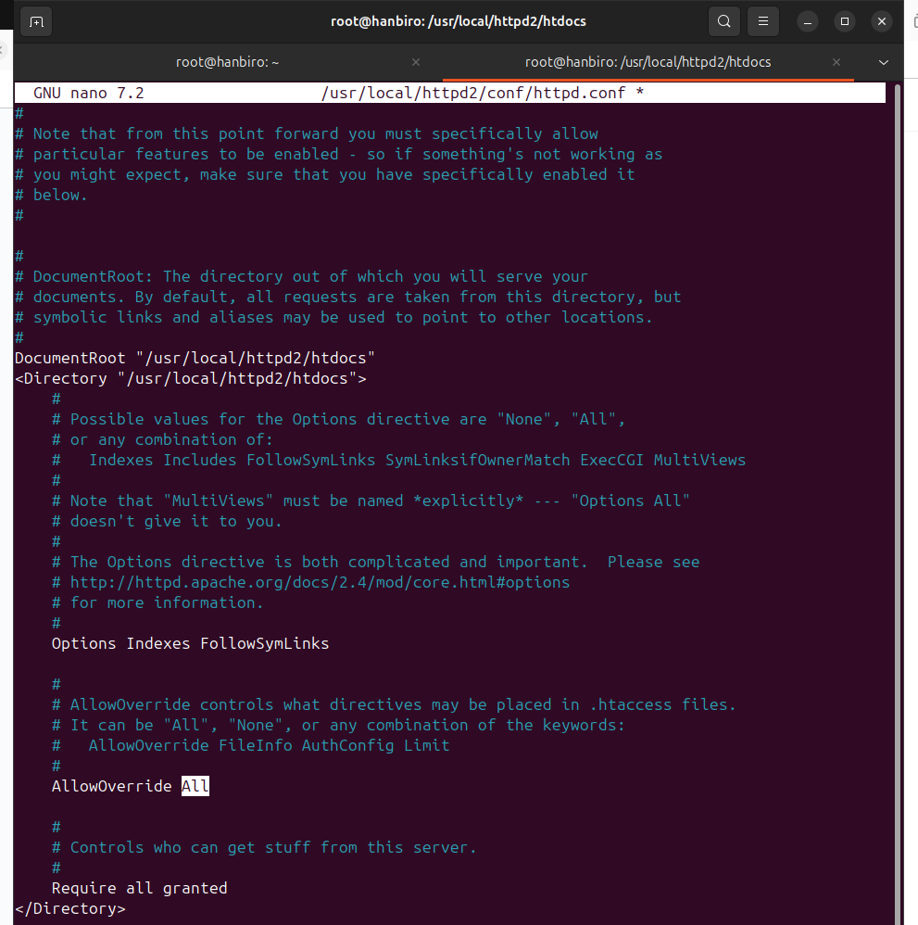

* restart Apache:

/usr/local/httpd2/bin/apachectl restart

* test with **curl http://localhost/pcretest**

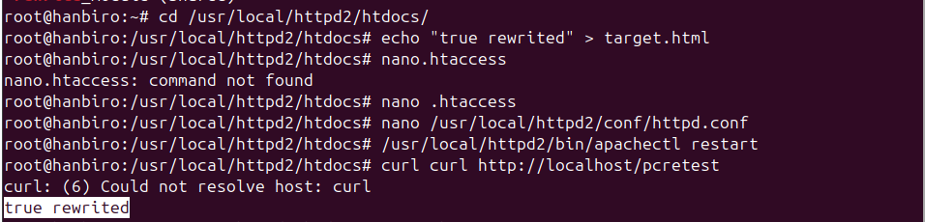

**php+ Install PHP**

**Question:**

* **Install PHP 7.2 the newest versionphp**

**install gd source (do not use bundle)**

* **- Install including basic image libraries such as jpeg and png**
* **- Set up to enable mysqli to use( configures either an extension or a source compilation ) )**

***!!! FOLLOW THESE STEPS:***

* update and install:

sudo apt update

sudo apt install -y build-essential libxml2-dev libssl-dev libcurl4-openssl-dev \

libjpeg-dev libpng-dev libmysqlclient-dev libgd-dev

*with:

**build-essential**  install basic development tools (gcc, make, …)

**libxml2-dev**  development library for XML

**libssl-dev** SSL development library

**libcurl4-openssl-dev** cURL library for communicating over HTTP/HTTPS

**libjpeg-dev, libpng-dev**  JPEG and PNG image processing libraries (required for GD)

**libmysqlclient-dev** MySQL client library

**libgd-dev** GD library for image processing

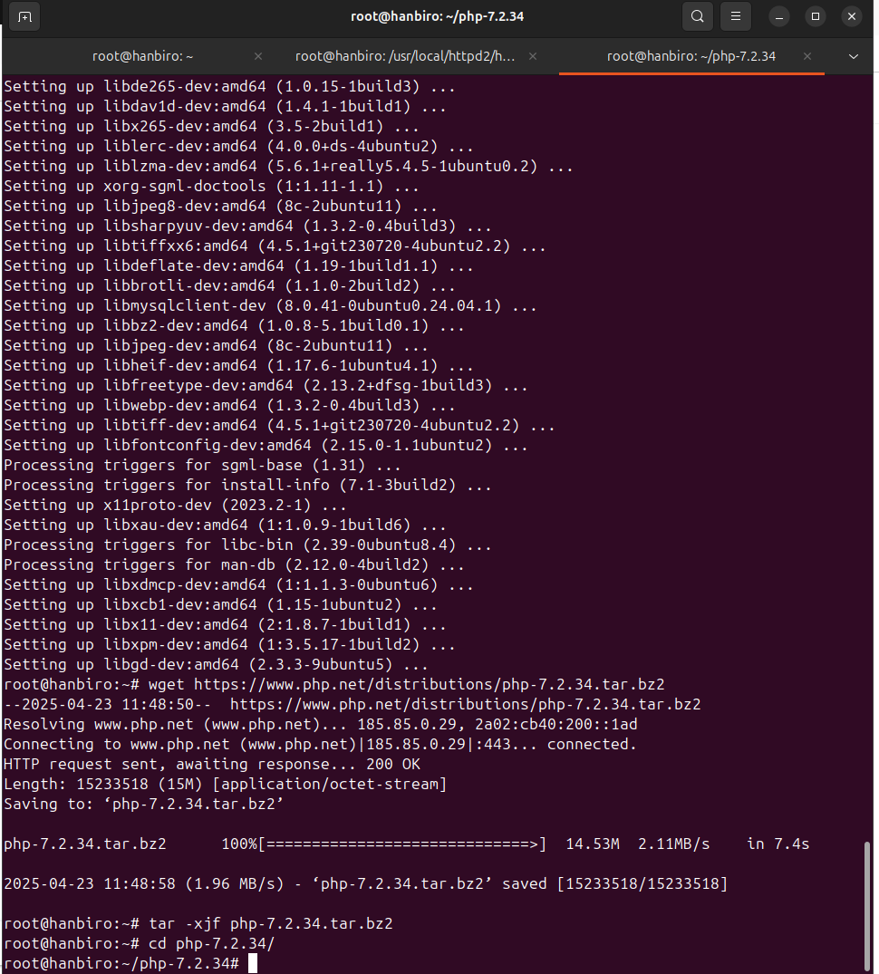

* download and unzip PHP 7.2.34 source code

cd ~

wget https://www.php.net/distributions/php-7.2.34.tar.bz2

tar -xjf php-7.2.34.tar.bz2

cd php-7.2.34

* PHP settings configuration:

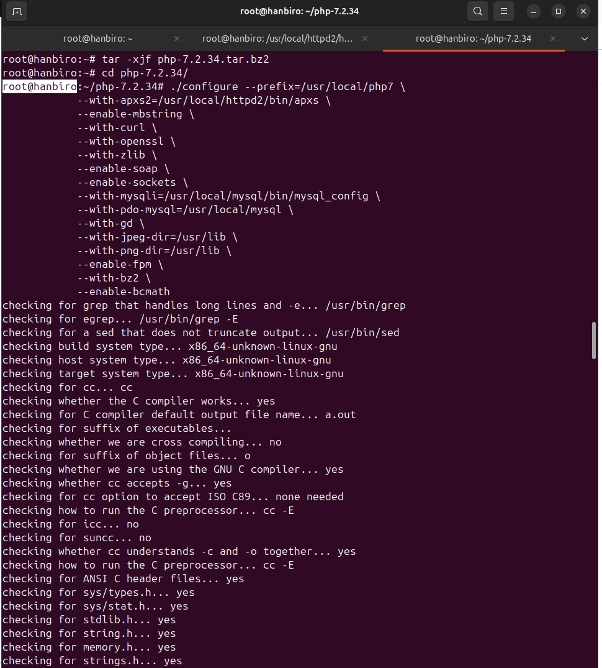

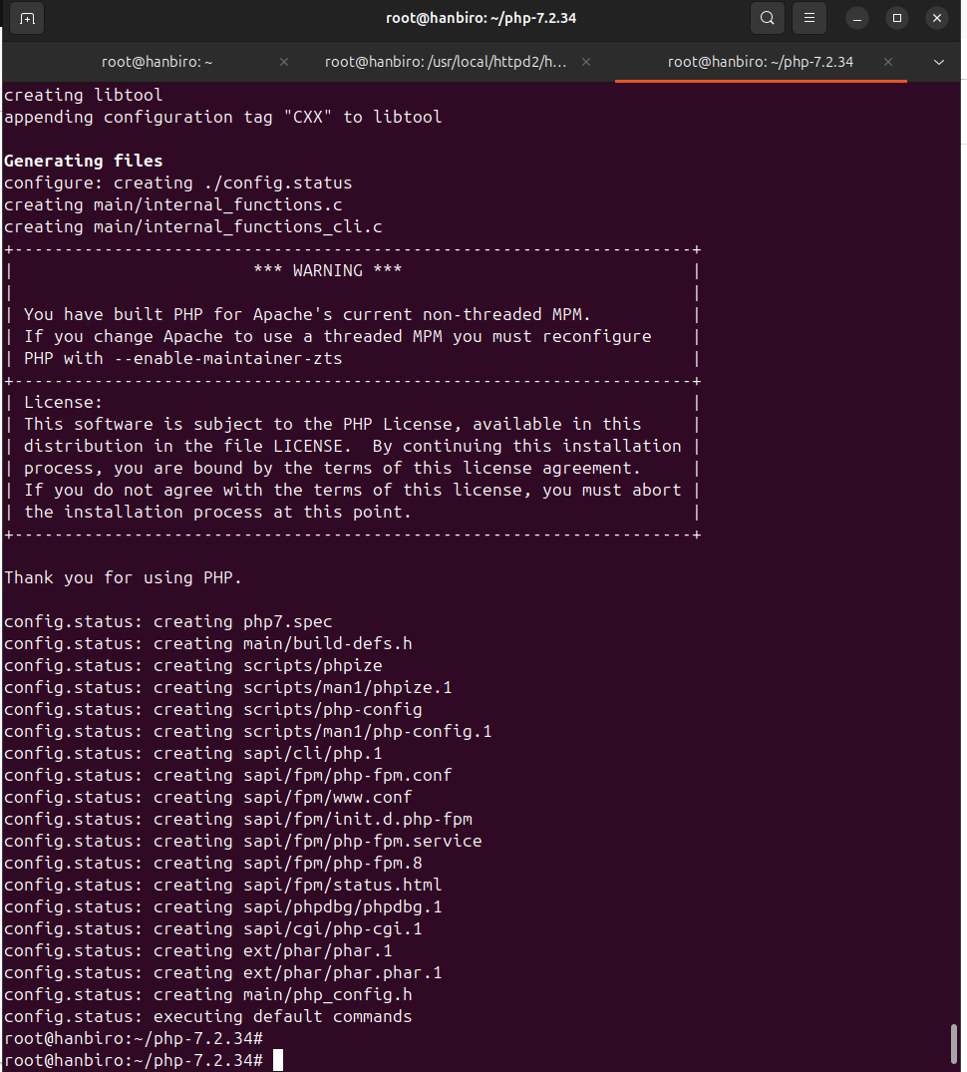

*with config options:

--prefix=/usr/local/php7 PHP installation directory

--with-apxs2=/usr/local/httpd2/bin/apxs connect to Apache

--enable-mbstring enable multibyte string support

--with-curl enable cURL support

--with-openssl SSL encryption support

--with-zlib data compression support

--enable-soap SOAP support

--enable-sockets socket support

--with-mysqli connect to MySQL via mysqli

--with-pdo-mysql PDO support for MySQL.

**--with-gd**  install GD library (not use bundle)

--with-jpeg-dir, --with-png-dir JPEG and PNG support for GD

--enable-fpm install PHP-FPM

--with-bz2 bzip2 support

--enable-bcmath enable BCMath support

* scss
* PHP compilation uses all CPU cores to speed up the process: **make -j$(nproc)**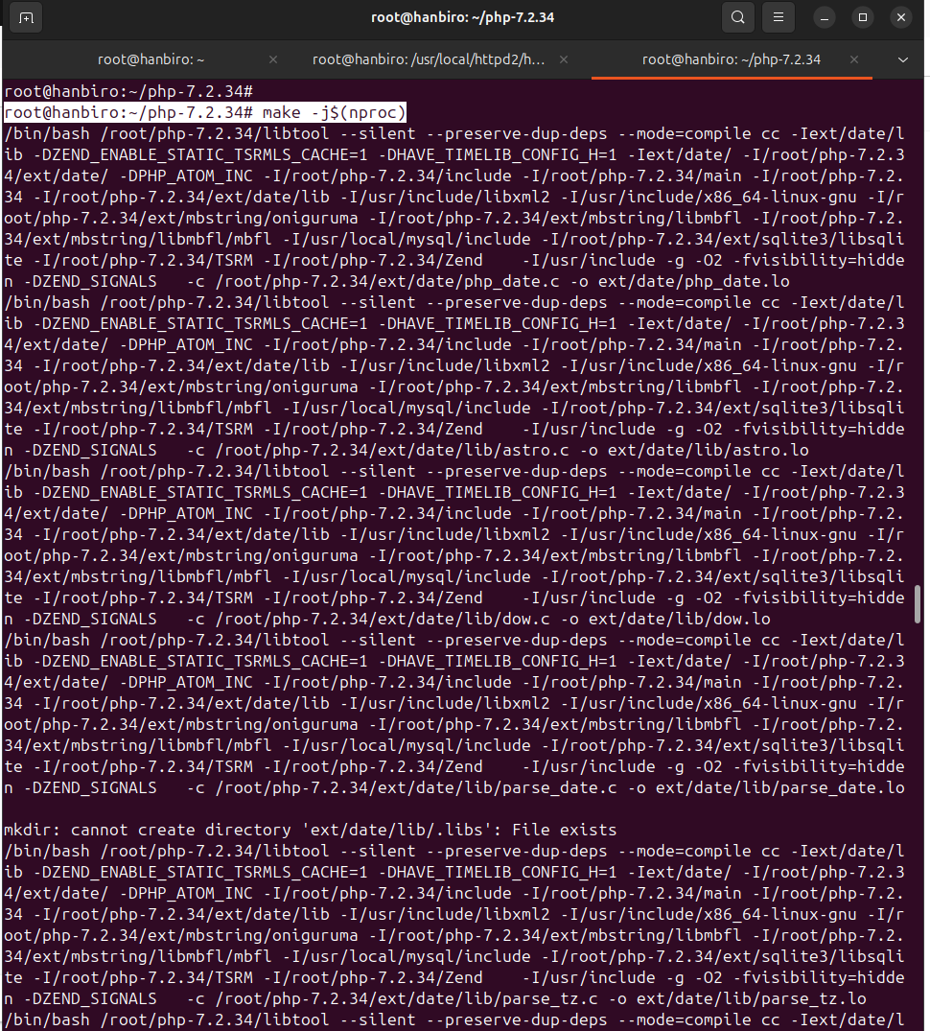

**issue:** PHP 7.2.34 uses a constant (RSA_SSLV23_PADDING) that has been removed in OpenSSL versions from 1.1.0 onwards

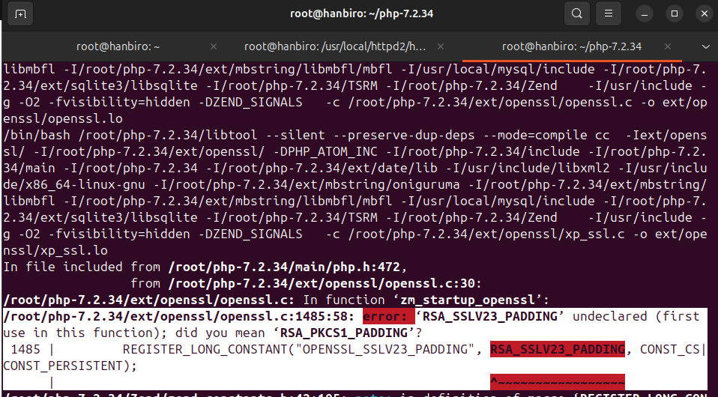

**resolve:**

* nano /root/php-7.2.34/ext/openssl/openssl.c
* comment the line containing OPENSSL_SSLV23_PADDING:

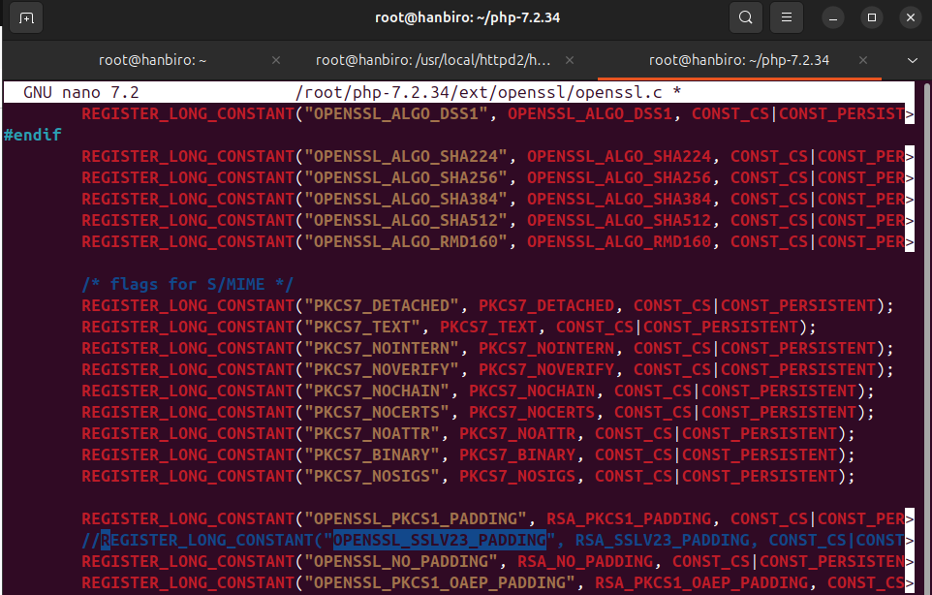

* run:

make clean

make -j$(nproc)

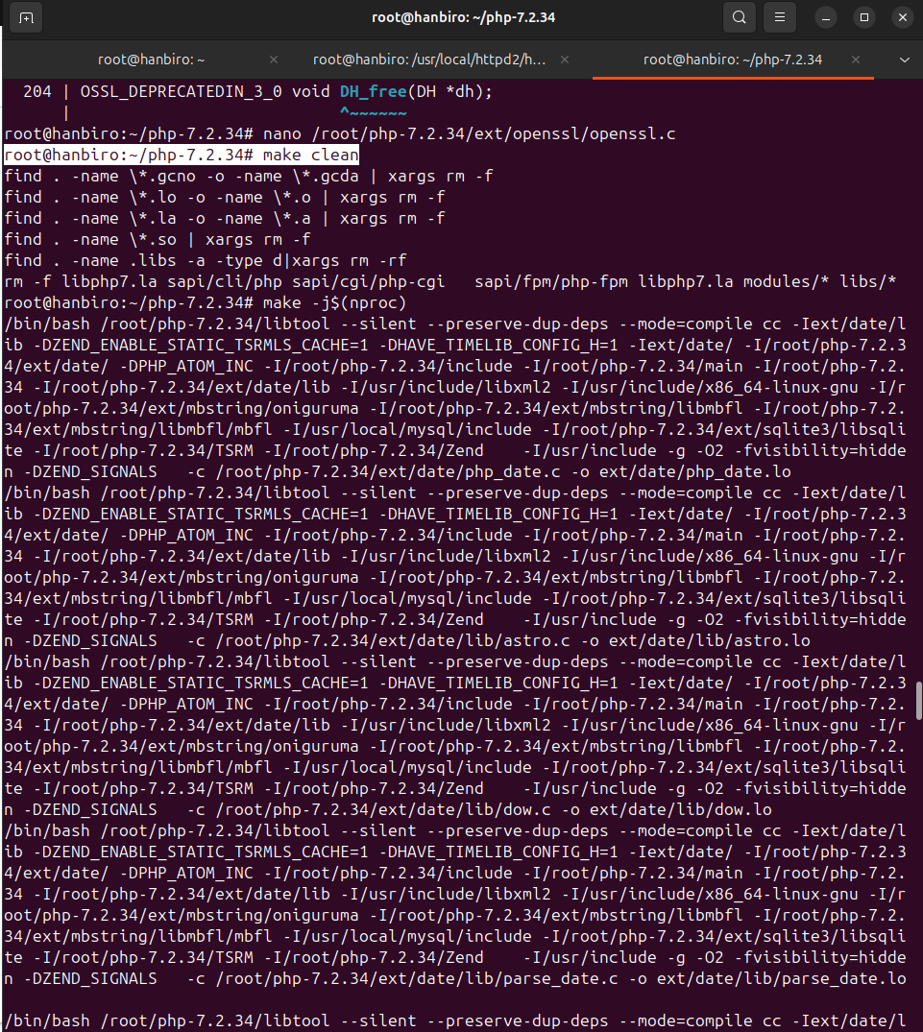

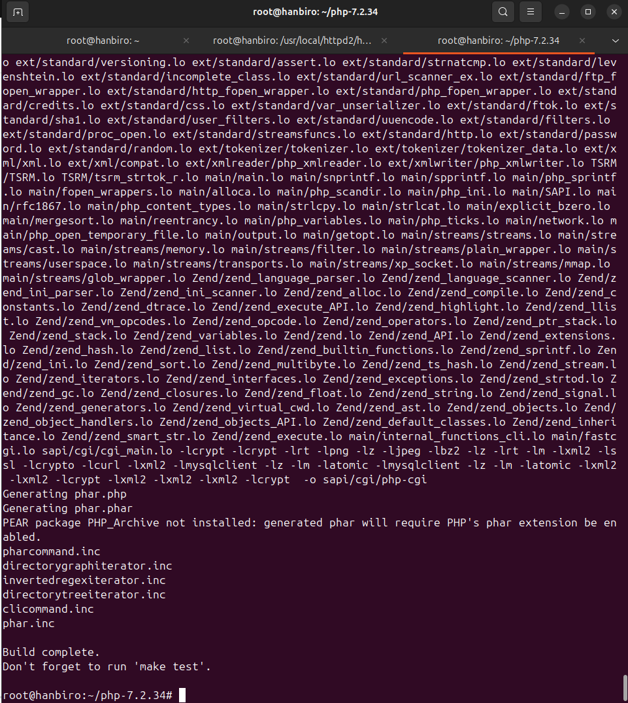

* install PHP into /usr/local/php7 directory

sudo make install

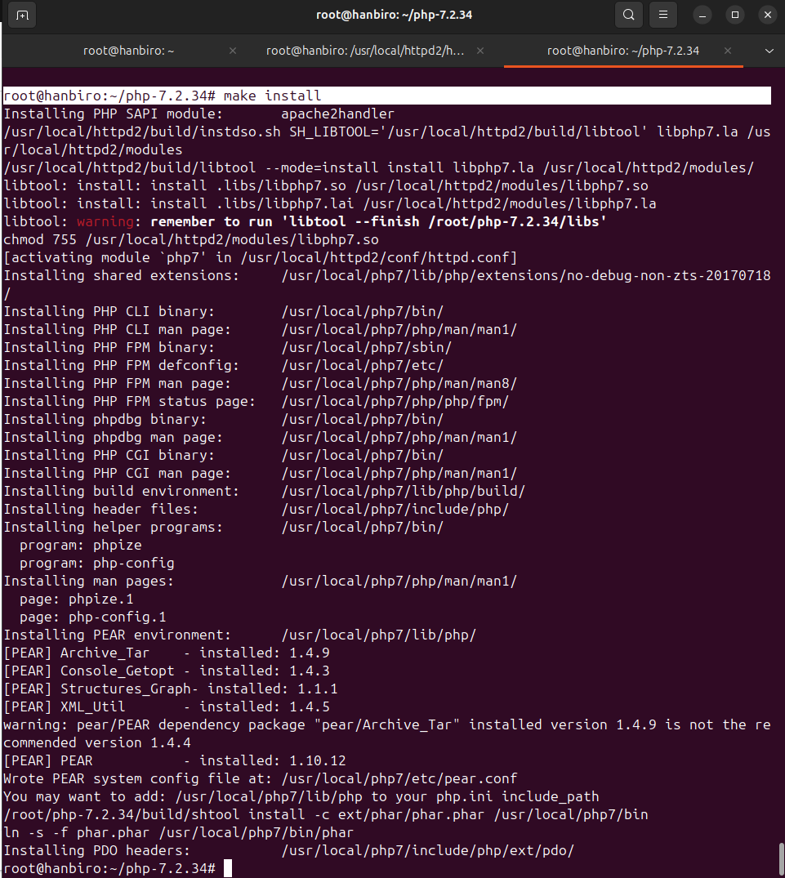

* add **AddType application/x-httpd-php .php** into httpd.conf file:

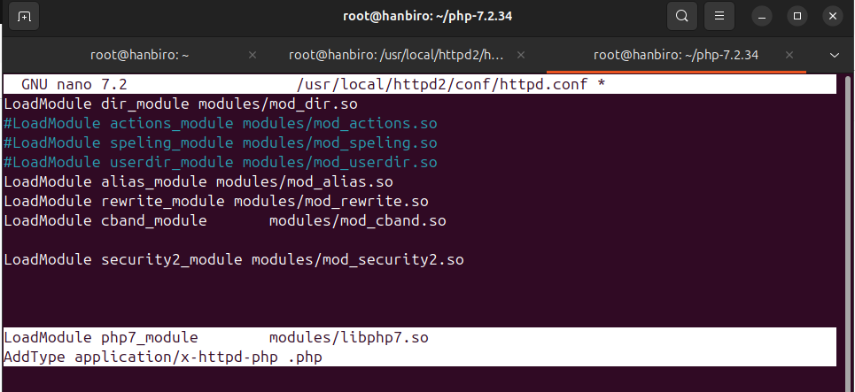

* create **info.php** file in web root directory of Apache (/usr/local/httpd2/htdocs/):

sudo nano /usr/local/httpd2/htdocs/info.php

*write code:

**<?php**

**phpinfo();**

**?>**

* restart Apache: sudo /usr/local/httpd2/bin/apachectl restart

*access your website via browser: http://localhost/info.php to see PHP configuration information.

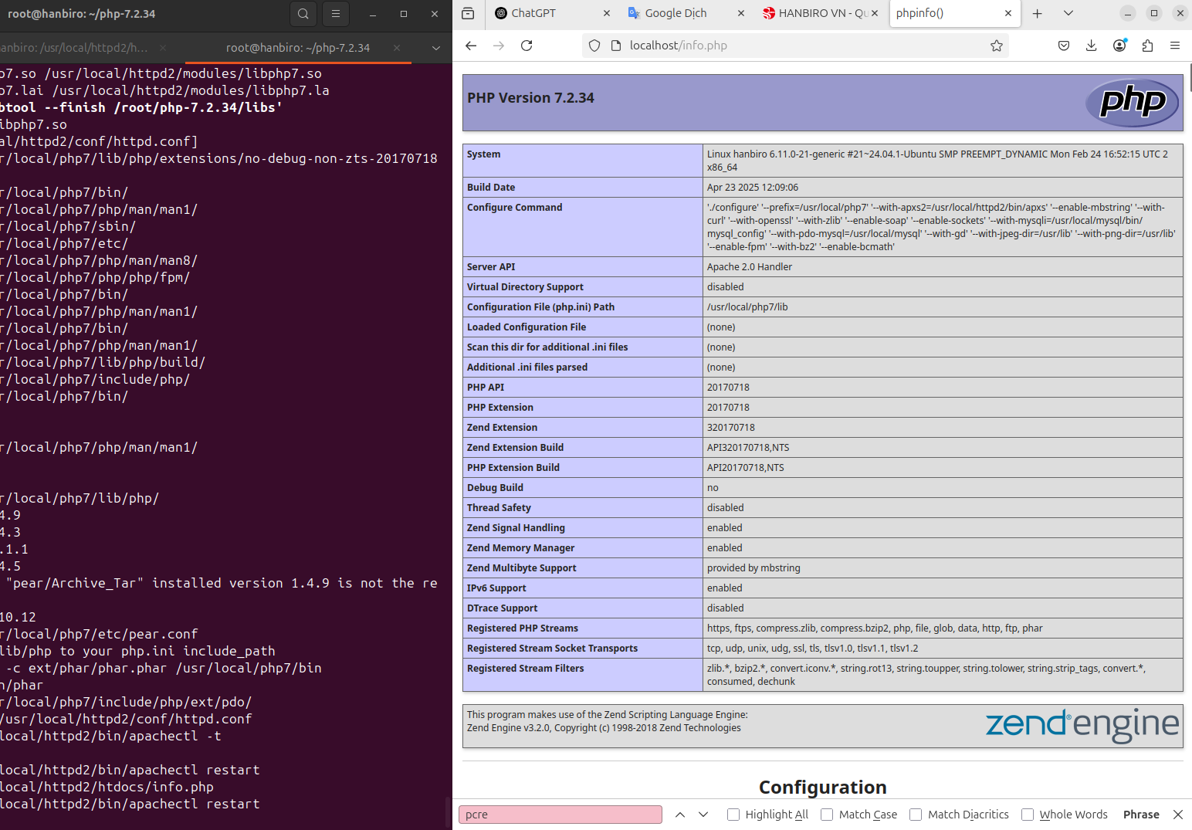

* recheck **GD, JPEG, PNG** (image processing) support:

GD Support enabled

JPEG Support enabled

PNG Support enabled

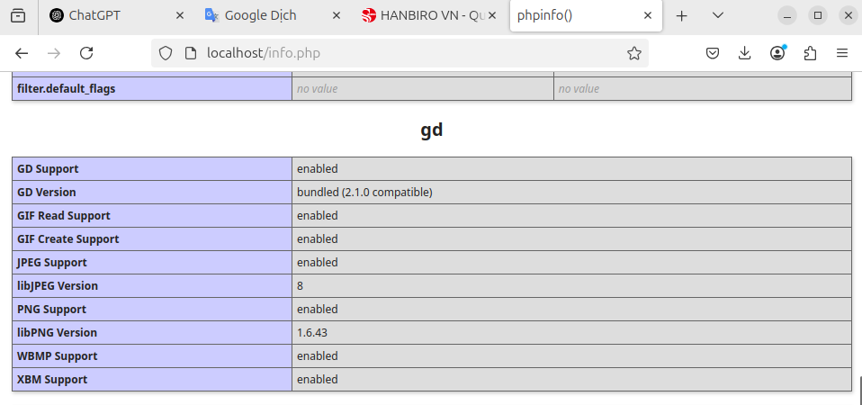

* recheck **mysqli** enable:

mysqli support enabled

Client API library version mysqlnd **5.7.28**

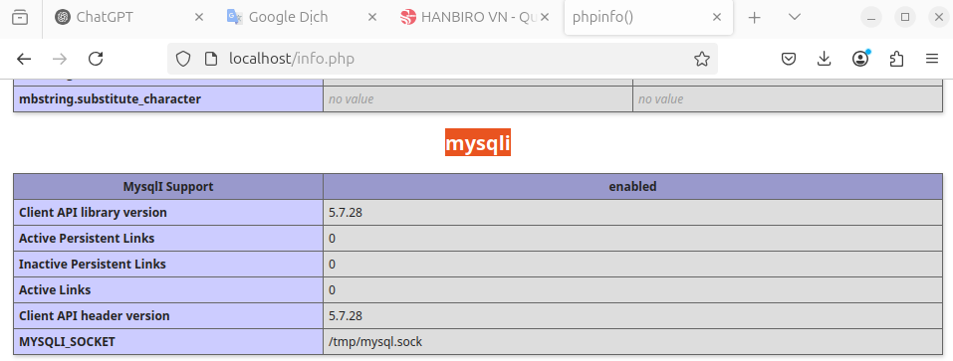

* recheck POP drivers:sqlite

PDO drivers => mysql, sqlite

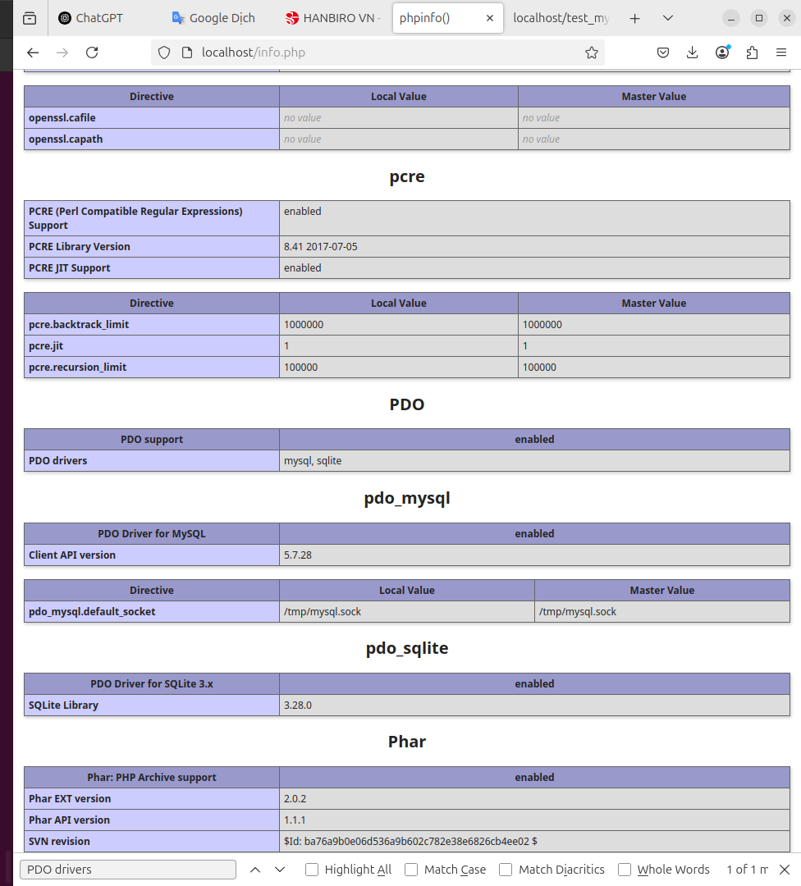mysql

**Question: Configure Apache and MySQL to connect with PHP.**

* create a real MySQL-PHP test file
* to test it, create a PHP file that connects to MySQL

sudo nano /usr/local/httpd2/htdocs/test_mysql.php

*write code to check connect (my password to connect MySQL is **your_new_password**):

**<?php**

**$mysqli = new mysqli("localhost", "root", "your_new_password", "mysql");new**

**if ($mysqli->connect_error) {**

**die("Connection failed: " . $mysqli->connect_error);**

**}**

**echo "Connected to MySQL successfully!";**

**?>**

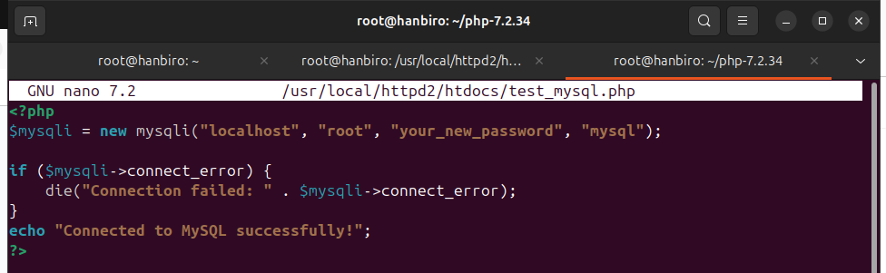

* restart service:

sudo /usr/local/httpd2/bin/apachectl restart

* access: http://localhost/test_mysql.php

=> if displayed: **Connected to MySQL successfully!** → PHP has successfully connected to MySQL

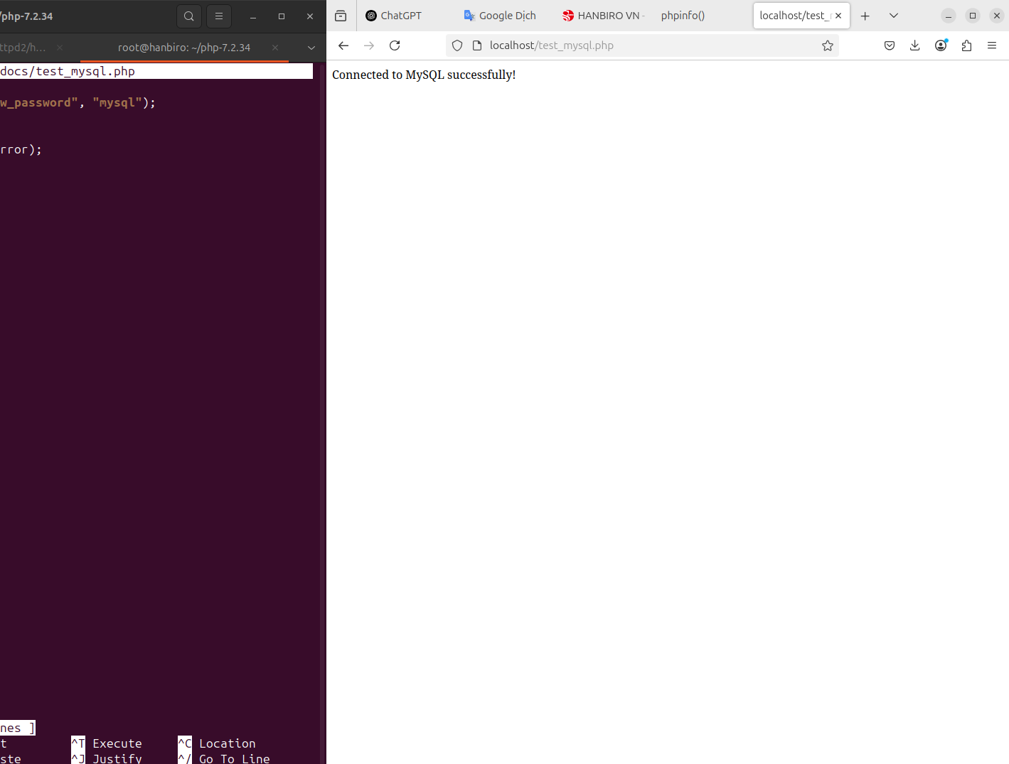

**Question: Refer the Hanbiro source script and summary the meaning of each option.**

* I access https://hanbiro.vn/info.php (PHP version 7.0.17)

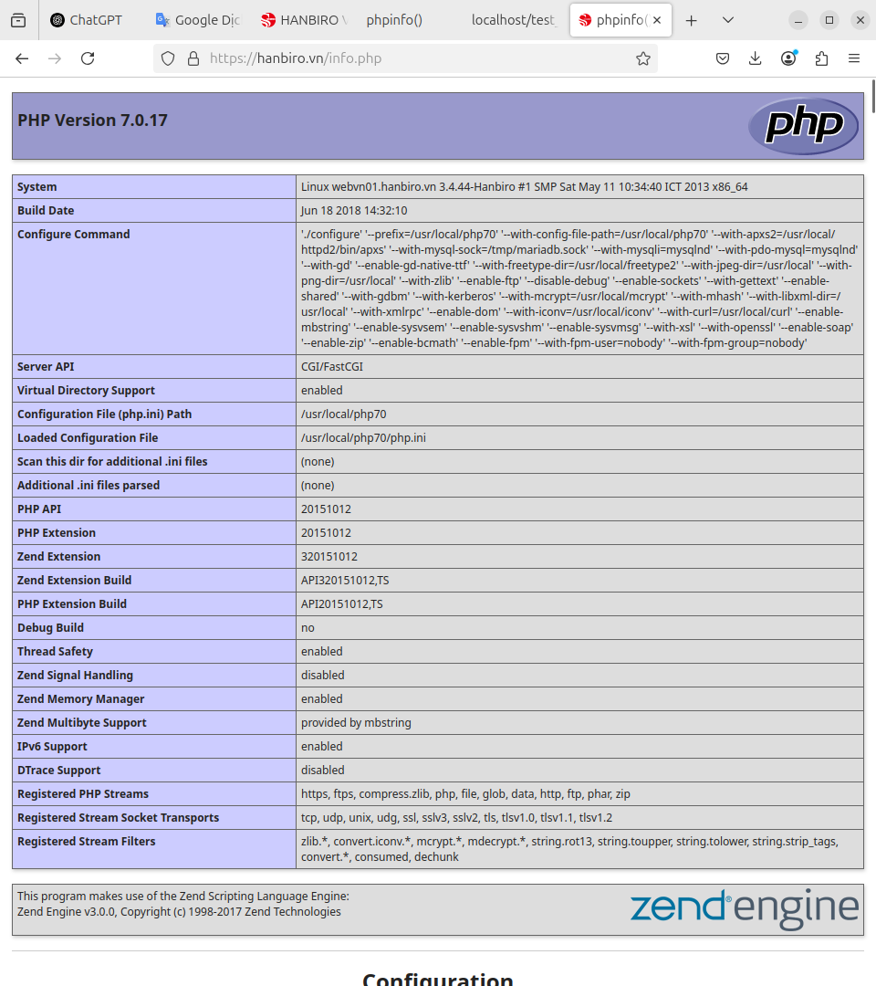

* recheck **GD, JPEG, PNG** (image processing) support:

GD Support enabled

JPEG Support enabled

PNG Support enabled

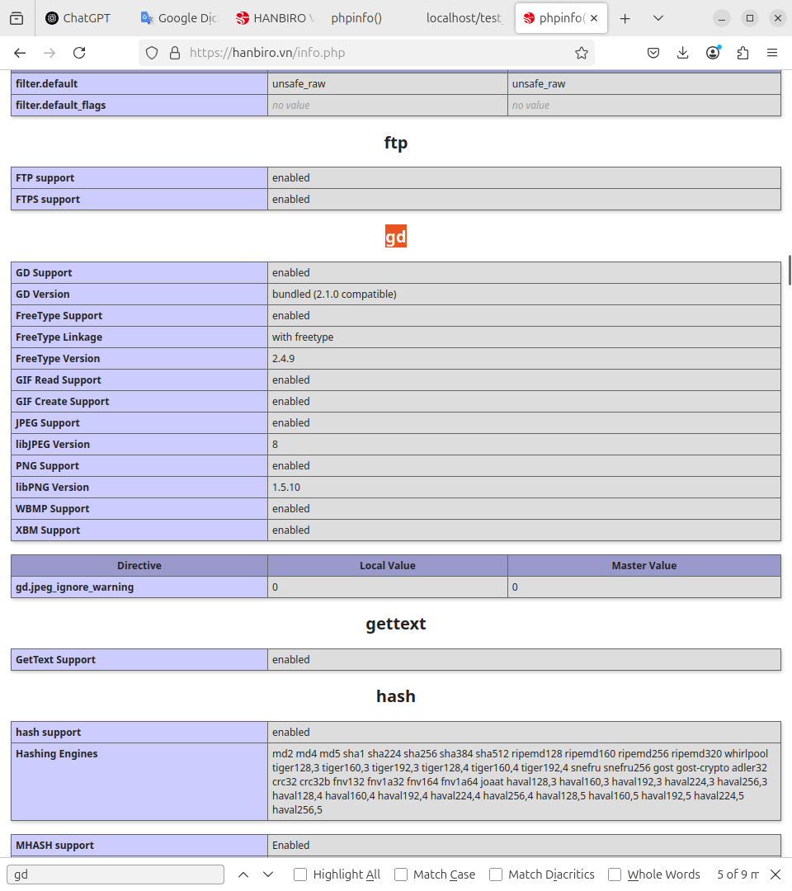

* recheck **mysqli** enable:

mysqli support enabled

Client API library version mysqlnd **5.0.12-dev - 20150407 - $Id: b5c5906d452ec590732a93b051f3827e02749b83 $**

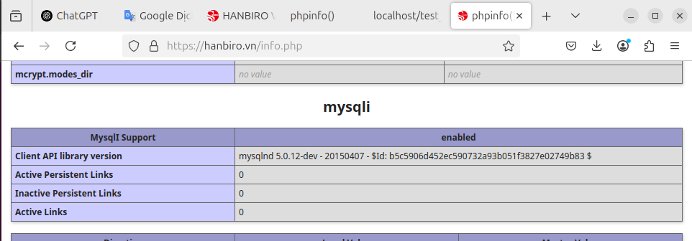

* recheck POP drivers:sqlite

PDO drivers => mysql, sqlite

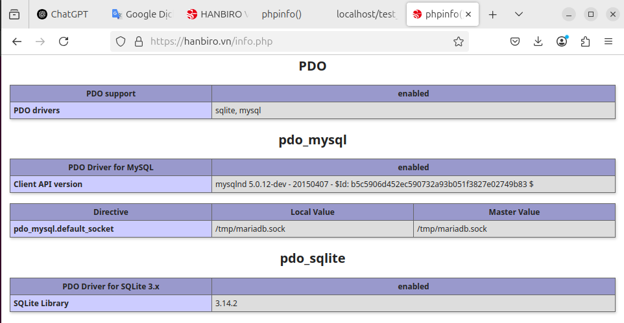

**2. Apache Basic**

**##### Role of Setup file #####**

**Question: httpd.conf ( Summary the content below)**

**Specific lines:**

* **ServerRoot** **"/usr/local/httpd2"**

→ directory containing Apache configuration files and binaries

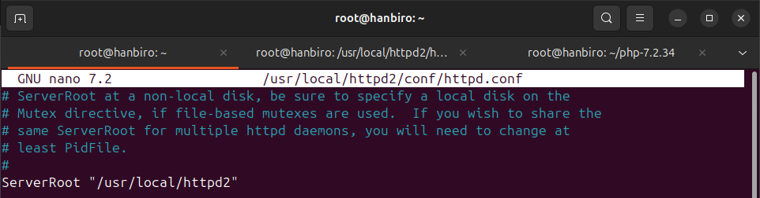

* **Listen 80**

→ Apache listens for HTTP connections on port 80

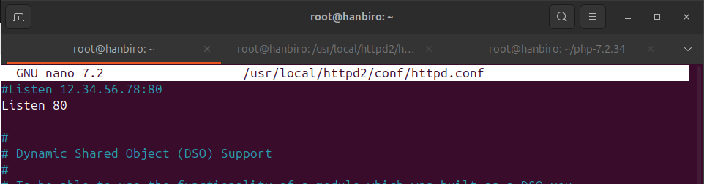

* **LoadModule** **cband_module modules/mod_cband.so**

→ loads the mod_cband bandwidth limit modulel

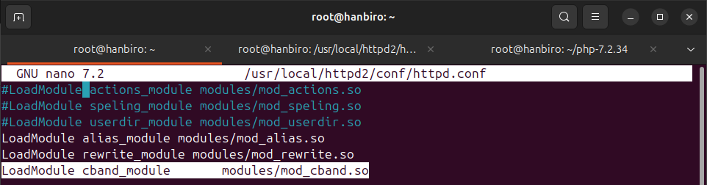

* **User nobody** and **Group ‘nobody’**

→ Apache runs as this user and group for increased security

*ex for user daemon and group daemon:*

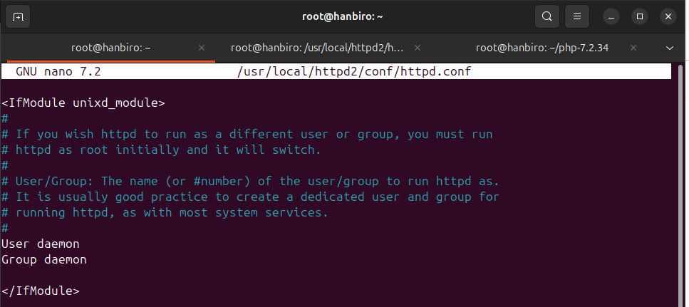

* **DirectoryIndex index.html index.htm index.php index.php3 index.php4 index.php5**

→ list of default files Apache looks for when accessing a directory (if no specific file is specified) - priority from left to right

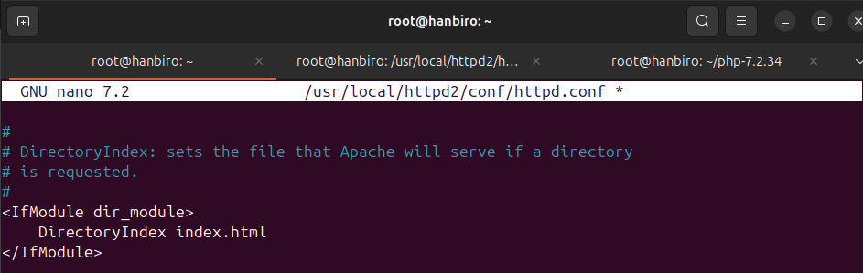

**<Directory> Tag: Most important in httpd.conf**

**ex:**

<Directory "/usr/local/httpd2/htdocs">

Options Indexes FollowSymLinks

AllowOverride All

Require all granted

</Directory>

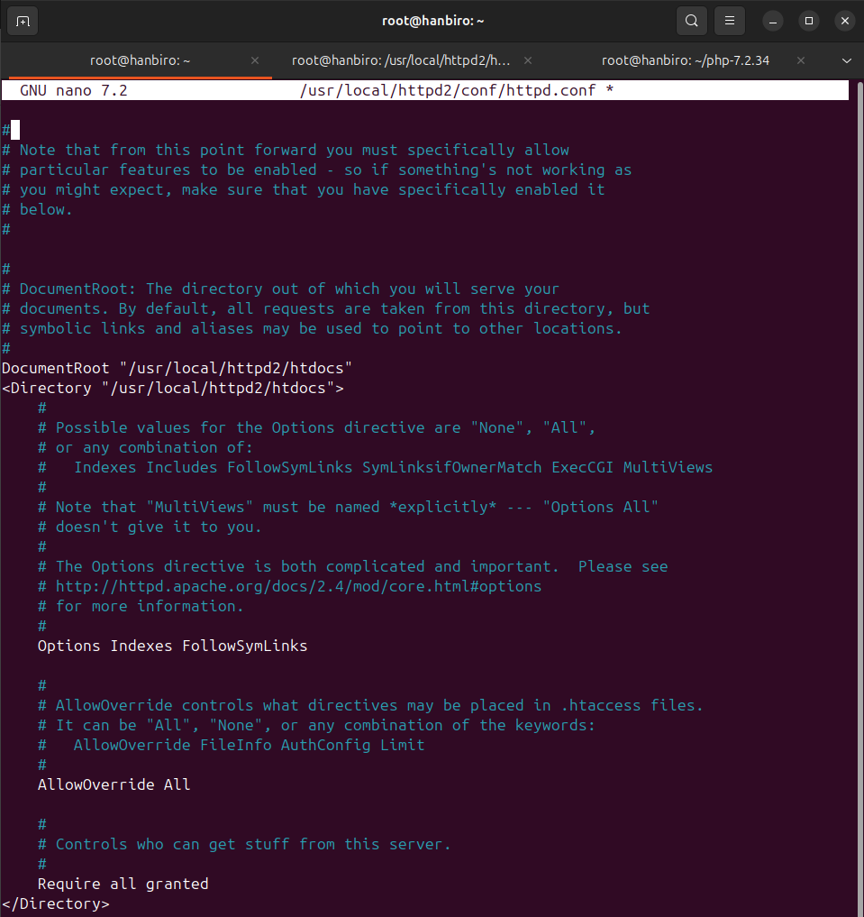

**OPTIONS - allows the feature in the folder to be applied:**

* **Indexes** shows a list of files if there is no index file (index.html, …)
* **FollowSymLinks** allows access to symbolic links
* **ExecCGI** allows running CGI files
* **Includes** supports Server Side Includes (SSI)

*\*(SSI are directives placed in static content pages such as HTML and set up on the web server, which help create dynamic content in static files such as HTML)*

**ALLOWS - allow (or not) the use of .htaccess to override configuration in this directory:**

* **None** do not allow overwriting anything via .htaccess
* **All** allow .htaccess to overwrite all settings like Rewrite, Auth,...
* **AuthConfig** allow authentication configuration only
* **FileInfo** allow overwriting MIME types, content-type,...

**ErrorLog, CustomLog:**

ErrorLog logs/error_log

CustomLog logs/access_log combined

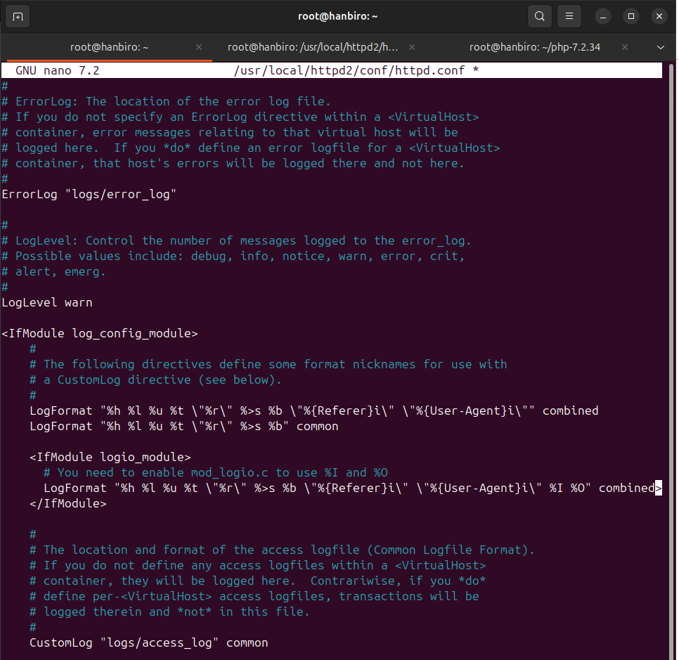

**ErrorLog** - save system errors, configuration errors, incorrect URL access errors, script errors, ...

**CustomLog**

* Record access information: IP address, date and time, browser, URL, ...
* *combined*: log format includes referrer and user-agent (SEO analysis, security)

**Question: httpd-default.conf**

**Meaning of Timeout**

Timeout 60

* maximum time Apache waits for a connection to complete (in seconds - e.g. 60s)
* lowering this value may prevent connection hangs but too low may disrupt the client

**What is difference between KeepAlive On and Off**

**On** keep the connection open so that the client can send multiple requests continuously on the same connection – faster

→ higher performance (multiple files in 1 connection)

**Off** each request creates a new connection – more resource intensive

→ save RAM but lower performance

**ServerTokens Prod (Full, Prod, Major, Minor, Min etc)**

***ServerTokens Prod***

* Prod: only show “Apache” → hide version for security.
* Full: Apache/2.4.41 (Unix) OpenSSL/1.1.1 → vulnerable to exploits.

**Level display Information**

Full name + version + OS

Prod Apache only

Major Apache 2

Minor Apache 2.4

Minimal Apache/2.4

**ServerSignature Off**

* hide server information in footer when returning error 403, 404,... (increase security)

→ helps increase security

**HostnameLookups Off**

* **Off:** do not perform reverse lookup IP → increase request processing speed
* **On:** Apache will translate IP to hostname (time consuming, unnecessary)

**AccessFileName .htaccess**

* the file name that Apache reads to apply the configuration to each directory
* if rename **.htaccess** to **.configfile**, you edit this line.

**UseCanonicalName Off**

* Apache does not use ServerName as the host name in the redirect URL, but instead uses the name sent by the client.

**TraceEnable off**

* disable HTTP TRACE method (avoid exposing headers - security)

**Question: httpd-mpm.conf**

*Summary the meaning of setting option of prefork module:*

***Parameter*** ***Meaning***

**StartServers** when Apache starts, it creates a number of processes ready to serve requests. Here are the first 5 processes created

**MinSpareServers** the minimum number of idle processes (not serving any requests) that Apache will maintain. If less than this, Apache will create new processes

**MaxSpareServers** maximum number of idle processes. If this is exceeded, Apache will automatically "kill" (terminate) redundant processes to save resources

**MaxRequestWorkers** maximum number of requests Apache can process concurrently (at the same time). This is a hard limit – if more than 150 requests arrive at the same time, the 151st request will have to wait (formerly called MaxClients)

**MaxConnectionsPerChild** how many requests will each process handle before it is recreated (terminated and a new process is created). This helps avoid RAM leaks. If set to 0, there is no limit – the process will run forever

***example:***

<IfModule mpm_prefork_module>

StartServers 5

MinSpareServers 5

MaxSpareServers 10

MaxRequestWorkers 150

MaxConnectionsPerChild 0

</IfModule>

**Question: what is different between of prefork, worker and event**

**MBM (Multi-Processing Module) has 3 modes:**

**prefork MPM**

* how it works:
* Apache creates multiple child processes
* each process handles a single connection at a time
* no threads, each process is independent
* advantages:
* **stable**, compatible with modules that do not support multithread (like the old mod_php)
* if a process fails → does not affect other processes
* disadvantages:
* consumes a lot of RAM because each process is separate
* ineffective when there are many simultaneous connections
* When to use:
* when using mod_php (PHP runs directly in Apache)
* when stability is needed more than performance

**worker MPM**

* how it works:
* Apache creates fewer processes, each with multiple threads
* each thread handles 1 connection
* threads share memory so they are lighter
* advantages:
* higher performance, uses less RAM than prefork
* suitable for websites with high traffic
* disadvantages:
* requires the module to be thread-safe (safe when running multiple threads)
* if a thread fails → it can affect other threads in the same process
* When to use:
* when not using mod_php (using PHP-FPM for example)
* when prioritizing performance and saving resources

**event MPM**

* how it works:
* same as **worker**: uses threads
* but manages keep-alive connections using events, no additional threads
* advantages:
* highest performance, especially when there are many keep-alive connections
* saves more RAM and CPU than **worker**
* disadvantages:
* thread-safe module is also required
* some very old modules may be incompatible (rare today)
* When to use:
* when using PHP-FPM (separate PHP from Apache)
* when to handle multiple simultaneous connections optimally

**Quick Comparison:**

| **Attribute** | **prefork** | **worker** | **event** |
| --- | --- | --- | --- |
| **Mechanism** | process | process + thread | process + thread + event |
| **RAM used** | high | medium | low |
| **Efficiency** | low-medium | high | very high |
| **Keep-Alive** | occupy slot | occupy thread | no occupy |
| **Non-thread-safe module** | good | not compatible | not compatible |
| **Recommended when** | use old mod_php | use PHP-FPM | use PHP-FPM + performance |

**3. MySQL Basic**

**Question: what is different between of myisam and innodb**

in MySQL, when creating a table (CREATE TABLE), you can choose the storage engine – that is, how data is stored and managed in the system. The two most popular storage engines are:

MyISAM: Old, simple, lightweight

InnoDB: More modern, more powerful, default from MySQL 5.5 onwards

each engine has different operations, performance and features.

| **Feature** | **MyISAM** | **InnoDB** |
| --- | --- | --- |
| **Transactions** | not supported | fully supported (ACID compliant) |
| **Locking** | table-level locking | row-level locking |
| **Crash Recovery** | no automatic recovery | automatic recovery using Redo Logs |
| **Indexes** | supports only FULLTEXT (up to MySQL 5.6) | supports B-Tree, FULLTEXT, Spatial indexes |
| **Foreign Keys** | not supported | fully supported with referential integrity |
| **Performance** | fast for SELECT, slow on UPDATE/DELETE | slightly slower SELECT, better for writes |
| **Storage Structure** | data and index stored in separate files | all stored in InnoDB tablespace |

### 

**Question: what is different between of SQL and NoSQL**

SQL and NoSQL are two types of database systems used for storing and retrieving data.

* **SQL** refers to relational databases such as MySQL, PostgreSQL, and Oracle.  
   ➜ Data is organized into structured tables with a predefined schema.
* **NoSQL** refers to non-relational databases such as MongoDB, Redis, and Cassandra.  
   ➜ Data is stored in flexible formats like documents (JSON), key-value pairs, graphs, or wide-columns.

| **Feature** | **SQL** | **NoSQL** |
| --- | --- | --- |
| **Data Structure** | Fixed schema, organized in rows and columns | Flexible schema, often document or key-value |
| **Query Language** | Uses standard SQL | Uses custom APIs (e.g., JSON-based queries) |
| **Scalability** | Vertically scalable (scale-up) | Horizontally scalable (scale-out) |
| **Data Consistency** | Strong consistency (ACID) | Prioritizes performance (BASE), tunable consistency |
| **Large Data Performance** | Efficient for structured data | High performance with unstructured or changing data |
| **Use Cases** | Complex relationships, strict data validation | Big data, fast-changing or flexible data models |

**!!! my.cnf Practice (The meaning of each option)**

view the contents of this file: cat /etc/mysql/my.cnf

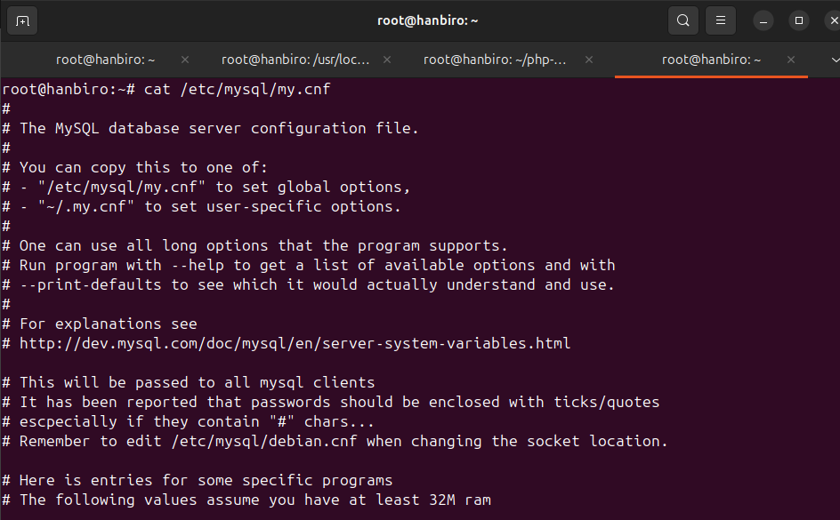

**[mysqld]**

* port = 3306 ; MySQL default port
* socket = /tmp/mysql.sock ; Internal socket file for Unix connection
* key_buffer = 2048M ; Memory for MyISAM indexes
* max_allowed_packet = 512M ; Maximum packet size for transfer
* table_open_cache = 2048 ; Number of tables that can be opened at once
* table_definition_cache = 4096 ; Table definition cache
* sort_buffer_size = 4M ; Memory for sorting
* read_buffer_size = 4M ; Used when reading sequentially
* join_buffer_size = 4M ; Used when JOINing without index
* read_rnd_buffer_size = 4M ; Used after sorting
* thread_cache_size = 32 ; Number of cached threads
* thread_concurrency = 64 ; Maximum 64 concurrent threads
* max_connections = 1024 ; Max concurrent connections
* wait_timeout = 10 ; Idle connections are closed after 10s
* long_query_time = 1 ; Log queries longer than 1 second
* query_cache_size = 1024M ; Cache query results
* query_cache_limit = 1024M ; Limit cached results
* query_cache_type = 1 ; Enable query cache
* max_heap_table_size = 256M ; MEMORY (RAM) table limit
* open_files_limit = 65535 ; Number of files that can be opened at once
* #character-set-client-handshake = FALSE ; Ignore client charset, force server charset
* character-set-server = utf8 ; Server default encoding
* init_connect = "set names utf8" ; Set utf8 for client when connecting
* tmpdir = /ramdisk ; Temporary directory (RAM is very fast)
* skip-name-resolve ; Skip DNS resolution, use IP directly
* skip-external-locking ; Increase performance by dropping external locks
* default-storage-engine = myisam ; Select default engine as MyISAM
* lower_case_table_names = 1 ; Case-insensitive table names
* collation-server = utf8_general_ci ; Default collation (string comparison)
* #skip-innodb ; Disable InnoDB (not recommended unless sure)
* local-infile = 0 ; Disable LOAD DATA LOCAL INFILE (secure)
* secure-file-priv = /tmp ; Restrict file import/export path
* slow_query_log = 1 ; Enable slow query logging
* slow_query_log_file = /usr/local/mysql/var/slow.log ; File to log slow queries
* log-error = /usr/local/mysql/var/error.log ; Error log location
* #log-update = /usr/local/mysql/var/update.log ; Deprecated log
* innodb_file_per_table ; Each table uses a separate file
* innodb_autoinc_lock_mode = 1 ; Higher performance with AUTO_INCREMENT
* innodb_buffer_pool_size = 8192MB ; InnoDB main memory for data/indexes
* innodb_buffer_pool_instances = 8 ; Split buffer pool for concurrency
* innodb_data_file_path = ibdata1:500M;ibdata2:500M:autoextend ; InnoDB data files
* innodb_adaptive_hash_index_parts = 16 ; Optimize hash index performance
* innodb_write_io_threads = 8 ; Number of I/O threads for writes
* innodb_read_io_threads = 8 ; Number of I/O threads for reads
* innodb_thread_concurrency = 64 ; Maximum concurrent InnoDB threads
* innodb_flush_log_at_trx_commit = 2 ; Balance between performance and durability
* innodb_log_buffer_size = 32M ; Memory buffer for logs
* innodb_log_file_size = 682M ; Size of each log file
* innodb_log_files_in_group = 3 ; Number of log files in the group
* innodb_max_dirty_pages_pct = 90 ; Maximum percentage of dirty pages before flush
* innodb_lock_wait_timeout = 120 ; Max wait time for a lock before error

**[mysqldump]**

* quick ; Increase dump speed (no buffering)
* max_allowed_packet = 64M ; Max packet size when dumping
* #extended-insert = FALSE ; Use one INSERT per row (larger dumps)
* #default-character-set = euckr ; Set charset to EUC-KR (Korean)

**[mysql]**

* no-auto-rehash ; Faster start, disables autocomplete
* prompt = mysql (d)> ; Custom mysql prompt

**[isamchk]**

* key_buffer = 512M ; Buffer size for index rebuilding
* sort_buffer = 256M ; Buffer size for sorting during checks
* read_buffer = 2M ; Buffer for reading during checks
* write_buffer = 2M ; Buffer for writing during checks

**[myisamchk]**

* key_buffer = 512M ; Same as isamchk - for MyISAM
* sort_buffer = 256M
* read_buffer = 2M
* write_buffer = 2M

**[mysqlhotcopy]**

* interactive-timeout ; Timeout for mysqlhotcopy sessions

**4. PHP Basic**

**+ Summary the meaning of php.ini options**

* SMTP = localhost ; Mail server for PHP's mail()
* allow_url_fopen = On ; Allow fopen() with URLs
* allow_url_include = Off ; Disallow include() with URLs (security)
* auto_append_file = ; Append file at end of all scripts (none)
* auto_globals_jit = On ; Delay global variables for better performance
* auto_prepend_file = ; Prepend file to all scripts (none)
* bcmath.scale = 0 ; Default scale for BC Math calculations
* cli_server.color = On ; Colored output for CLI server
* default_charset = "UTF-8" ; Default charset for PHP output
* default_mimetype = "text/html" ; Default content type for output
* default_socket_timeout = 60 ; Default socket timeout (seconds)
* disable_classes = ; Classes to disable (none)
* disable_functions = ; Functions to disable (none)
* display_errors = On ; Show errors in output
* display_startup_errors = On ; Show errors during PHP startup
* doc_root = ; Web root (none means any path allowed)
* enable_dl = Off ; Disable dynamic loading via dl()
* engine = On ; Enable PHP engine
* error_reporting = E_ALL ; Report all errors
* expose_php = Off ; Hide PHP version in HTTP headers
* extension = "...imagick.so" ; Load ImageMagick extension
* extension_dir = ".../extensions" ; Directory for PHP extensions
* file_uploads = On ; Enable file uploads
* html_errors = On ; Format error messages in HTML
* ibase.allow_persistent = 1 ; Allow persistent InterBase connections
* ibase.dateformat = "%Y-%m-%d" ; Format for InterBase dates
* ibase.max_links = -1 ; Unlimited InterBase connections
* ibase.max_persistent = -1 ; Unlimited persistent InterBase connections
* ibase.timeformat = "%H:%M:%S" ; Format for InterBase time
* ibase.timestampformat = "%Y-%m-%d %H:%M:%S" ; Format for InterBase timestamps
* ignore_repeated_errors = Off ; Show repeated errors
* ignore_repeated_source = Off ; Show same-source errors
* implicit_flush = Off ; Don’t flush output automatically
* ldap.max_links = -1 ; Unlimited LDAP connections
* log_errors = On ; Log errors to error log
* log_errors_max_len = 1024 ; Max length of each error log entry
* mail.add_x_header = On ; Add script name to mail headers
* max_execution_time = 30 ; Max script runtime (seconds)
* max_file_uploads = 20 ; Max number of uploaded files
* max_input_time = 60 ; Max time to parse input data
* memory_limit = 128M ; Max memory per script
* mysqli.allow_persistent = On ; Allow persistent MySQLi connections
* mysqli.cache_size = 2000 ; MySQLi query result cache size
* mysqli.default_host = ; Default MySQL host (none)
* mysqli.default_port = 3306 ; Default MySQL port
* mysqli.default_pw = ; Default MySQL password
* mysqli.default_socket = ; Default MySQL socket
* mysqli.default_user = ; Default MySQL user
* mysqli.max_links = -1 ; Unlimited total MySQLi connections
* mysqli.max_persistent = -1 ; Unlimited persistent connections
* mysqli.reconnect = Off ; Don’t auto-reconnect
* mysqlnd.collect_memory_statistics = On ; Collect memory stats (MySQL native driver)
* mysqlnd.collect_statistics = On ; Collect general stats
* odbc.allow_persistent = On ; Allow persistent ODBC connections
* odbc.check_persistent = On ; Check if persistent ODBC exists
* odbc.defaultbinmode = 1 ; ODBC binary data handling
* odbc.defaultlrl = 4096 ; Max bytes returned in one column
* odbc.max_links = -1 ; Unlimited ODBC connections
* odbc.max_persistent = -1 ; Unlimited persistent ODBC connections
* opcache.enable = 1 ; Enable OPcache
* opcache.enable_cli = 1 ; Enable OPcache for CLI
* opcache.interned_strings_buffer = 8 ; Buffer for interned strings (MB)
* opcache.max_accelerated_files = 10000 ; Max cached PHP scripts
* opcache.memory_consumption = 128 ; Memory for OPcache (MB)
* opcache.revalidate_freq = 1 ; Check script updates every 1s
* opcache.save_comments = 1 ; Keep comments/docblocks
* output_buffering = 4096 ; Buffer output size
* pdo_mysql.cache_size = 2000 ; PDO MySQL result cache
* pdo_mysql.default_socket = ; Default socket for PDO MySQL
* pgsql.allow_persistent = On ; Allow persistent PostgreSQL connections
* pgsql.auto_reset_persistent = Off ; Don’t reset persistent connections
* pgsql.ignore_notice = 0 ; Show PostgreSQL notices
* pgsql.log_notice = 0 ; Don’t log PostgreSQL notices
* pgsql.max_links = -1 ; Unlimited PostgreSQL connections
* pgsql.max_persistent = -1 ; Unlimited persistent connections
* post_max_size = 8M ; Max size of POST data
* precision = 14 ; Float number precision
* register_argc_argv = Off ; Don’t register $argc/$argv in web
* report_memleaks = On ; Report memory leaks
* request_order = "GP" ; Accept GET, POST (not COOKIE)
* serialize_precision = 17 ; Float precision for serialize()
* session.auto_start = 0 ; Don’t start session automatically
* session.cache_expire = 180 ; Cache expiry (minutes)
* session.cache_limiter = nocache ; Don’t allow browser caching
* session.cookie_domain = ; Session cookie domain
* session.cookie_httponly = ; Prevent JS access to cookies
* session.cookie_lifetime = 0 ; Cookie expires with browser close
* session.cookie_path = / ; Path for session cookies
* session.gc_divisor = 1000 ; Garbage collection divisor
* session.gc_maxlifetime = 1440 ; Session expiration (seconds)
* session.gc_probability = 1 ; GC probability = 1/1000
* session.hash_bits_per_character = 5 ; Complexity of session ID
* session.hash_function = 0 ; Session ID algorithm (MD5)
* session.name = PHPSESSID ; Default session name
* session.referer_check = ; Disable referer check
* session.save_handler = files ; Store sessions in files
* session.serialize_handler = php ; Serialization method
* session.use_cookies = 1 ; Use cookies to store session ID
* session.use_only_cookies = 1 ; Don’t allow session ID in URL
* session.use_strict_mode = 0 ; Allow unknown session IDs
* session.use_trans_sid = 0 ; Disable transparent session IDs in URL
* short_open_tag = Off ; Don’t allow <? for PHP tags
* smtp_port = 25 ; Port for SMTP
* soap.wsdl_cache_dir = "/tmp" ; SOAP WSDL cache location
* soap.wsdl_cache_enabled = 1 ; Enable WSDL cache
* soap.wsdl_cache_limit = 5 ; Max WSDL files cached
* soap.wsdl_cache_ttl = 86400 ; Time to live for WSDL cache
* sql.safe_mode = Off ; Safe mode disabled (deprecated)
* tidy.clean_output = Off ; Don’t auto-clean output with Tidy
* track_errors = Off ; Don’t track last error in $php_errormsg
* unserialize_callback_func = ; Callback when class not found in unserialize
* upload_max_filesize = 2M ; Max size for uploaded file
* url_rewriter.tags = "...input=src..." ; Tags with URL session IDs
* user_dir = ; User-specific directories disabled
* variables_order = "GPCS" ; Order: GET, POST, COOKIE, SERVER
* zend.assertions = 1 ; Enable runtime assertions
* zend.enable_gc = On ; Enable garbage collection
* zend_extension = "...opcache.so" ; Load Zend extension (e.g., OPcache)
* zlib.output_compression = Off ; Don’t compress output with gzip

**5. APM Practice**

**+ Set up SSL**

**- Issuing Free 30 Days SSL with the domain you purchased**

**- accessing on** [**https://www.xxx.shop**](https://www.xxx.shop) **and showing the lock icon in the browser window**

* buy domain **kiethanbirooo.shop** from Hostinger with 1,23$

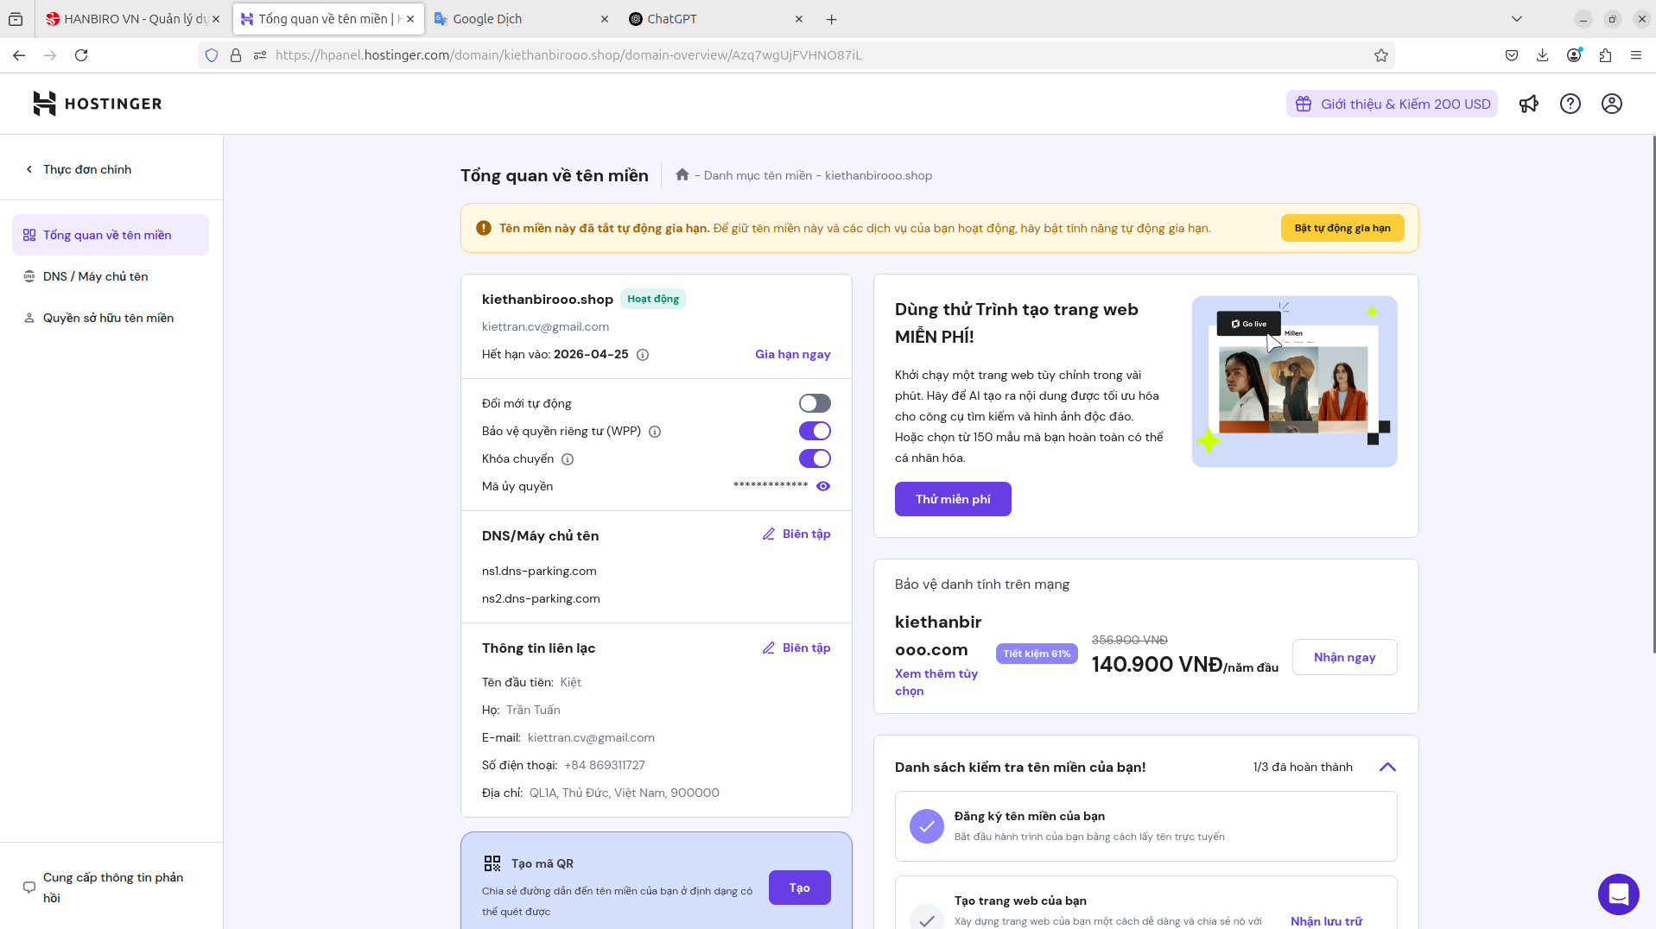

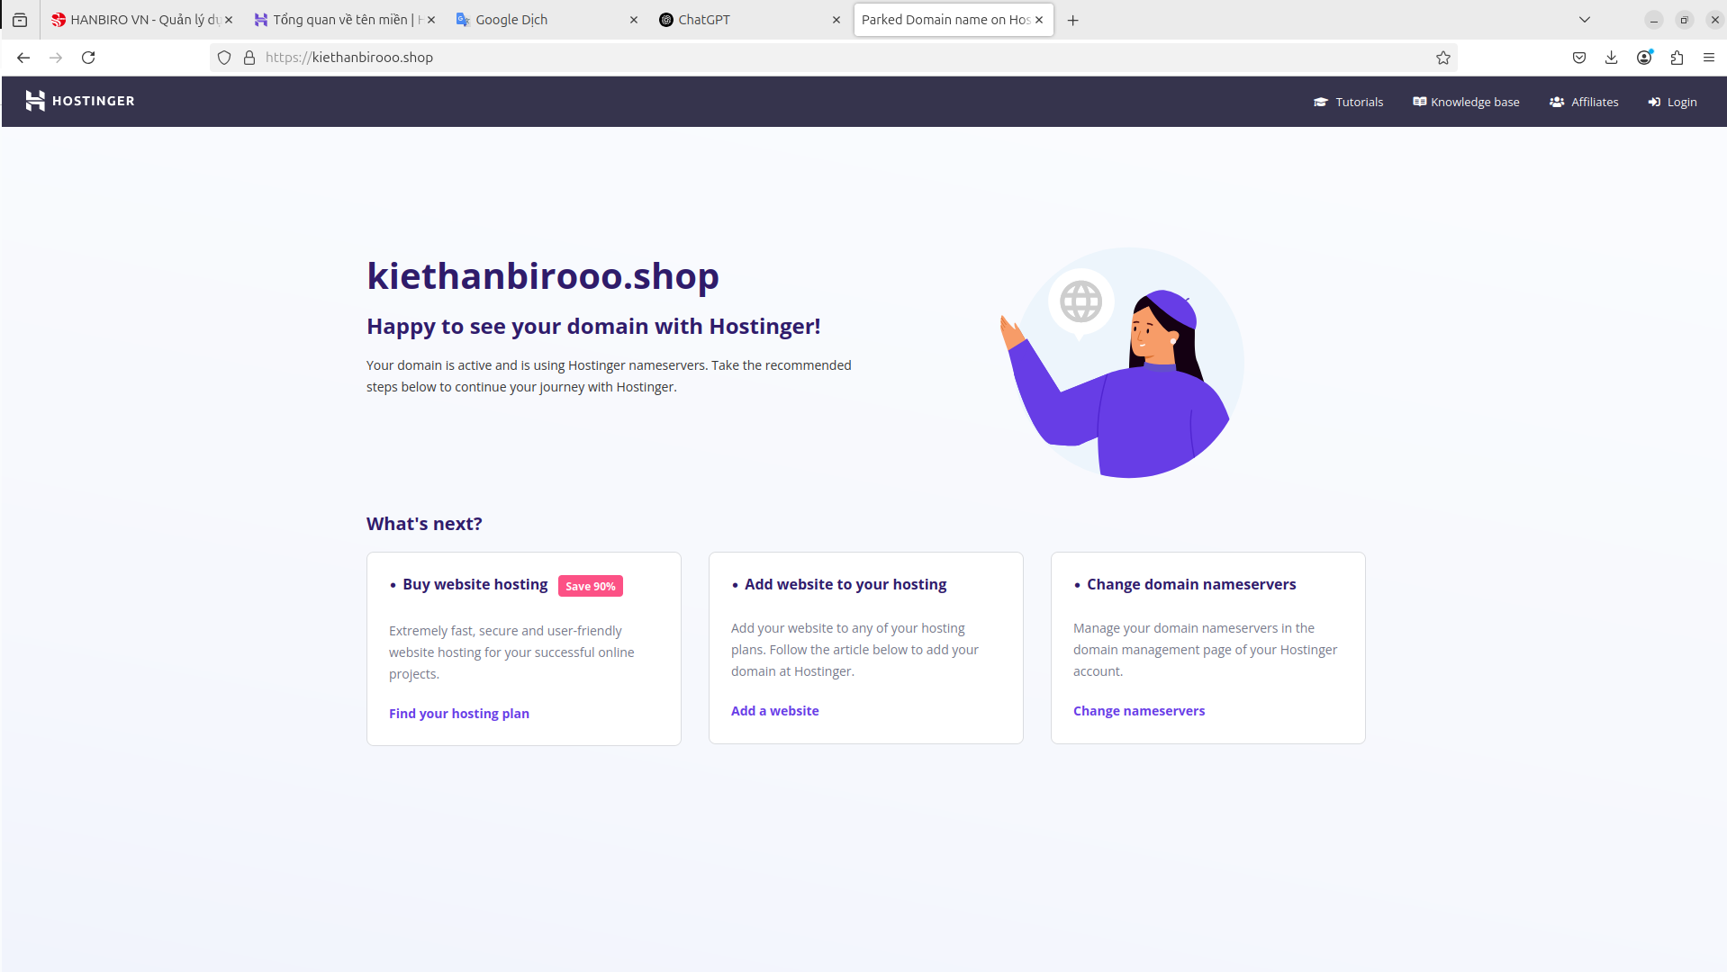

**+ Set up wordpress**

**-** [**http://blog.xxx.shop**](http://blog.xxx.shop)

**- Set up word press 5.3**

**- blog theme configuration(apply on the admin page)and a post upload to view it.**

* download Wordpress v5.3 and extract it:

cd /usr/local/httpd2/htdocs

wget https://wordpress.org/wordpress-5.3.tar.gz

tar -xvzf wordpress-5.3.tar.gz

* move all WordPress files to the home directory

sudo mv wordpress /usr/local/httpd2/htdocs/blog

* create a MySQL database for WordPress:

CREATE DATABASE wordpress;

CREATE USER 'wp_user'@'localhost' IDENTIFIED BY 'kiet317';

GRANT ALL PRIVILEGES ON wordpress.* TO 'wp_user'@'localhost';

FLUSH PRIVILEGES;

EXIT;

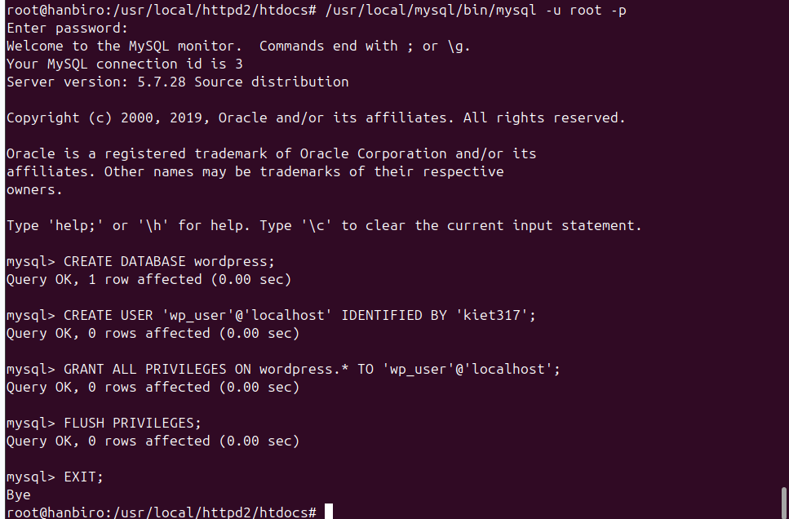

* create WordPress configuration file, move to WordPress root directory and copy sample configuration file

cp wp-config-sample.php wp-config.php

* edit the wp-config.php file to connect to the MySQL database:

nano wp-config.php

*edit:

define( 'DB_NAME', 'wordpress' );

define( 'DB_USER', 'wp_user' );

define( 'DB_PASSWORD', 'kiet317' );

define( 'DB_HOST', 'localhost' );

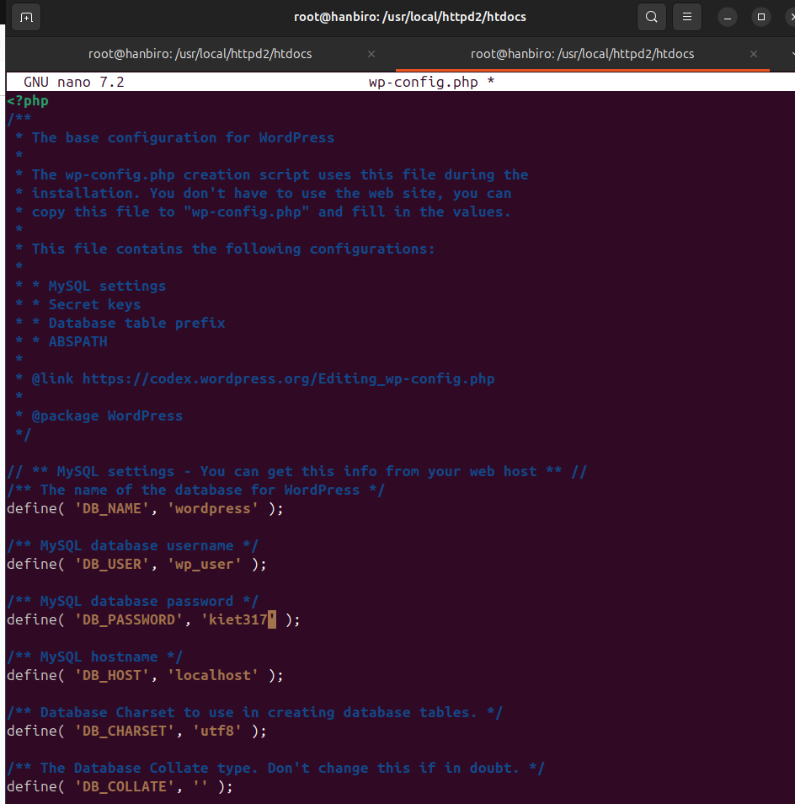

* create a virtual host in httpd.conf:

sudo nano /usr/local/httpd2/conf/httpd.conf

*add:

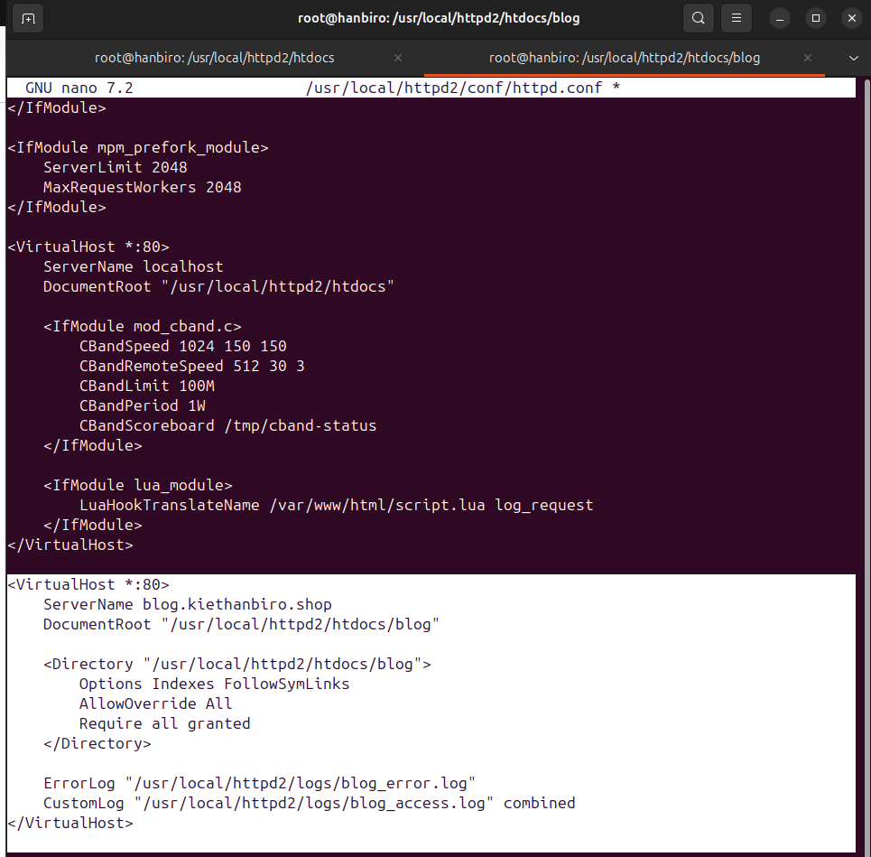

*add: **index.php** to be given priority

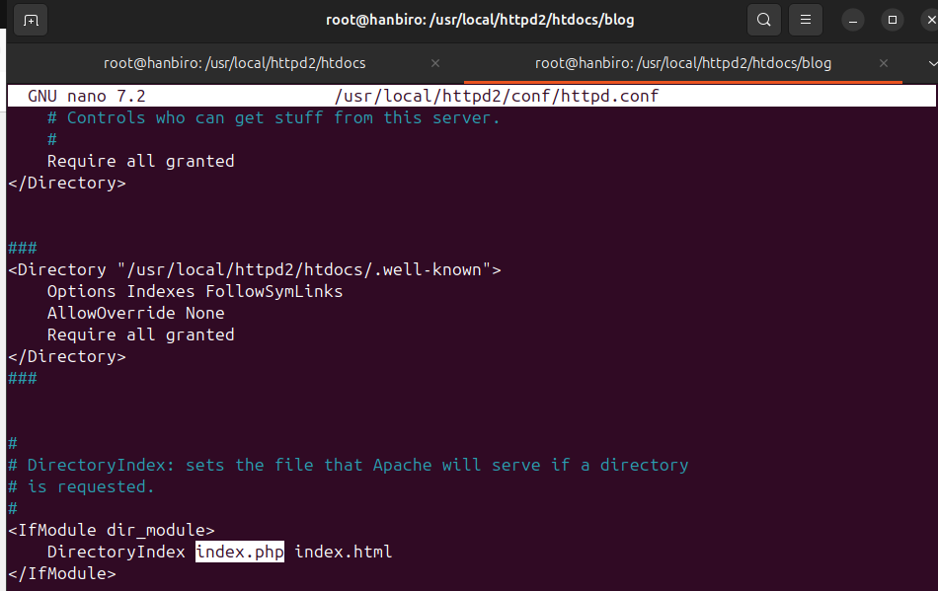

* need to map domain name **blog.kiethanbiro.shop** to **127.0.0.1**:

nano /etc/hosts

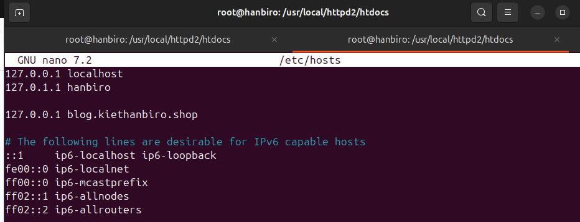

* restart service: /usr/local/httpd2/bin/apachectl restart
* access: http://blog.kiethanbiro.shop

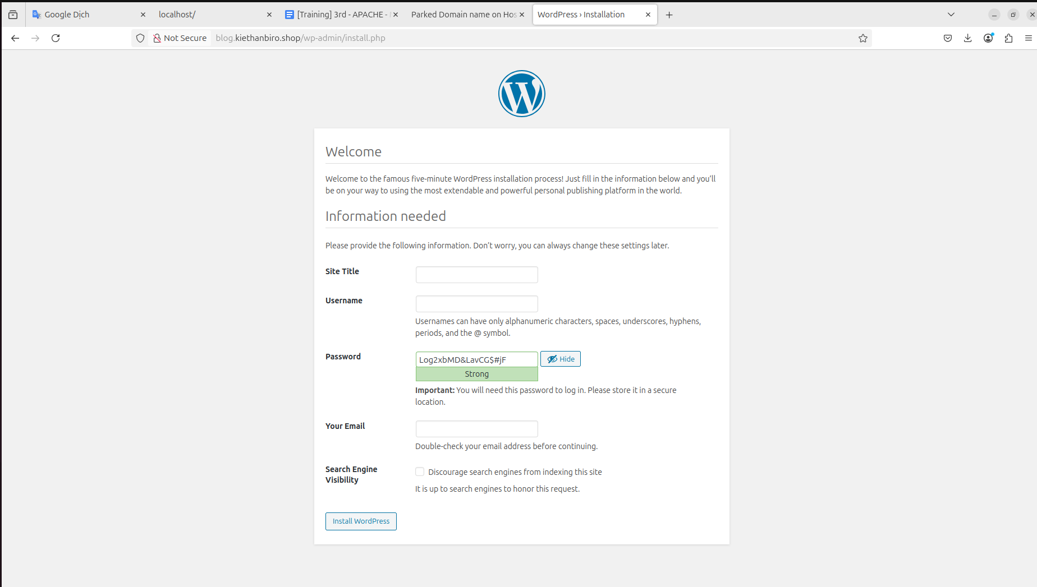

* create account and login:

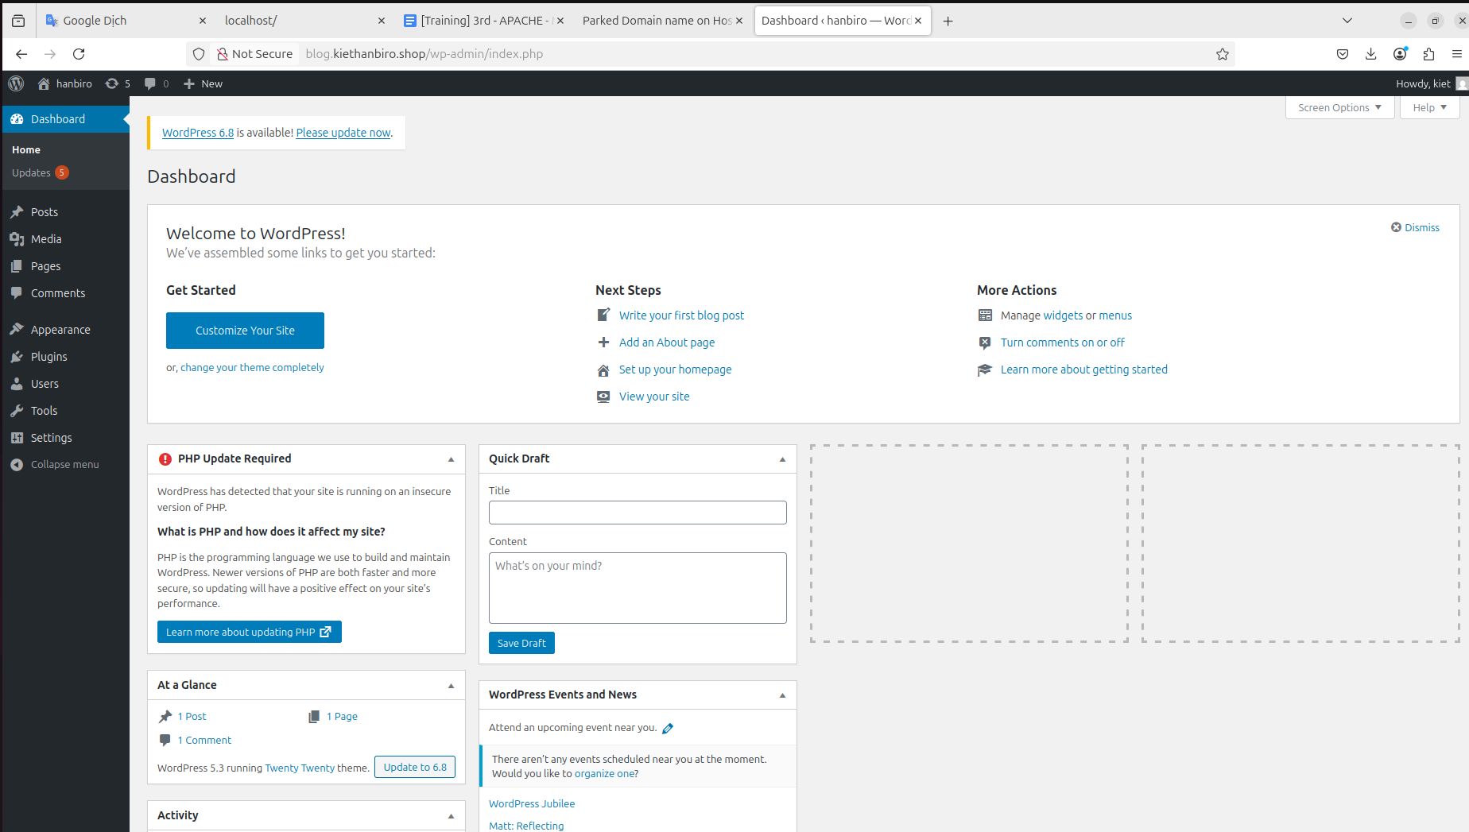

* active Themes

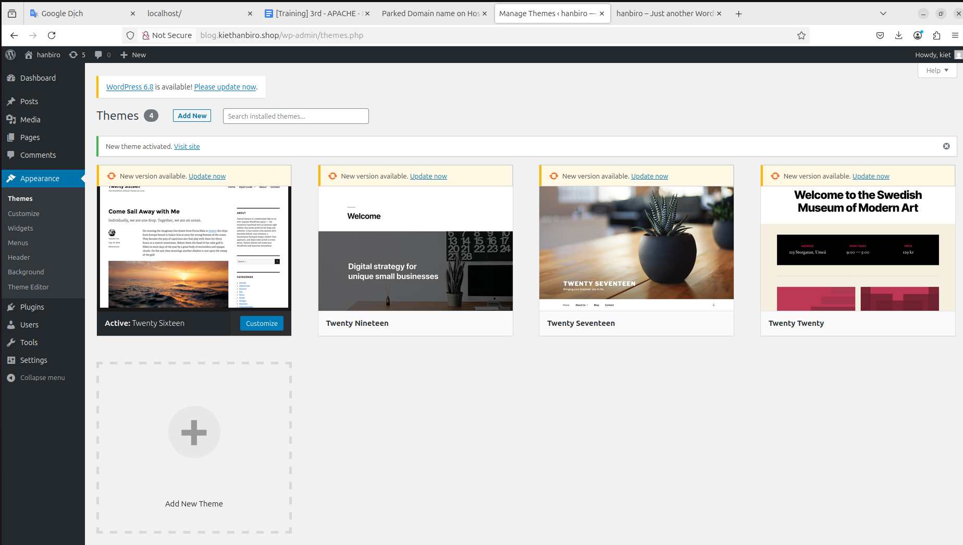

* write new post and publish

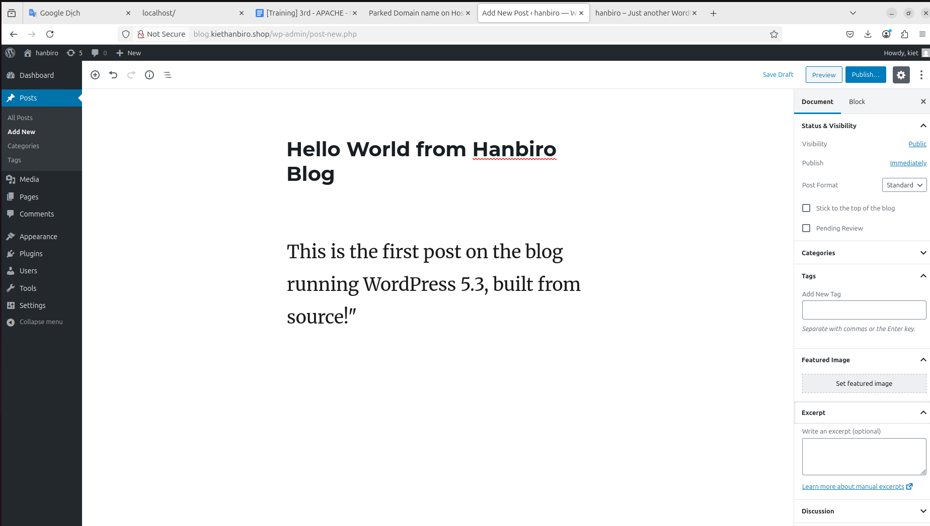

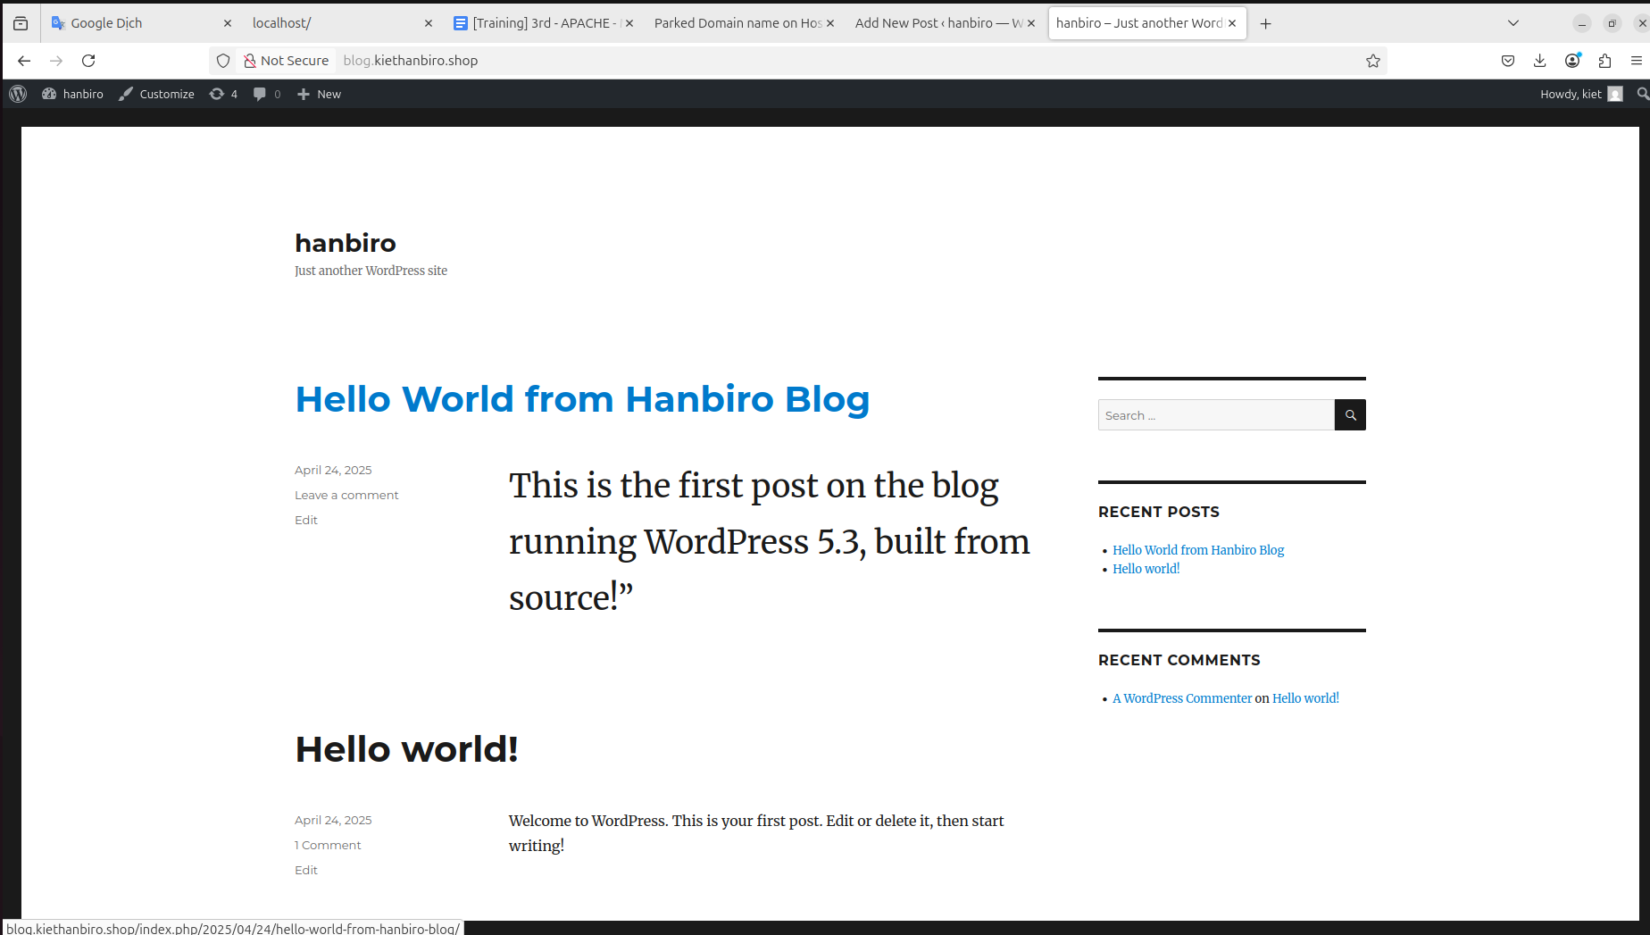

**+ Set up board program**

**-** [**http://bbs.xxx.shop**](http://bbs.xxx.shop)

**Select the board program you want.**

**- Create a board.**

**- Register and checkthe posts**

* install and extract phpBB:

cd /usr/local/httpd2/htdocs

mkdir bbs

cd bbs

wget https://download.phpbb.com/pub/release/3.3/3.3.11/phpBB-3.3.11.zip

unzip phpBB-3.3.11.zip

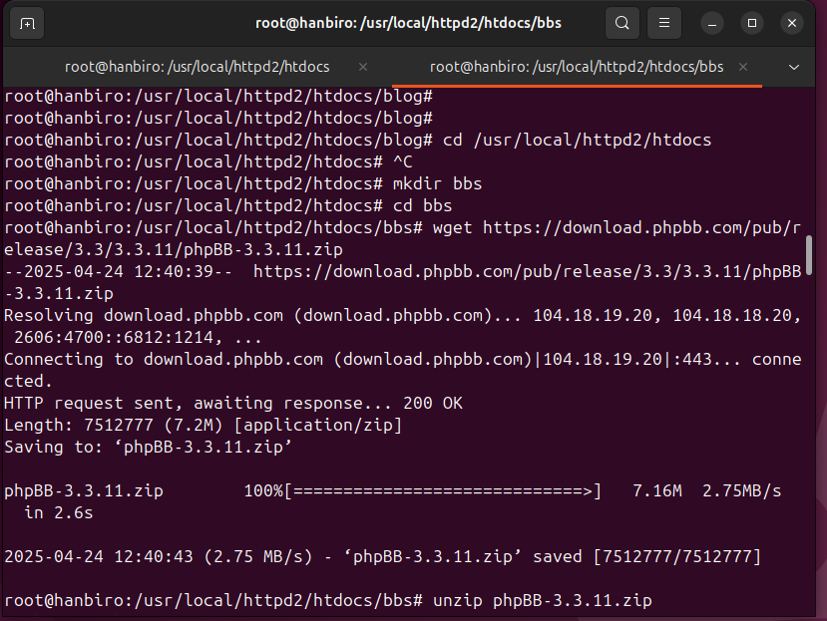

* create database:

sudo /usr/local/mysql/bin/mysql -u root -p

CREATE DATABASE phpbb CHARACTER SET utf8mb4 COLLATE utf8mb4_unicode_ci;

EXIT;

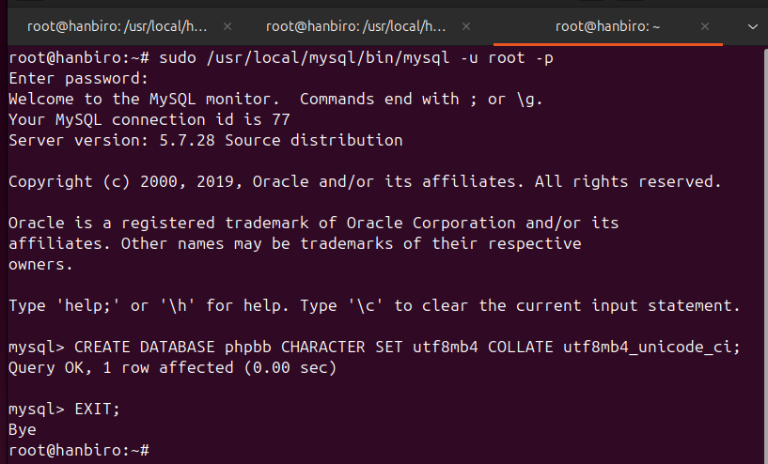

* config virtual host for bbs.kiethanbiro.shop:

*add:

<VirtualHost *:80>

ServerName bbs.kiethanbiro.shop

DocumentRoot "/usr/local/httpd2/htdocs/bbs"

<Directory "/usr/local/httpd2/htdocs/bbs">

Options Indexes FollowSymLinks

AllowOverride All

Require all granted

</Directory>

ErrorLog "/usr/local/httpd2/logs/bbs_error.log"

CustomLog "/usr/local/httpd2/logs/bbs_access.log" combined

</VirtualHost>

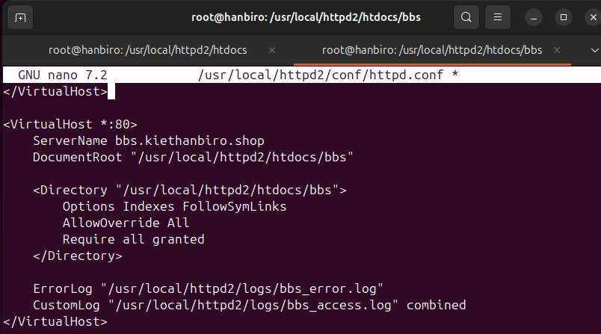

* need to map domain name **bbs.kiethanbiro.shop** to **127.0.0.1**:

nano /etc/hosts

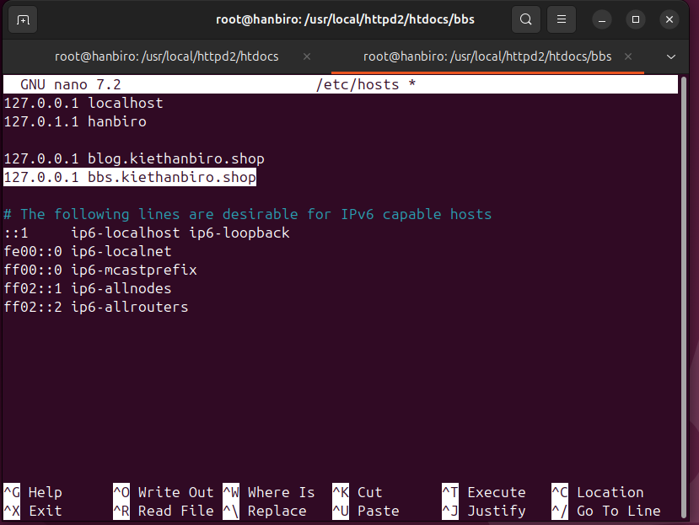

* restart service: /usr/local/httpd2/bin/apachectl restart
* access http://bbs.kiethanbiro.shop/install/

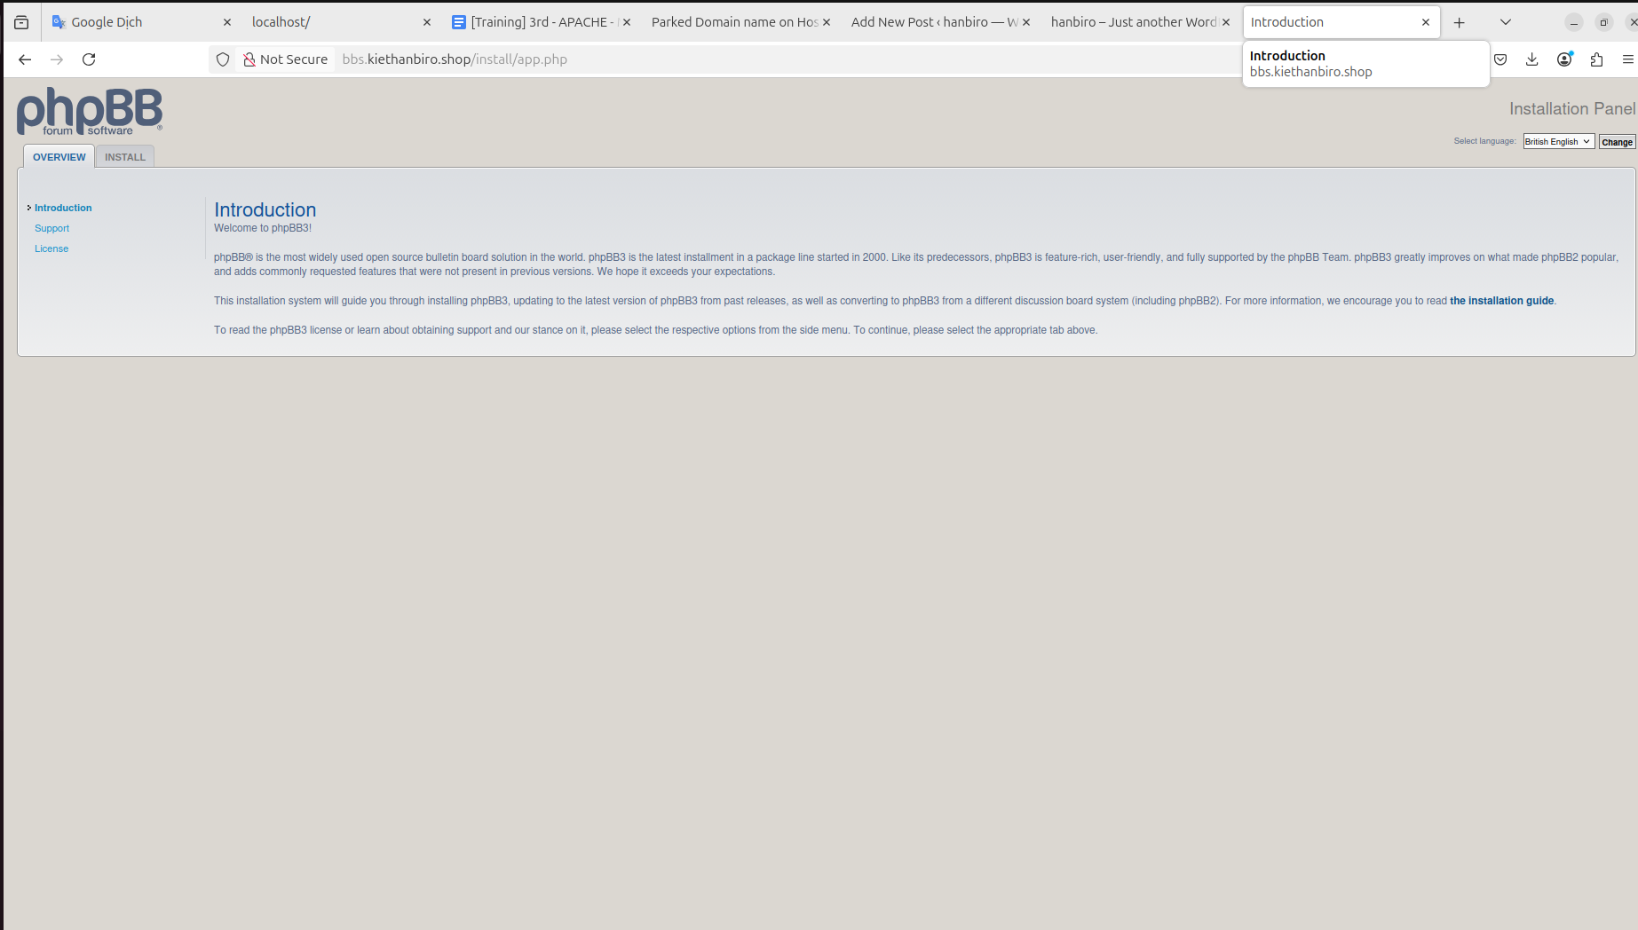

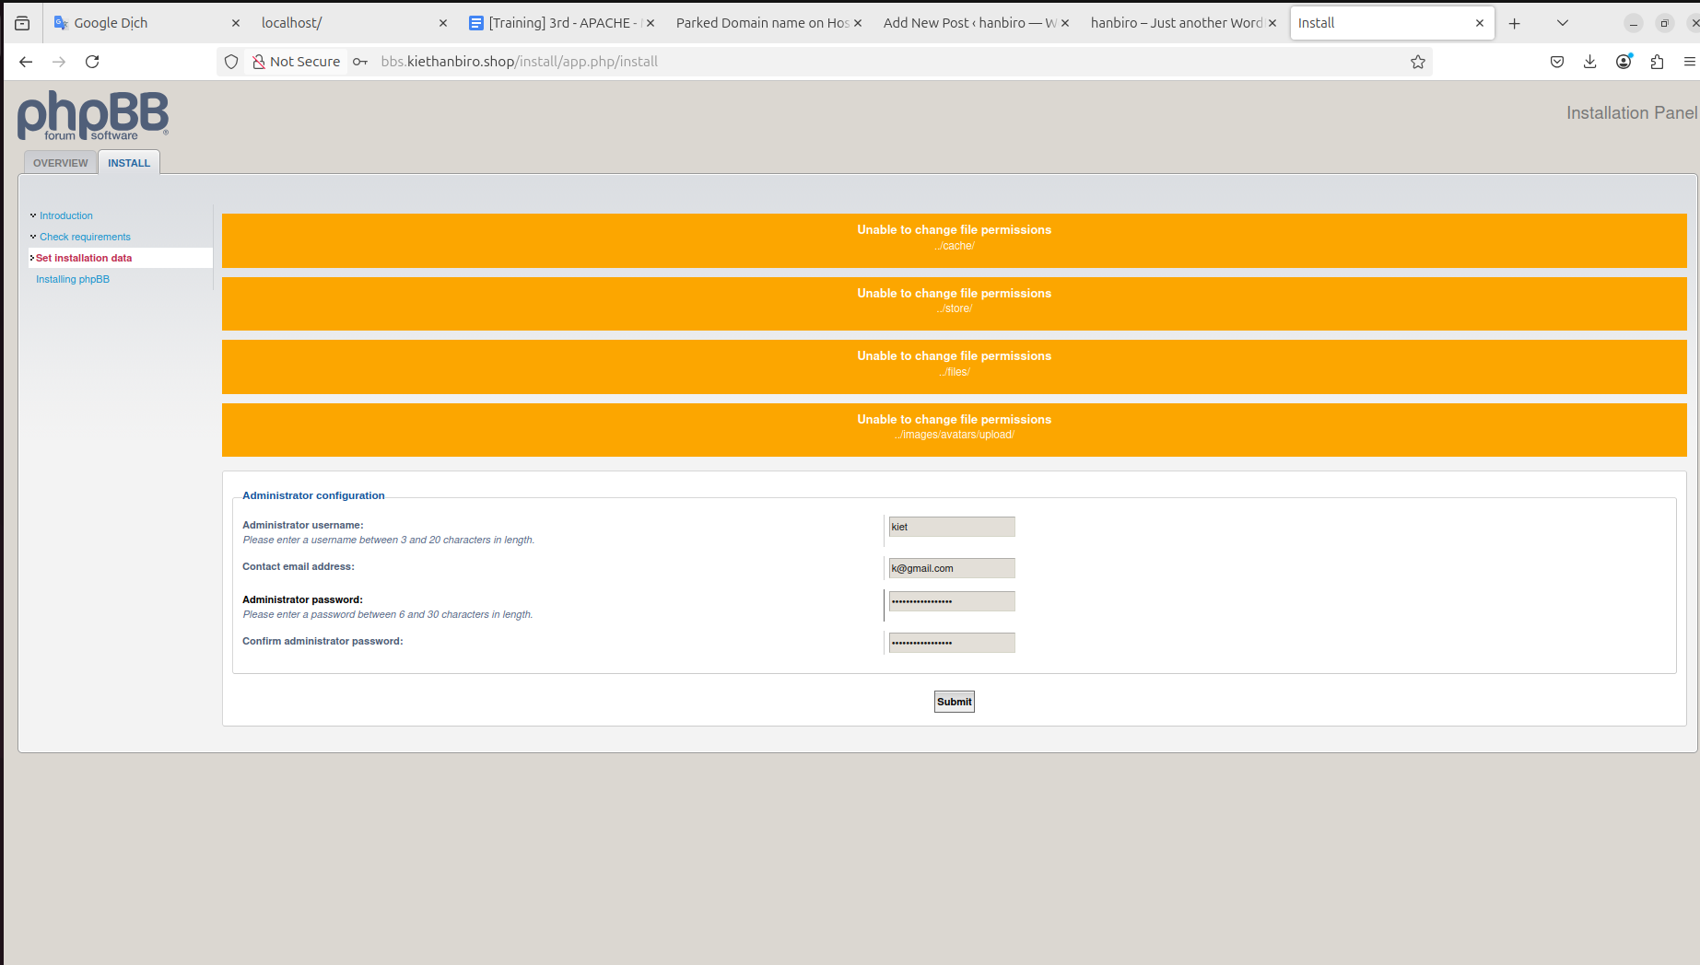

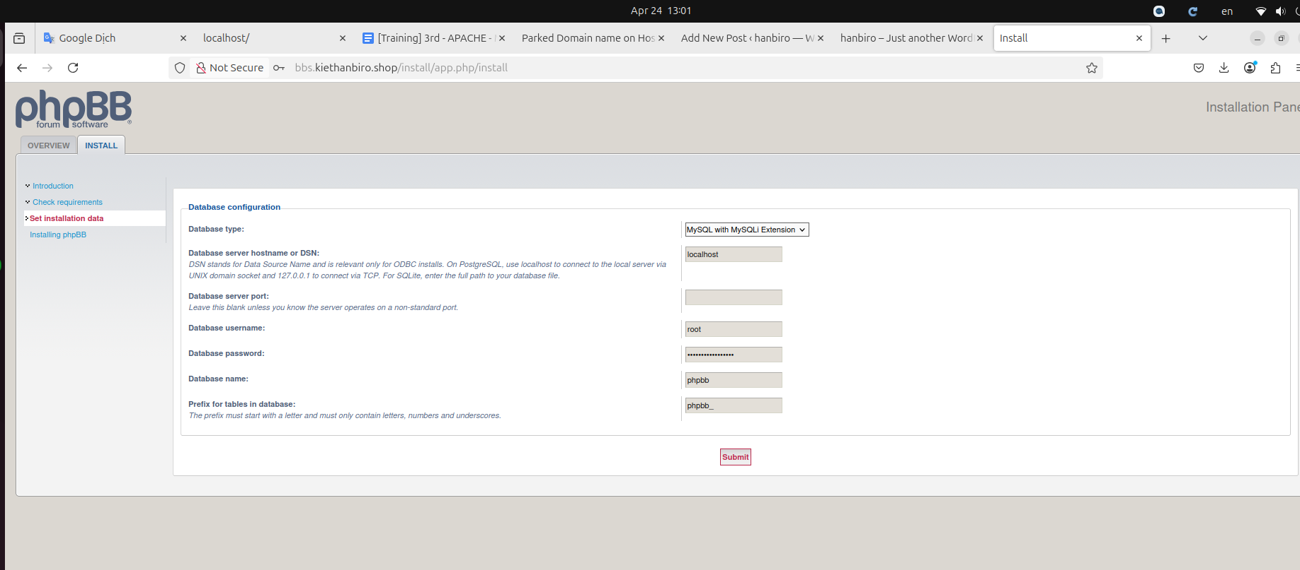

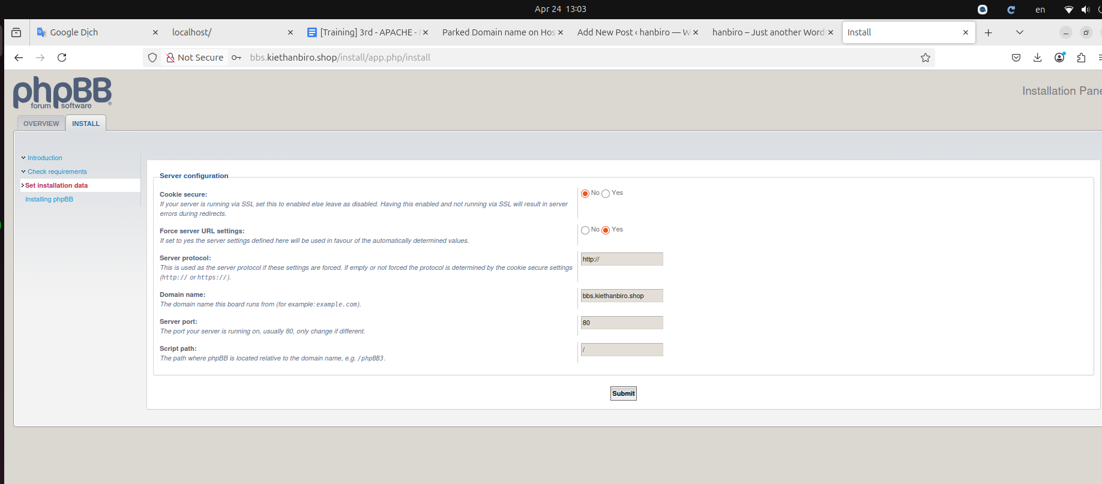

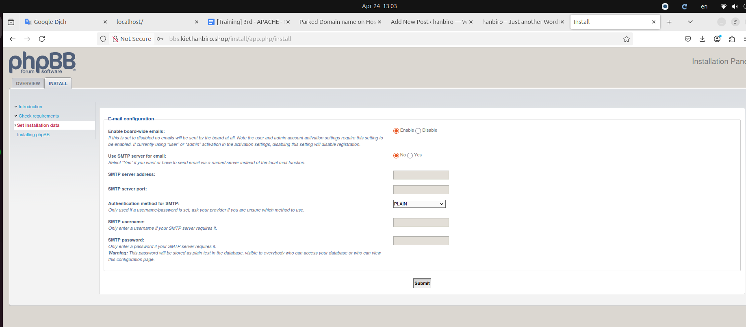

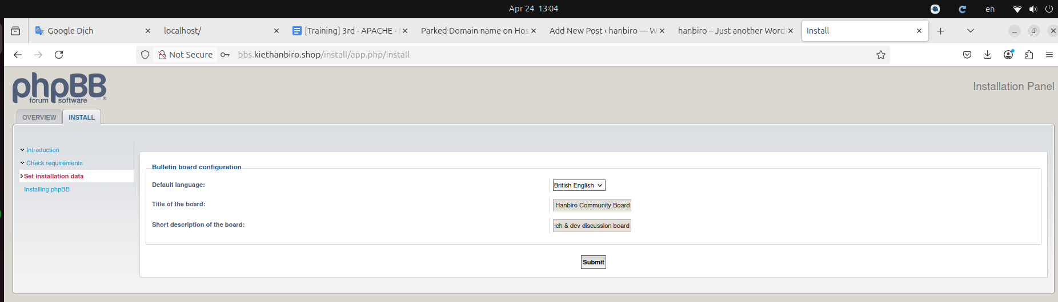

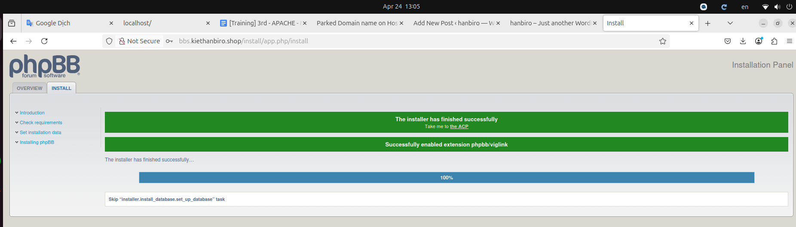

* for security reasons, phpBB requires the install/ directory to be deleted before the forums or administration pages can be accessed

sudo rm -rf /usr/local/httpd2/htdocs/bbs/install

* access: http://bbs.kiethanbiro.shop and into **Admin Control Panel**

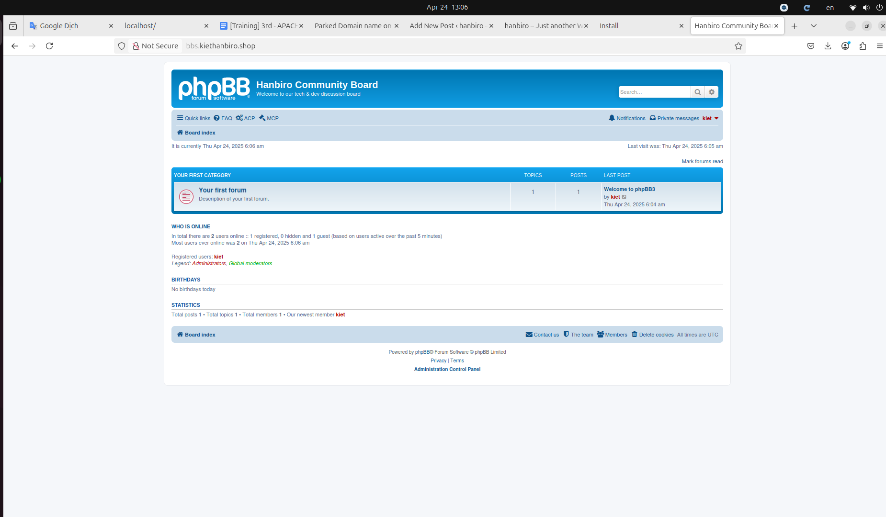

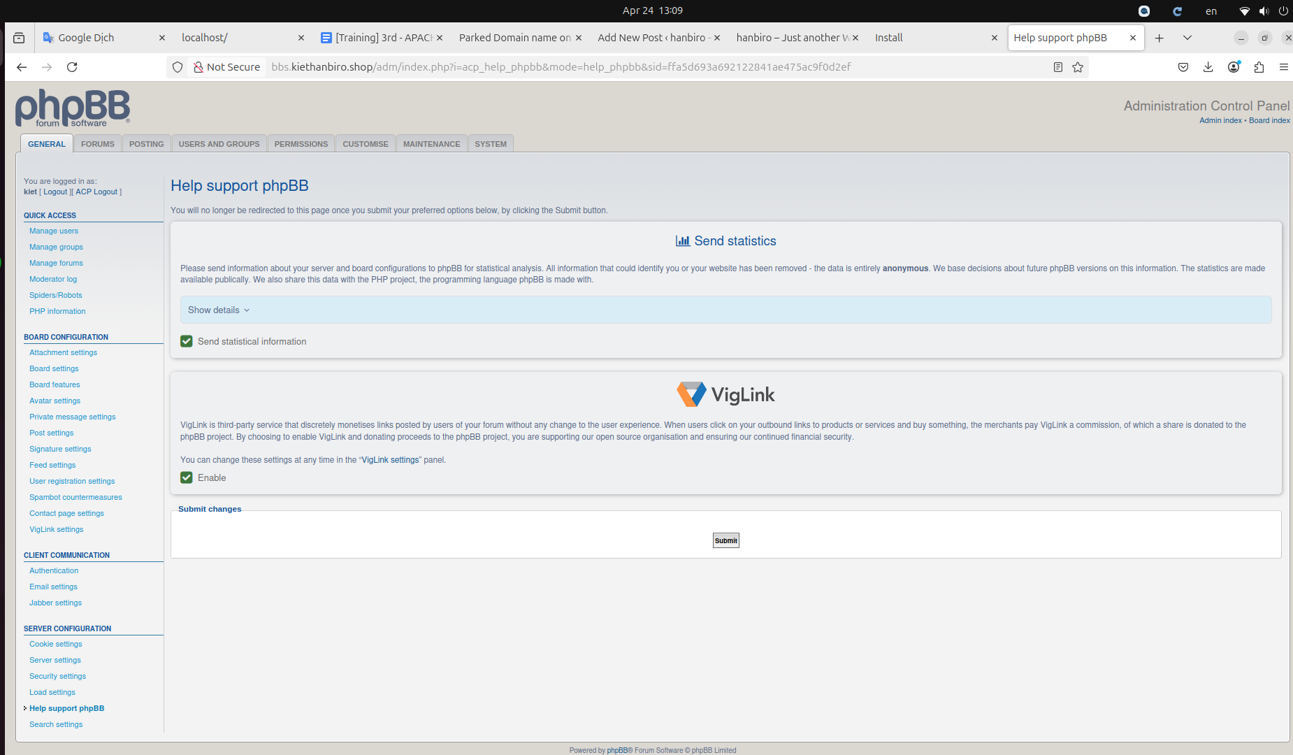

* create New Topic:

